ERASMUS + activity form

The title of the action: Scientist Anders Celsius and thermometer
A brief description of the action: Kids examine the researcher's invention claimed. Find out how to have the thermometer in daily life to help. The principle of the manifestos of the thermometer. Solve tasks of the thermometer readings for comparison
Through the activities of the release time (date, time):
Group: Naerulinnud The age of the children: 4-5

The teachers: Meeli Lugus, Hege Mardiste

Objectives:
The child shall examine the thermometer and its principle of operation.
Kids will make different mathematical assignments with the reading of the thermometer.
Tools: Different thermometers, two jugs, one for cold and one for hot water. Pictures of the scientist A. Celsius and his inventions.
The action: How can we make sure what kind of weather is outside. Is it worm or cold weather? How can we know do you have a fever? (children´s answers) For this we have different kind of thermometers in the world. Already in the older times scientists made many different scaled thermometers, but it made a lot of mess. Swedish scientist Anders Celsius invented a thermometer that had a zero degree what implemented the freezing of the water and hundred degrees that implemented boiling of the water. This was the thermometer that people started later to call Celsius’s thermometer (show the children picture of Celsius and the thermometer)
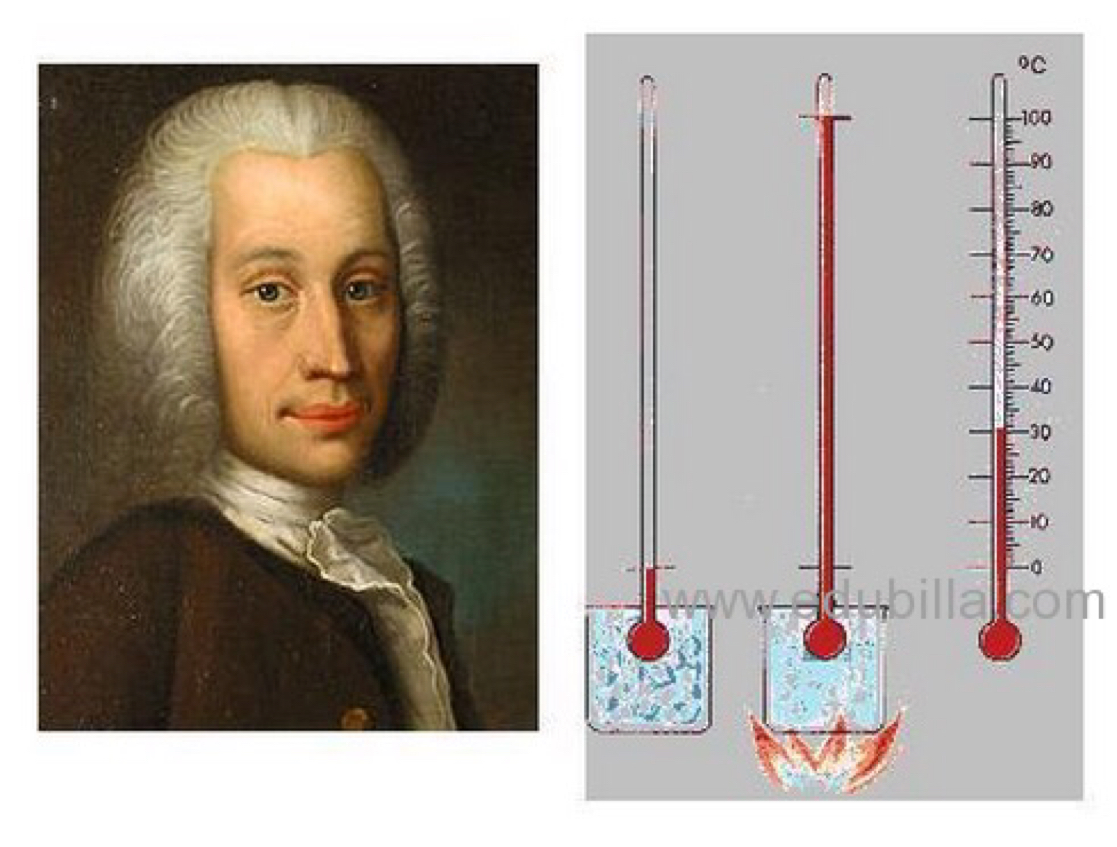
Nowadays this is the thermometer that is widely used around the world. His thermometers always have a ‘C’ so people would understand that this is his invention. Let’s see does our thermometers have the same markings?
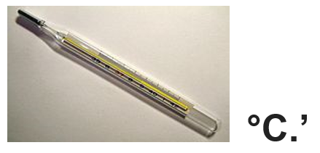

I have here many different thermometers, let’s see why are they used for.
Let’s see what the thermometer is made of and what parts does it contain. Thermometer has a scale of numbers, then there is a container of liquid and a small glass pipe where is possible for the liquid to move up and down. When the liquid gets warmer it will expand and move up the small glass pipe, when the liquid gets colder it decreases and moves down the glass pipe.
Tools: Thermometer, 2 jugs for hot and gold water.
Experiments: First the kids will get the thermometers and will observe the room temperature. For the next step they will put the thermometer in to the cold water and they will see the liquid starting to go lower as it decreases inside, and then they will make the same experiment with the hot water and see the thermometer go up.
Tools: Small pictures of sun and moon. Small items for counting.
Test: Sunday morning thermometer was showing +3, in the day time the sun was up and thermometer went up for the evening +6. How many degrees did the thermometer rise? (Kids will count and set up the morning and the evening result of the thermometer, they will make comprising and will find a solution)
Test: Monday morning the temperature was +5, it was raining it the daytime and in the evening the temperature was risen +6 degrees. How many degrees did the temperature rise? Etc.

Sources:
Lukner, H, Müürsepp, M (2017). Füübits. Teaduse ja tehnika esimene lugemik huvilisele lapsele. Tallinn: Tammerraamat.

https://et.wikipedia.org/wiki/Anders_Celsius

