ERASMUS+ I LOVE SCIENCE!
Form of activitie

Name of the activitie: FEEL THE NUMBERS
Short description: In this game the children needed to guess thru touching what (wich number) is hidden under the blanket
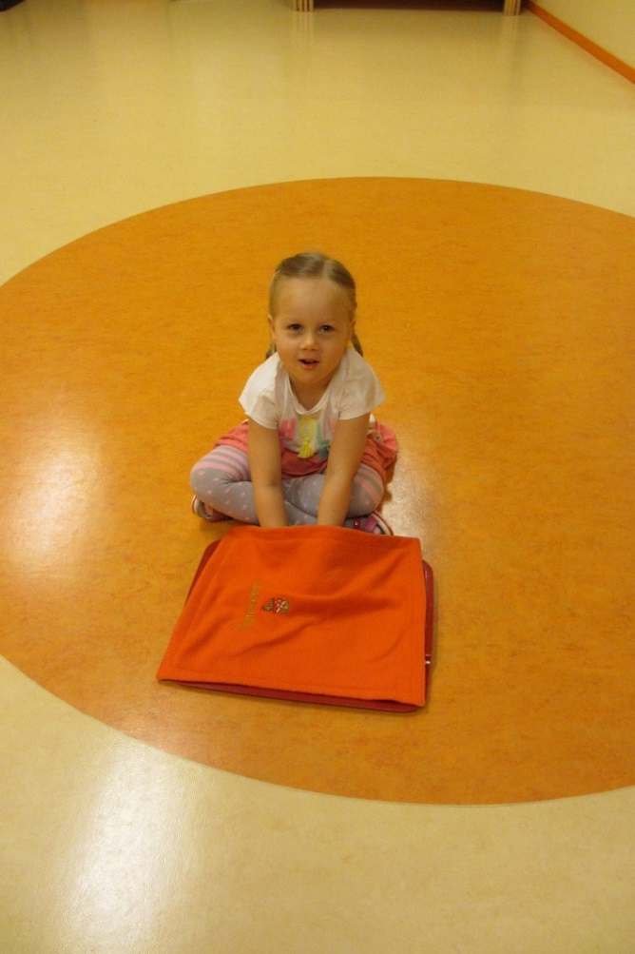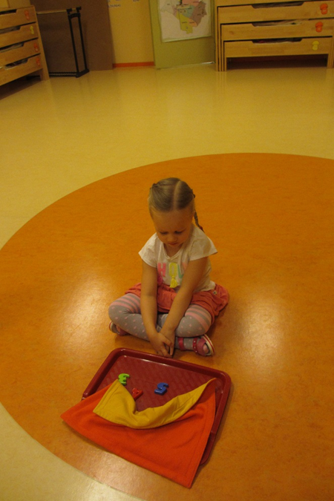
Name of the class: Õnneseened Age of the children: 4-5 years
Teachers: Kätrin Pukk and Laura Lisanna Saidla
Purpouse of the activitie:
- The child studied different numbers thru touching.
- The childs eye and hand coordination improves.
Tools: tray, colored numbers, blanket
Detailed description of the activitie: Before the game begun the children did not know what was hidden under the blankett. Each child came and sat next to the tray, put her/his hands under the blanket and tryed to guess what is hidden under without looking. Each child had to guess the number they where touching.

