ERASMUS + Action Form

Action title: Battery, rechargeable battery, electricity
Short description of activities: In the activity the children will see and loot the battery that A. Volta invented. Find out what's the difference between the battery and the rechargeable battery. Search the battery and rechargeable battery the hazardous waste sign and find out why they must not be thrown into the same trash. Where we have electricity. How to safely walk around the electricity.

Time of activity (date, time): 22.12.2017
Group: Naerulinnud Age of children: 4-5 Years

Teachers: Meeli Lugus, Hege Mardiste

Objectives:
The child knows where the electricity is coming from, which is battery and rechargeable battery.
The child appoints objects and activities that may be dangerous (electricity).
The child knows that batteries/rechargeable batteries are dangerous to the environment and are not thrown into the trash.
The child is acquainted with the researcher's Alessandro Volta invented battery.

Facilities:

Action Gear: I have a single item (battery) Today, what is it used for? The first battery was invented by the Italian physicist Alessandro Volta (picture). Let's look at the movie how he saw the first battery he invented, and what he consisted of Https://www.youtube.com/watch?v=c_0N-0lfxpE . That's what the first battery looked like, but over time, it has changed a lot.
There's a battery now, and there's a rechargeable batteries on the side, do you know what the difference is? ()
Here are a variety of batteries and rechargeable batteries, we'll find out where they can be used. For example, how Power Bank works (battery charging, use options).
If the battery, or the battery becomes empty/old, can you just throw them in the trash? We are looking for a corresponding character (picture) on the battery. Batteries and other hazardous waste must be collected separately and carried out in the corresponding collection points.
Do you know where electricity is coming to your homes? () electricity is produced in Estonia in power plants. In order to produce electricity, oil shale is extracted from the ground. It transported power plants and burns in ovens. As a result, the combustion is emitted by heat and energy, which makes it work on a machine that produces electricity. From there, the wires had to move to the homes.
We're going to make one game to understand how electricity moves in the circuit. Let's grab our hands and form a circle. The Power's going to move. Game host squeezes the hand of the child on the left, the electricity moves from the game to his other hand and he squeezes the hand of his friend, etc. The pace of the game will be accelerated and played for a short time.
Electricity is a powerful energy that makes many machines work. People have a lot of help in electricity, but electricity is a very dangerous thing. Let's look at the pictures together and talk about the safety of electricity. https://www.slideshare.net/pirka/elektr-44209040

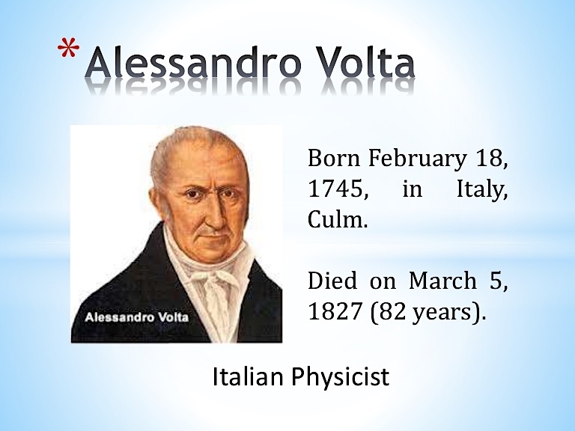

Sources:
https://www.youtube.com/watch?v=c_0N-0lfxpE
https://www.slideshare.net/pirka/elektr-44209040

