Where’s my magic wand ?
I want to change !

I will go see the world with lots of travel to see new people.

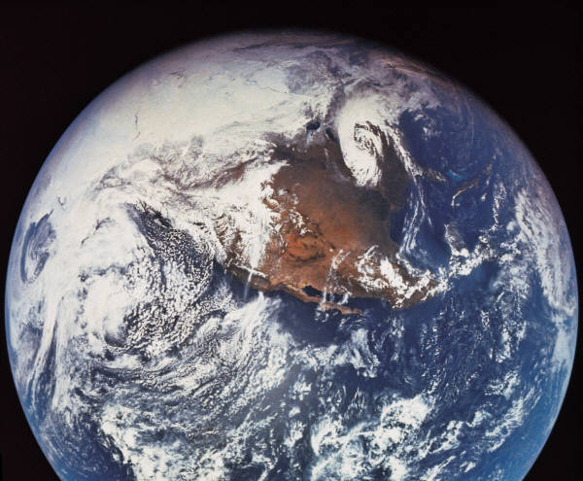

Being rich and enjoy life and to enjoy a close to my everything I have learned in my life
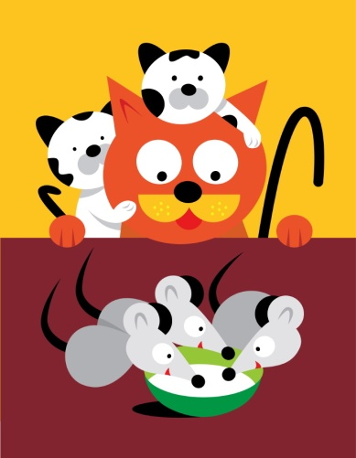

and the money I won because I'm a big bussiness women.
