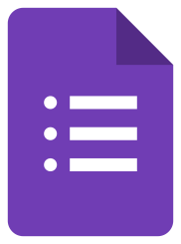 GOOGLE FORMS to make surveys  
  
 PADLET to make boards on pages  
 CANVA to make logos and posters

 POSTERMYWALL to write e-letters

 KAHOOT ! To make tests

 WORD to create files

 OURBOOX to make e-book

 GOOGLE MAP to define the participants hometowns

 AVATOON to make avatars

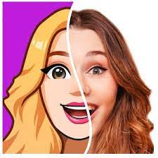 Mİrror to make avatars and comics

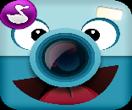 CHATTERPIX to make their avatars to speak  
 YOUTUBE to upload videos

 GOOGLE to search

 WEBRAZZI to make videos

 WHATSAPP to communicate faster

 INSTAGRAM as a social media

 ZOOM to meet online

VIVA VIDEO to create videos

 POPPLET to make mind-mapping

 MICROSOFT TEAMS to make mixed groups of students

CAPCUT to render,edit and combine the videos

BLOGSPOT to create our blog page

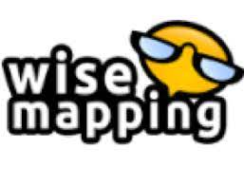To create Brain Mapping

 Quizzez to test online and challengce the students

 Comic Book to create comics

Comic page creator to edit comics

 Quizlet to make online tests

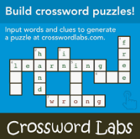 Crosswordlabs to make crossword puzzle

Youtube to upload our videos

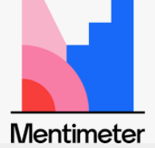 Mentimeter to test

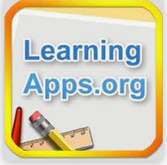 Learningapps to prepare and make test

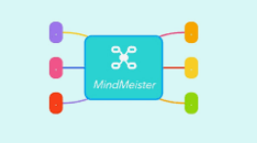 Mindmeister to collaborate at mind mapping

 Coggle to make brainmap

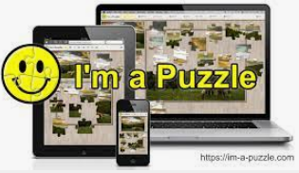 i-am-apuzzle to make puzzle

zumpad to collaborate

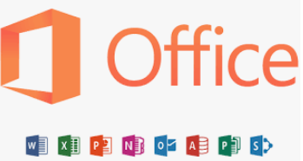 Office programs for eveything

 Emaze to make an exhibition

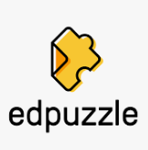 Edpuzzle to make puzzle

 to make online books and stories

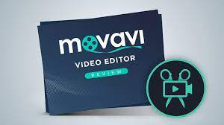 MOVAVİ to make videos

 İnshot to mak videos