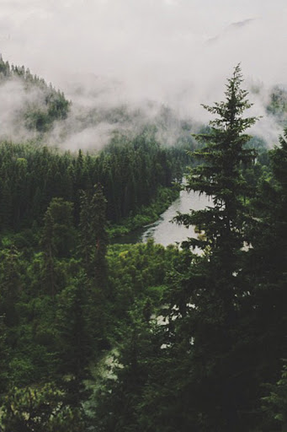
PROTECTING ENVIRONMENT IN SLOVAKIA
An environment is the natural world that surrounds us. It is very important to keep it clean in order to live healthy and peaceful life. However, the environmental pollution has become one of the biggest threats for Earth. It can affect our future one day. People suffer from their own mistakes. Pollution endangers our existence and destroys our living environment. So here are few examples of what should people do to save the Earth:
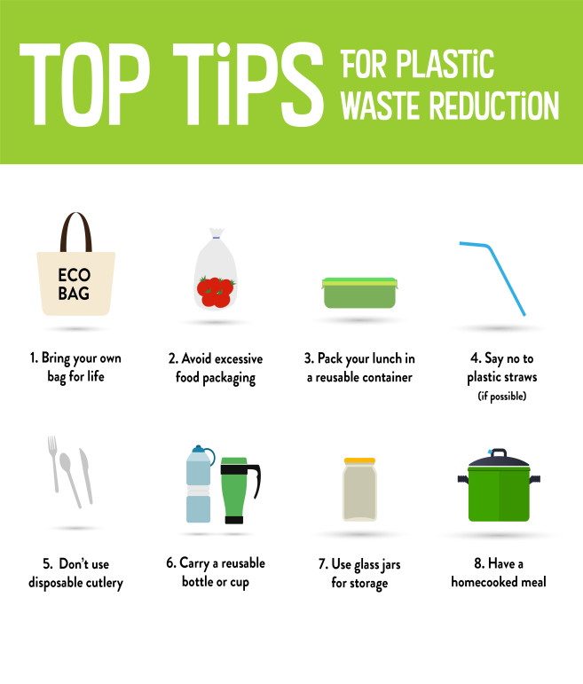
- REDUCE YOUR WASTE- Recycling what we can reduces the amount of new materials we are making, and upcycling is a creative way to make old items into something more valuable. This could be reusing a jam jar as a candle holder, or using old tins as plant pots – the possibilities are endless!
- OPT FOR A SHOWER - Switching your bath for a shower can make a huge difference. Baths use approximately double the amount of water a shower uses. This not only saves water, but it saves you money on heating the excess water too.
- BUY LOCAL PRODUCTS- Where possible, buy local produce. This saves all the pollution incurred by transporting goods long distance.
- DON´T USE PLASTIC CARRIER BAGS- Plastic carrier bags are not biodegradable, nor are they recyclable. They sit in landfills where they often end up polluting the ocean and infiltrating food sources. Use a stronger, reusable bag.
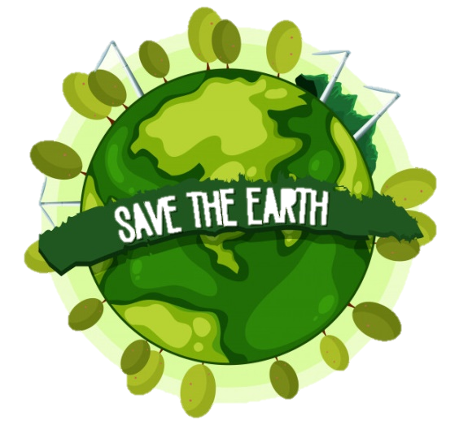
No one surely knows what will happen with our Earth in 100 years. But we predict that if we continue with our todays lifestyle it will be worse and worse. It can bring droughts, heat waves, floods and diseases.
We should be aware about what will happen to us if we did not do anything. First of all, people should learn again how to treat Earth and the most important thing is to start with ourselves, because every small act which helps our Planet counts. So, let’s start protecting Slovakia and our whole planet to build better future for us and our kids!

