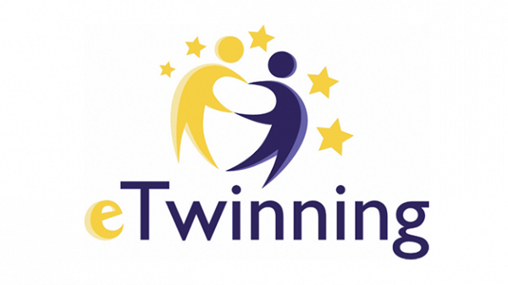
The planning of a trip from Slovakia to Poland
Travel costs

General information
Republic of Poland
Poland is an EU member state located in Central Europe, housing a population of nearly 40 million. It borders Lithuania, Belarus, Ukraine and Russia to the East, Slovakia and Czechia to the south and Germany on the Western side. The country´s population is heavily Catholic since the late 10th century. Warsaw is the capital and most populous city in the country. Poland´s other major cities are Krakow, Lodz, Poznan and Gdansk.
Zabór
It is located in western Poland. Its most famous attraction is the Zabór Castle, a residence built in the Baroque style. It used to be held by nobles, the house of Schoenaich-Carolath, also for a period of time it housed Princess Hermine Reuss of Greiz, the widow of the last German Emperor. The Napoleon Oak, the biggest oak in Poland used to stand nearby, but it has unfortunately collapsed in 2010.
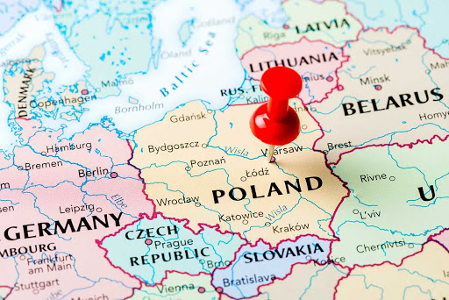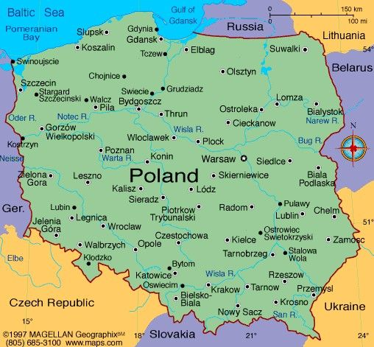
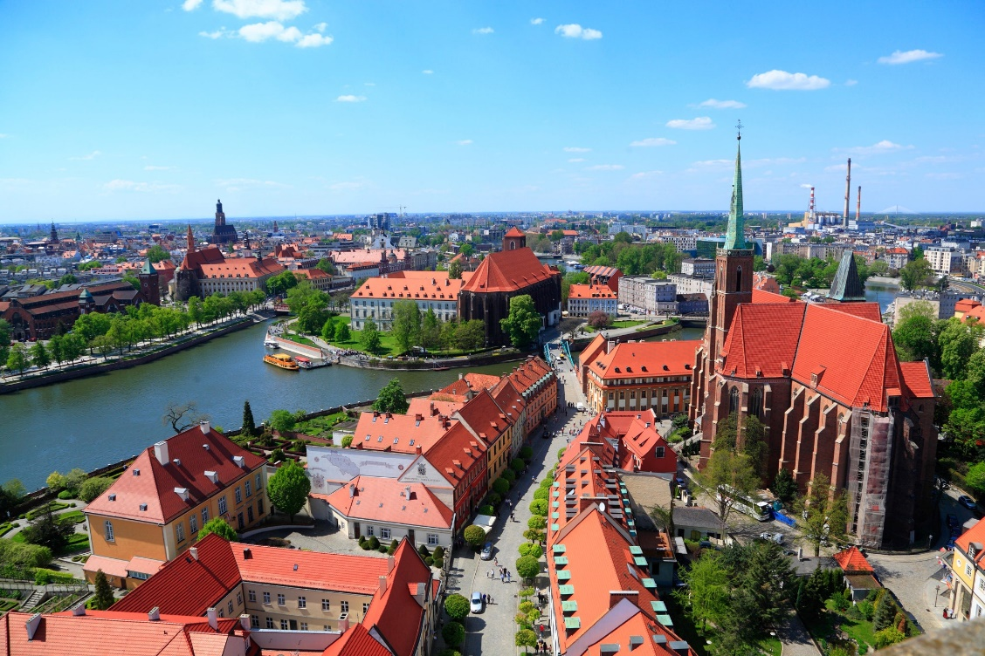
Warsaw
The Polish capital city is built around the Vistula River, the biggest and longest river in the country. A population of 1.8 million resides in the administrative area of Warsaw. Thanks to Sigismund III. it became the capital city in the 16th century. The city was conquered by Nazi Germany during the Second World War and throughout this time period was the location of two major uprisings, which largely contributed to 85% of the city´s buildings destroyed and ruined.

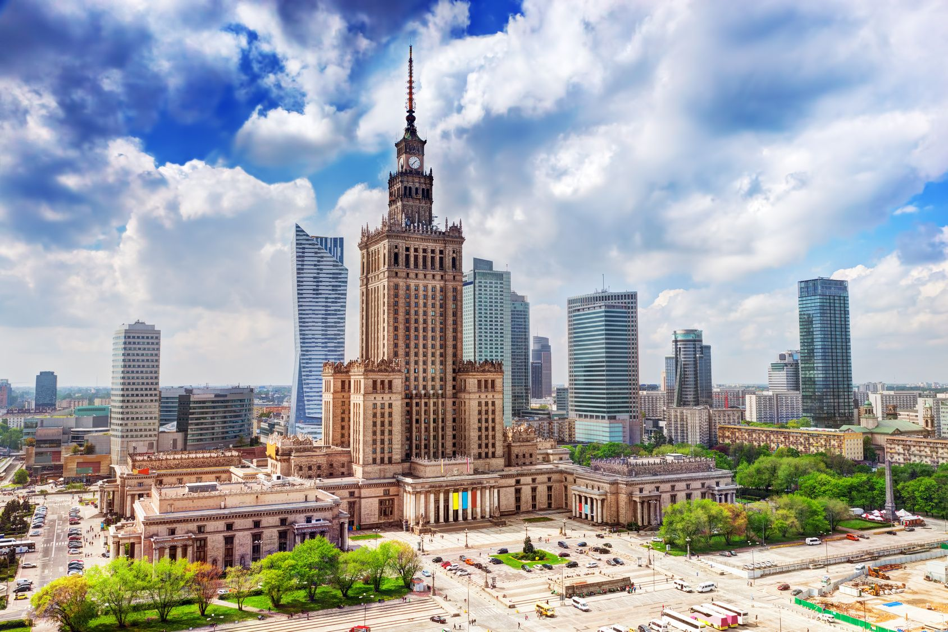

The Palace of Culture and Science has become one of the city’s most widely recognised symbols. The Palace houses a cinema, a swimming pool, four museums, four theatres, four universities and numerous coffee stores and bars. Visitors can also take advantage of the terrace located on the 30th floor, offering a mesmerising view of the city’s panorama.

Old Town
Included on the UNESCO World Heritage list, Warsaw’s Old Town was completely rebuilt after World War II, based mostly on 18th century paintings by the Italian painter Canaletto. The heart of the area, guarded proudly by the Warsaw mermaid, is the Old Town Market Place with its restaurants and cafés. Visitors should also make sure to see the Barbican and St. John’s Cathedral, as well as explore the picturesque winding streets.

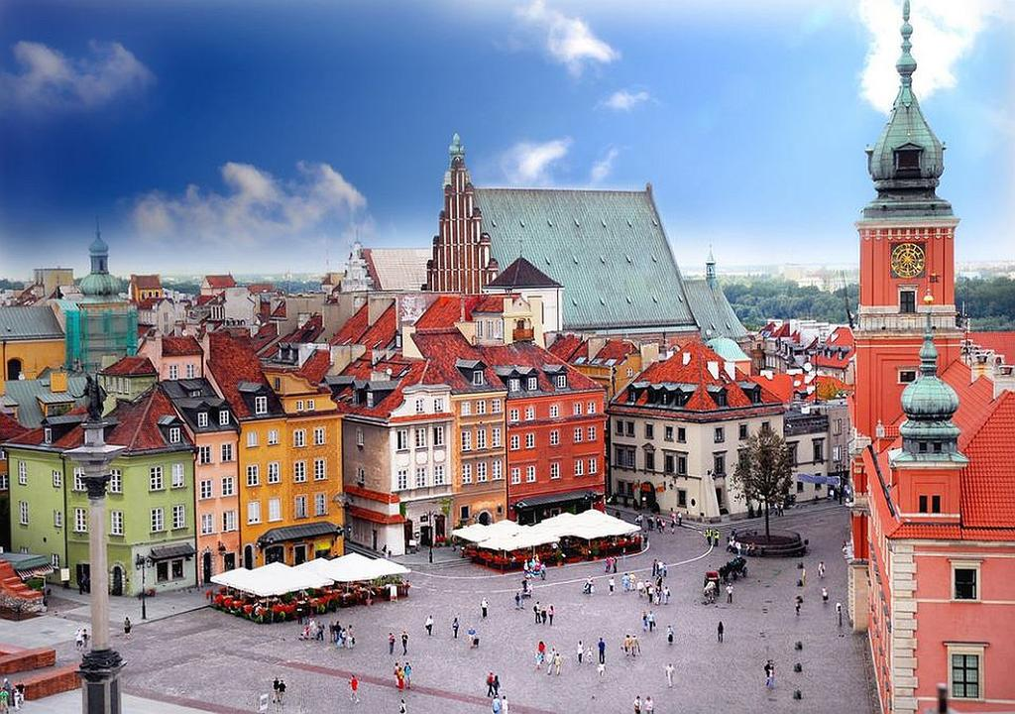

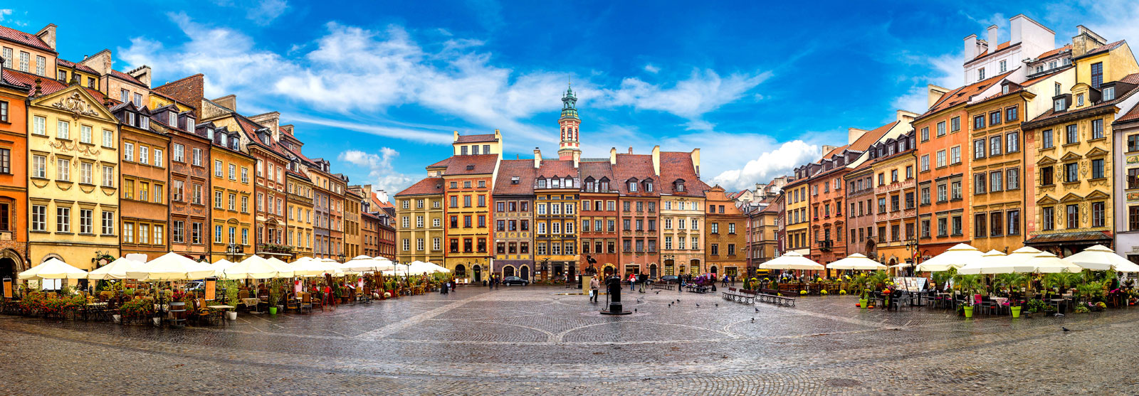

Copernicus Science Centre in Warsaw
Science Museum

Located on the bank of Vistula River, Copernicus Science Centre is the largest science centre in Poland, with over 450 interactive exhibitions in six interdisciplinary galleries. Especially worth visiting is The Heavens of Copernicus planetarium which offers movie screenings and live shows. Those who want to escape the crowds of excited children can choose to visit the centre during adults-only evenings taking place once a month between 7pm and 10pm.

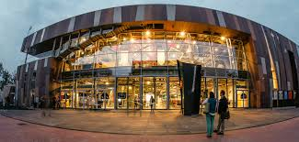

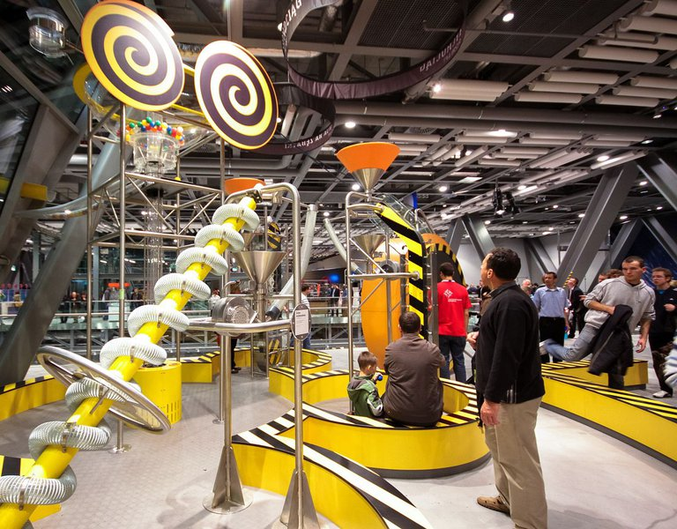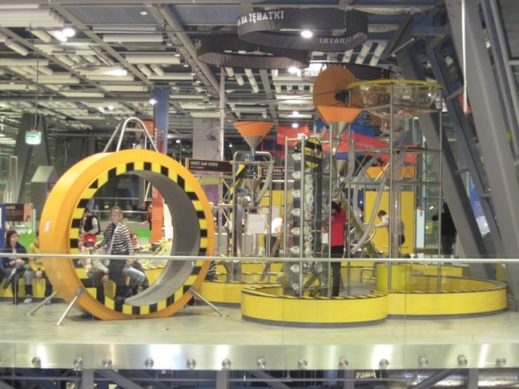

Krakow
It is the second largest city in Poland, with the population of 770 thousand as of 2020. Similar to Warsaw it lies on the Vistula River. It probably originated in the 8th century and it was considered a busy trading centre as far back as the 10th century. The city had its golden age during the 15th and 16th centuries. Some of the worst concentration camps were built in its proximity during the Holocaust. Today it is the cultural and artistic centre of the country.
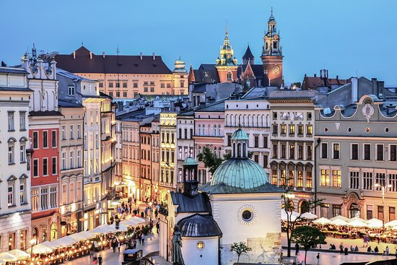
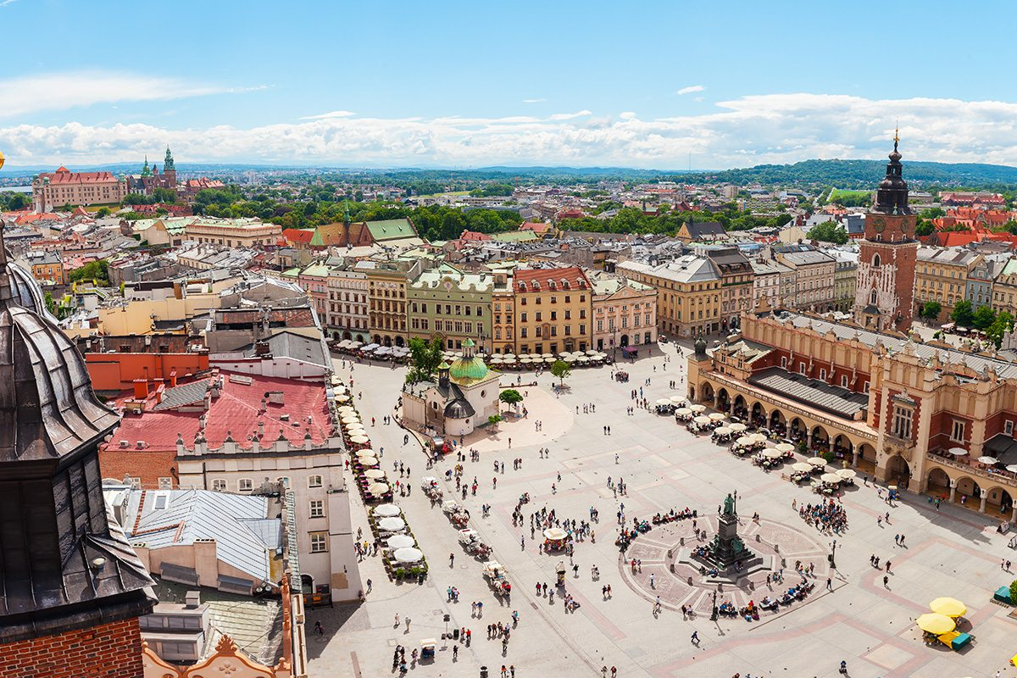
Specifics of the trip

Attendance: 30 students (class1-numberofstudents1, class2-numberofstudents2, …)
Duration: 5 days (date1-date5)
Total (cost): cost (6500 €)
Total per person (cost): cost (217 €)

Route: Hlohovec-Krakow (Day 1), 313 km
Krakow-Warsaw (Day 2), 293 km
Warsaw-Zabór (Day 3), 465 km
Zabór-Krakow (Day 4), 449 km
Krakow-Hlohovec (Day 5), 313 km
Transport (type): Bus
Transport (cost): total (2000 €), per student (67 €)
Stay: Hotel at Krakow (20 € cost per night + breakfast)
Hotel at Warsaw (25 € cost per night + breakfast)
Hotel at Zabór (25 cost per night + breakfast)
Hotel at Krakow (20 € cost per night + breakfast)
Stay (cost): total (2700 €), per student (90 €)
Attractions (cost): total (1800 €), per student (60 €)

Route of the trip

Full route (5 days)

Route (Day 1)

Route (Day 2)

Route (Day 3)

Route (Day 4)

Route (Day 5)

