**“What was any art but a mold to imprison for a moment the shining elusive element which is life itself. Life hurrying past us and running away, too strong to stop, too sweet to lose”**

[](allegati/ARTE.docx)

[](allegati/Cinema.docx)[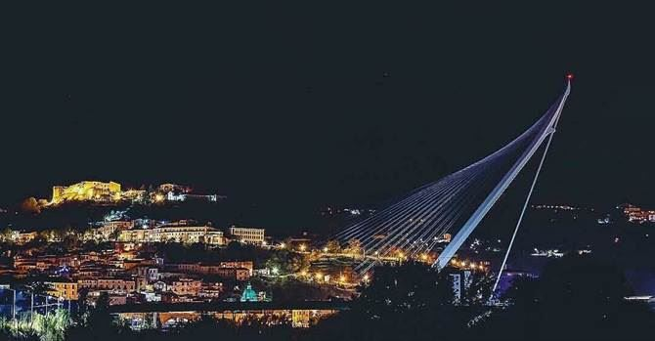](allegati/ARCHITETTURA.docx)

[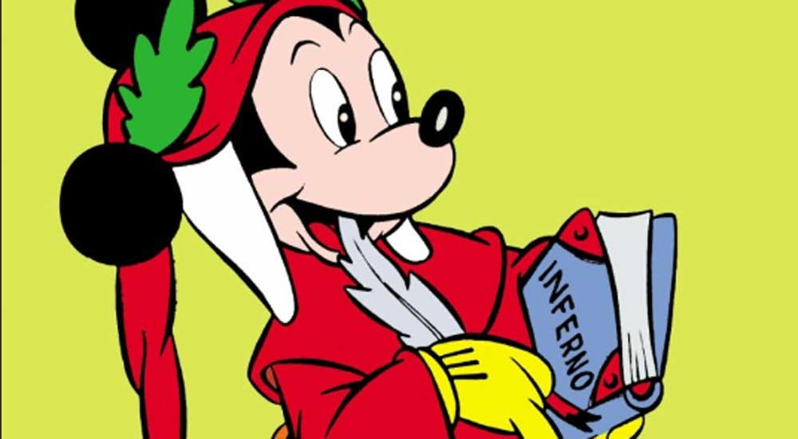](allegati/COMICS.docx)[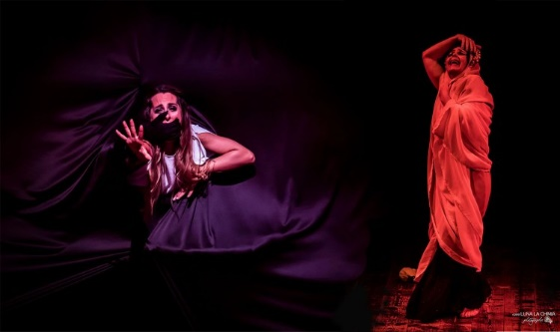](allegati/Dance.docx)[](allegati/Music.docx)[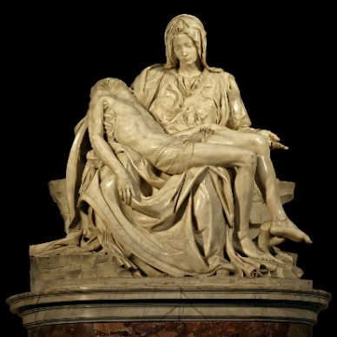](allegati/SCULTURA.docx)[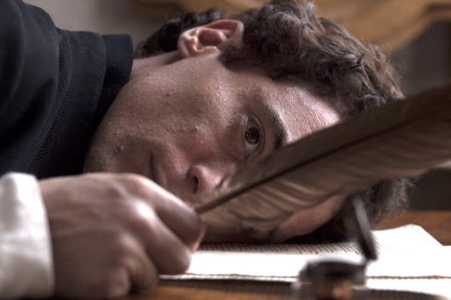](allegati/POETRY.docx)[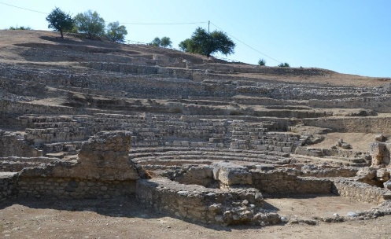](allegati/THEATRE.docx)[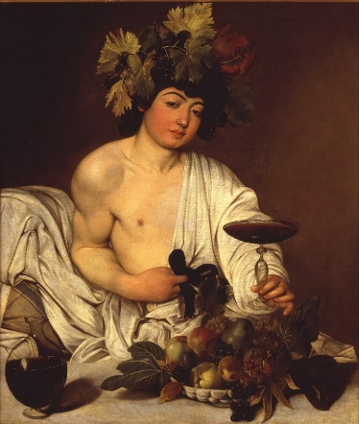](allegati/Painting.docx)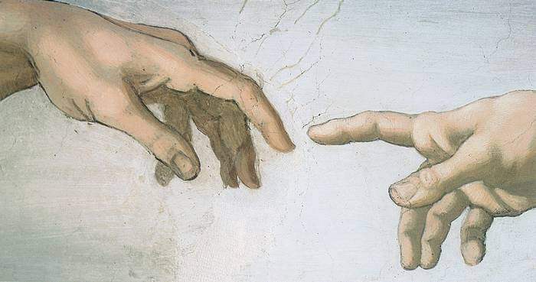

Cinema

Architecture

*CTRL + Click on the images to explore*

Paintingg

Theatre

Sculpture

Comics

Dance

Music

Poetry

**Art is freedom. Art is what makes men free. Free from life’s chains, free from human pain. Through personal talents, Art lets misery turn into beauty, making everyone different and equal at the same time. Art is equality. Art is a universal language by which it is possible to go beyond any wall, overstepping time. Art is what makes men immortal. It is next to God. God gave life to men. Life is Lord’s most important grant. So, Art becomes men’s gift to God, a perfect bond that connects earth and sky. For men, art represents the best way to show God their closeness and gratitude.**