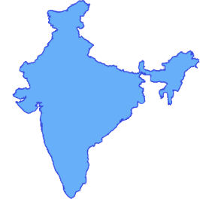
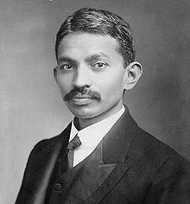
Mahatma Gandhi
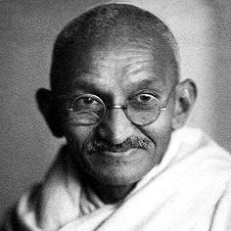
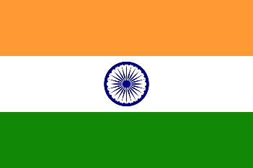

Click on the images to open information websites.
- What did Gandhi do for Indian people?
- What name did the Indian people give to Gandhi and what did it mean?
- Gandhi spent time in jail. How long and what for?
- Why did Gandhi write to Adolph Hitler?
- What happened in 1947?
- Put into your own words, ‘An eye for an eye will make the whole world blind.”
- Why did Gandhi fast in 1948?
- How did Gandhi die?
- What is Satyagraha?
10. Do you believe Gandhi’s example proves that non-violence works as a way to stand up for your rights?
5 or more facts about Gandhi, his life and work:

