Task: Can you match the pictures of famous entrepreneurs to their names and descriptions?
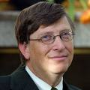
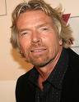
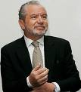
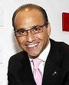
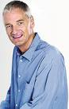

Theo Paphitis
I am a famous entrepreneur, who is currently working with other entrepreneurs. I invest money in small businesses. I owned many companies, which also include La Senza and Partners.
Simon Cowell
I work with other 3 judges on TV. I am very rich and famous but my main job is to make talented individuals known in the public eye.

James Dyson
I am a famous inventor in England. I was vacuuming my house when I realised my vacuum cleaner was losing suction. This has led me to produce my well known product.
Bill Gates
I am an American businessman and one of the world’s wealthiest people. I am one of the best known entrepreneurs of the personal computer revolution.
Alan Sugar
I am an English entrepreneur, from East end of London. N my early days, I have made money by boiling and selling beetroot from a stall. Now I feature in one of the famous programmes on TV.

Richard Branson
I am from South London. I started my own business by selling records out of the boot of my car.

