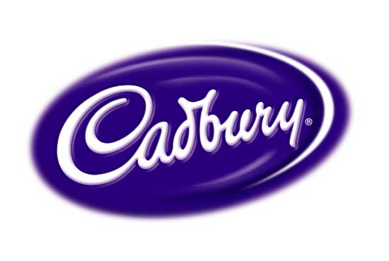
Year 6 Enterprise: Chocolate Bar Task

Ingredients: | Cost per Chocolate bar:
Milk Chocolate | £0.08
White Chocolate | £0.10
Dark Chocolate | £0.10
Raisins | £0.03
Biscuit | £0.08
Caramel | £0.15
Nuts | £0.05
Wafer | £0.08
Fudge | £0.15
Honeycomb | £0.20
Coconut | £0.05
Strawberry Cream | £0.15
Mint Flavouring | £0.05

If there are ingredients you want to include that aren’t on the list see your teacher for their price.

