COLLECTIVE EVALUATION REPORT
For the (number) Short term (students/ teachers) teaching and learning activity
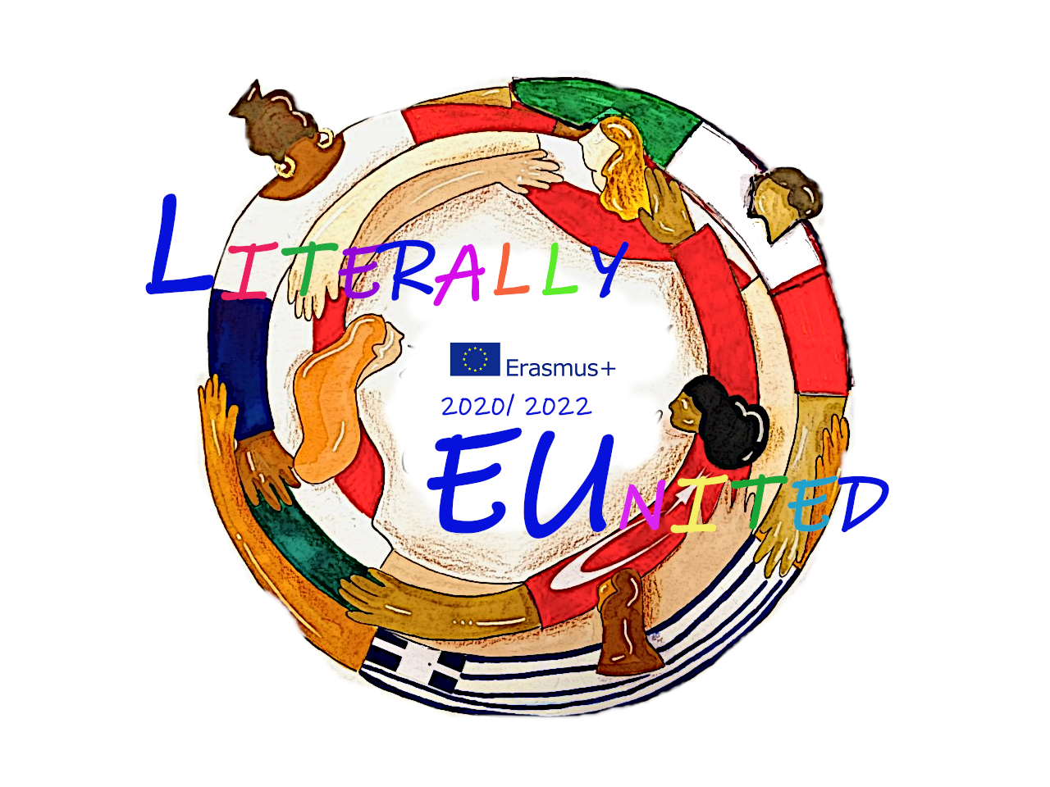

Areas and Activities Discussed/ Presented
During the meeting we presented/ discussed the following:

Questions raised

Team Comments

Turkey Team ( number members of staff from Mustafa Kemal Ortaokulu Kültür Mahallesi, Kuyumcuzade Bulvarı, Merkez/Düzce Turkey

- Kerim Sivrikaya - CO-ORDINATOR

-

Evaluation of the meeting:

Italian Team number members of staff from Istituto Comprensivo Statale San Giorgio STRADALE SAN GIORGIO 29 95121 CATANIA Italy

- Laura Anselmi - CO-ORDINATOR

Evaluation of the meeting:

France Team number members of staff from Collège Elsa Triolet, 2 rue Malik Oussékine 77130 Varennes sur Seine, France

- Mira Hamrit (Teacher) - CO-ORDINATOR

Evaluation of the meeting:

Hungary Team (number) members of staff from Szabó Pál Általános Iskola és Alapfokú Muvészeti Iskola, Vésztő

- Istvan Orban - CO-ORDINATOR

Evaluation of the meeting:

Poland Team (number) members of staff from Szkola Podstawowa nr 30 , Wroclaw

- Elzbieta Karas - CO-ORDINATOR

Evaluation of the meeting:

Greece Team (number) members of staff from E10013873 GENIKO LYKEIO NEOU SKOPOU, NEOS SKOPOS

- Thekla Kafkia - CO-ORDINATOR

Evaluation of the meeting:

