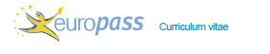

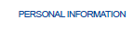

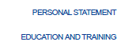
Motivated student wishing to develop his language skills.

03/28/2022
01/04/2022 Host School: GENIKO LYKEIO NEOU SKOPOU, GREECE

Acquired Skills

- Speaking Skills: Students presented information about their schools, staff, towns, regions. Presented their talents and performed scenes.
- Students presented school activities demonstrating the module Environment literacy
- Understanding skills: Performances/ Attendance to performances
- Writing Skills: Writing drama
- Cultural Awareness: Learning about the host country culture, local customs and crafts. Learning local, traditional musics

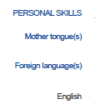
French
