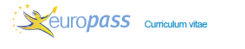

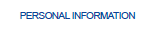

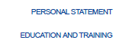
Motivated student wishing to develop his language skills.

01/25/2021 -
01/29/2021

School name

- Speaking Skills:
- Understanding skills:
- Writing Skills:
- Cultural Awareness:



