I am Neil, a student at Soundwell College, how are you? How are you enjoying your summer? We are soon going on holiday to Penzance in Cornwall!

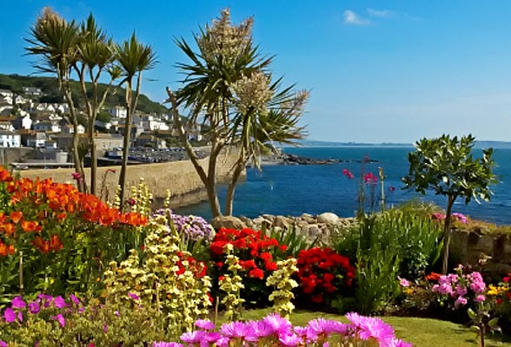
Best wishes from Neil

