To Jo,
Thank you for allowing us to e Twin with you and your e-Twinners from Poland, Spain & Romania.
Here is where I like to go on holiday in the summer. 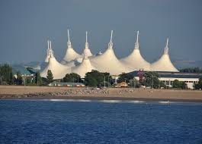
This is Butlins in Minehead in Somerset.I am going in two weeks time with my support workers and housemates.I have a niece called Penelope Grace. She is 5 months old. I attend City of Bristol College 2 days a week. The days I attend college are Wednesday & Friday. I do Citizenship on a Wednesday and Creative Technology on a Friday . It has been nice to share your lives and experiences with you. It has been nice to communicate with you.
Best wishes and good luck in everything you do.
Emma

