Dear Friends ,

I am going on holiday in three weeks to Burnham on Sea with my support worker Julie and Katherine and Paula.
I have got a new boyfriend Danny who is finishing at college like me. I help him walk the dog and I go to a new Gateway club on Thursday night. It was sunny today and I saw all my friends. I work in the PDSA charity shop on Thursdays.

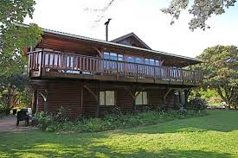
From Sarah Turner

