Youth has the Midas Touch!
POST SURVEY (ON STUDENTS)
We finished our Project and here is the survey results we applied at the end of our Project.
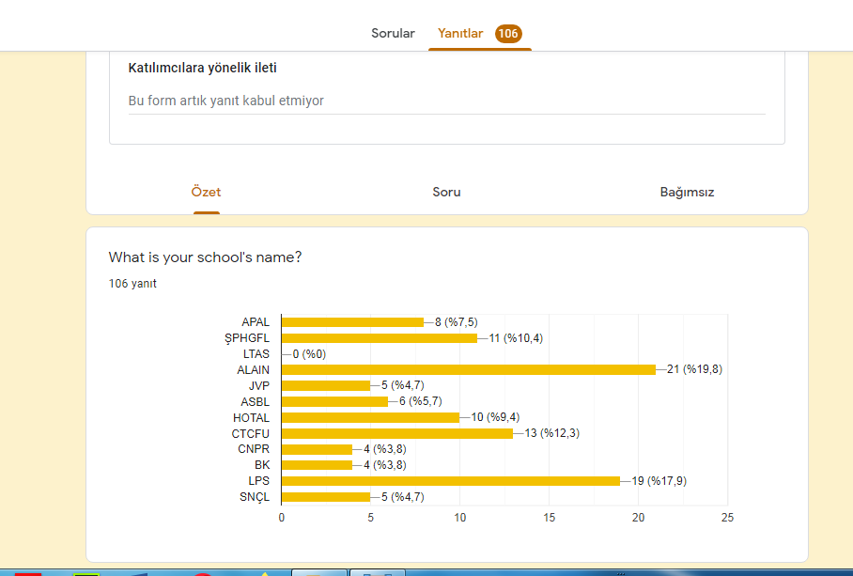
1)106 students joined the post surveys. Unfortunately LTAS students did not join.
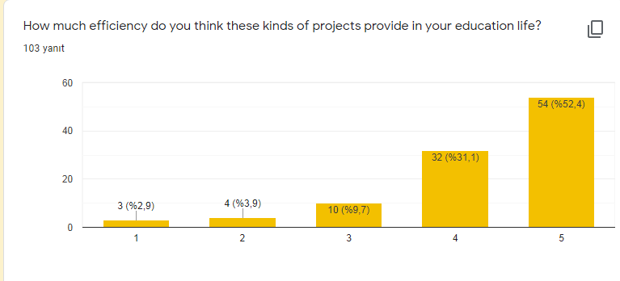
2)%54 of them thinks that the Project is very efficient in their education life.

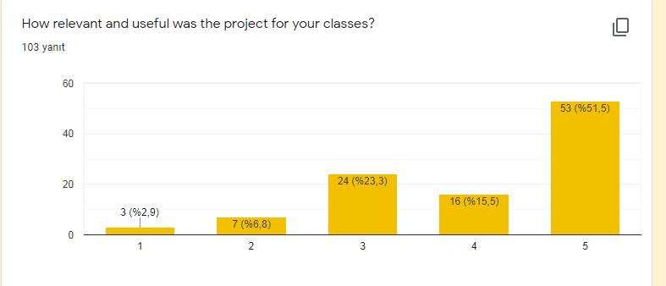
3) %54 of them thinks that the Project is very erelevnt in their classes.
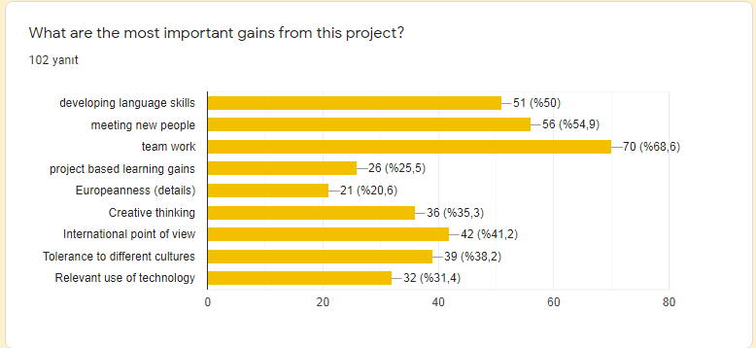

4)%70 of the said that team work has been the most important gain of the Project.
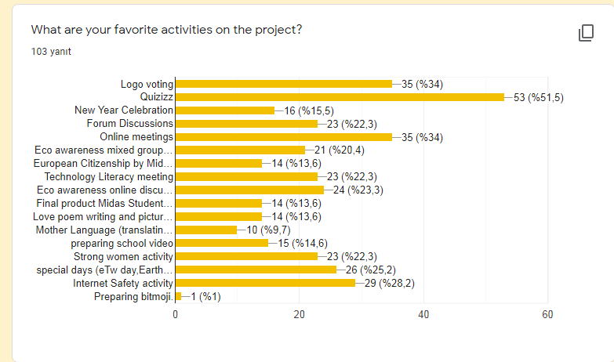

5)Quizizz,logo voting and online meetings were the favourite activities for students.

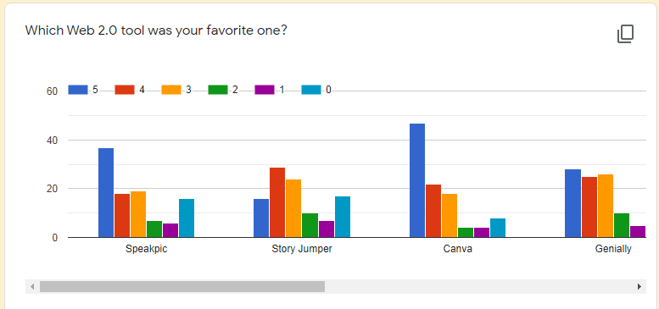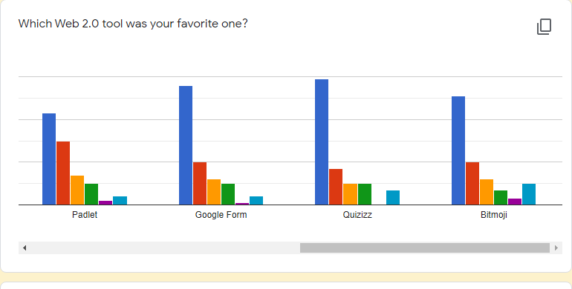
6)It is said that Googleforms,canva,Quizizz,Bitmoji and Speakpic were the best Web2.0 tools to use but Storyjumper was challenging to use easily.
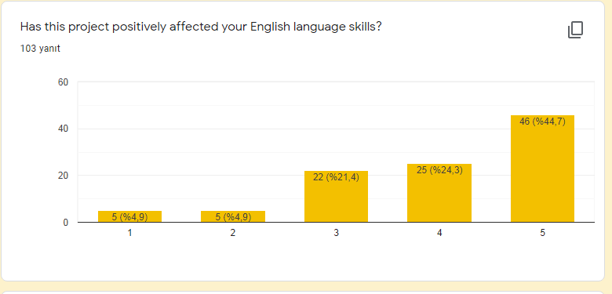
7) Most of the students said that their English language skills have been positively effected by tthe Project.
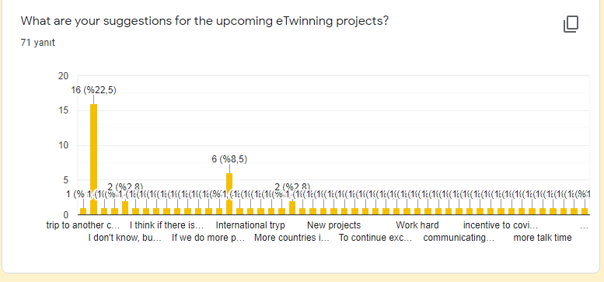
8) Most of our students suggest and prefer some more projects including international school trips.
9) In the last question which is “eTwinning is…… for me” Students have written very positive and motivating answers such as Respect Good, Community,Creativity,interesting,Emphaty,Love,Collaboration,Acceptance,A multicultural Exchange,great,unique,Education,Future,Good and funny experience,A great experience etc.

