Enviromental problems in Heraklion Crete
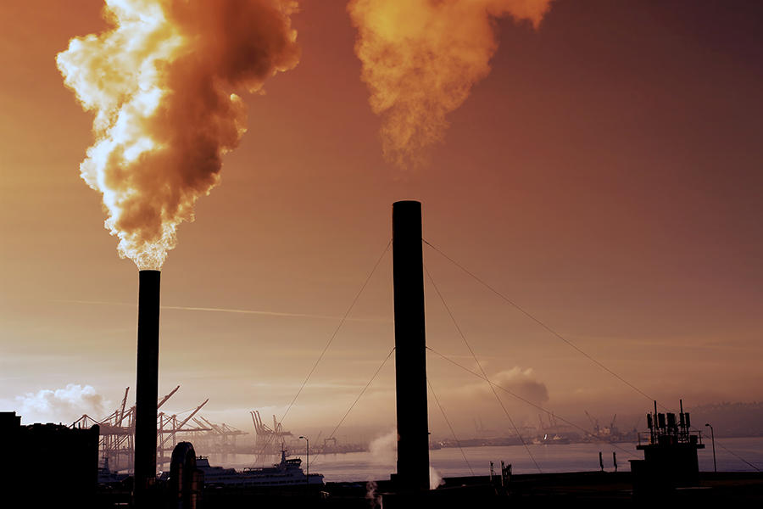  https://www.iqair.com/greece/crete  Air Pollution |  | 12.50%
Drinking Water Pollution and Inaccessibility |  | 50.00%
Dissatisfaction with Garbage Disposal |  | 43.75%
Dirty and Untidy |  | 46.88%
Noise and Light Pollution |  | 40.00%
Water Pollution |  | 48.33%
Dissatisfaction to Spend Time in the City |  | 18.33%
Dissatisfaction with Green and Parks in the City |  | 46.67%
Air pollution
- In accordance with the World Health Organization's guidelines, the air quality in Greece is considered moderately unsafe. Contributors to poor air quality in Greece include food processing, and the tourism, textile, mining, and oil and gas industries.
- During quarantine air pollution reduced dramatically, but after that many cities in Greece were burnt and this worsened the situation.

Solutions
There are many things we can do so that air quality can be improved such as:
- Recycle or reuse of old objects.
- Transfer with means of transfer, bicycles or with electric skaters.
- Reduce the usage of plastic bags.
- Participate in volunteering programs for environment that can clean up dirty places or plant trees.

