Air Pollution

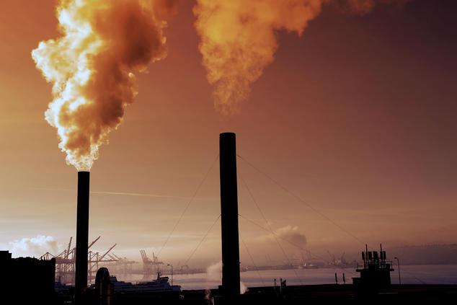
When someone thinks of air pollution, most immediately picture one "dark cloud" sweeping over cities and industrial factories. This is the most obvious form of air pollution, but it is not the only one. Air pollution is an issue that has taken enormous proportions in the developed world and is one of the most characteristic problems of the modern industrial age. Air pollution is harmful to our health and ecosystems and a large part of the population does not live in a healthy environment and sometimes presents breathing and heart problems. In a few words,
affects everyone: humans, animals, crops, cities, forests, aquatic ecosystems, etc…

Recently, due to the pandemic, air pollution in Greece after the restrictive measures, began to decrease. However, concentrations of air pollutants remain too high and air quality problems persist.
Causes of Air Pollution
Air pollution is caused by solid and liquid particles and certain gases that float in the air. These gases can come from car and truck exhaust, factories, dust, volcanoes and fires. Also, another one major cause of air pollution is ozone which is either good or bad for the environment.

Solutions to Air Pollution
- Minimize the Use of Fossil Fuel Powered Automobiles.
One way to do this is by switching to a hybrid vehicle, or better yet, one that runs on fully electric. Other ways include taking public transportation, carpooling with friends and colleagues, or even riding a bike to your destination.
- Be Mindful of Energy Consumption.
When you’re leaving home, be sure to turn off the lights, TV, and any other electronic appliances. Fossil fuel plants are a major cause of air pollutants, and the less energy you need, the less we have to rely on those plants to generate electricity.
- Clean Energy.
Every day, technology continues to advance that improves the efficiency and cost of clean energy such as solar, wind, and geothermal. These types of energy sources create much less air pollution.
- Recycle.
Recycling can help reduce air pollution. Instead of throwing away used containers and material, try reusing them or recycling them to be used again by someone else.

Environmental problems in Greece

- Climate change where temperatures rise, rainfall characteristics change, glaciers and snow melt and the global average sea level rises.
- Deforestation is the removal of a forest or tree where the soil is then used for non-forest uses.

These are some of the problems of Greece.

