That’s what I want

People with multiple disabilities are in some circumstances dependent on the help and assistance of others.

For people limited in their verbal and communicative skills it is often very complicated to talk about their wishes and perceptions. That’s why we try to be their facilitator.

In encounters with our disabled friends who have learned and experienced a lot. For that we tried to put ourselves in their place. We always tried considering their particular situation.

What behaviour of the assistants would be helpful and desirable?

In this brochure we tried to outline assistance best and most helpful behaviour.

What do I want?

We suppose how we like to be treated is how you and other people would like to be treated.

The pictures drawn by Mrs. Zerluth for this brochure should help you to engage in everyday situations.

We would like to warmly thank Mrs Zerluth for these wonderful drawings.

Do you recognize some of the situations? How do you feel with it?

What would you like?

It would be nice if we came closer to each other with “What do I want”.

We would be glad, if with this brochure we spoke from the souls of the people who experience the help and assistance every day.

A special thank goes to our IT-specialists Halil Özcan and Thomas Wild for enabling the layout and print of this brochure.

Table of contents

Communication 4

Food 8

Drinks 12

Encounters according
to age 16

Active cooperation 20

Out of the world 22

Last but not least 24

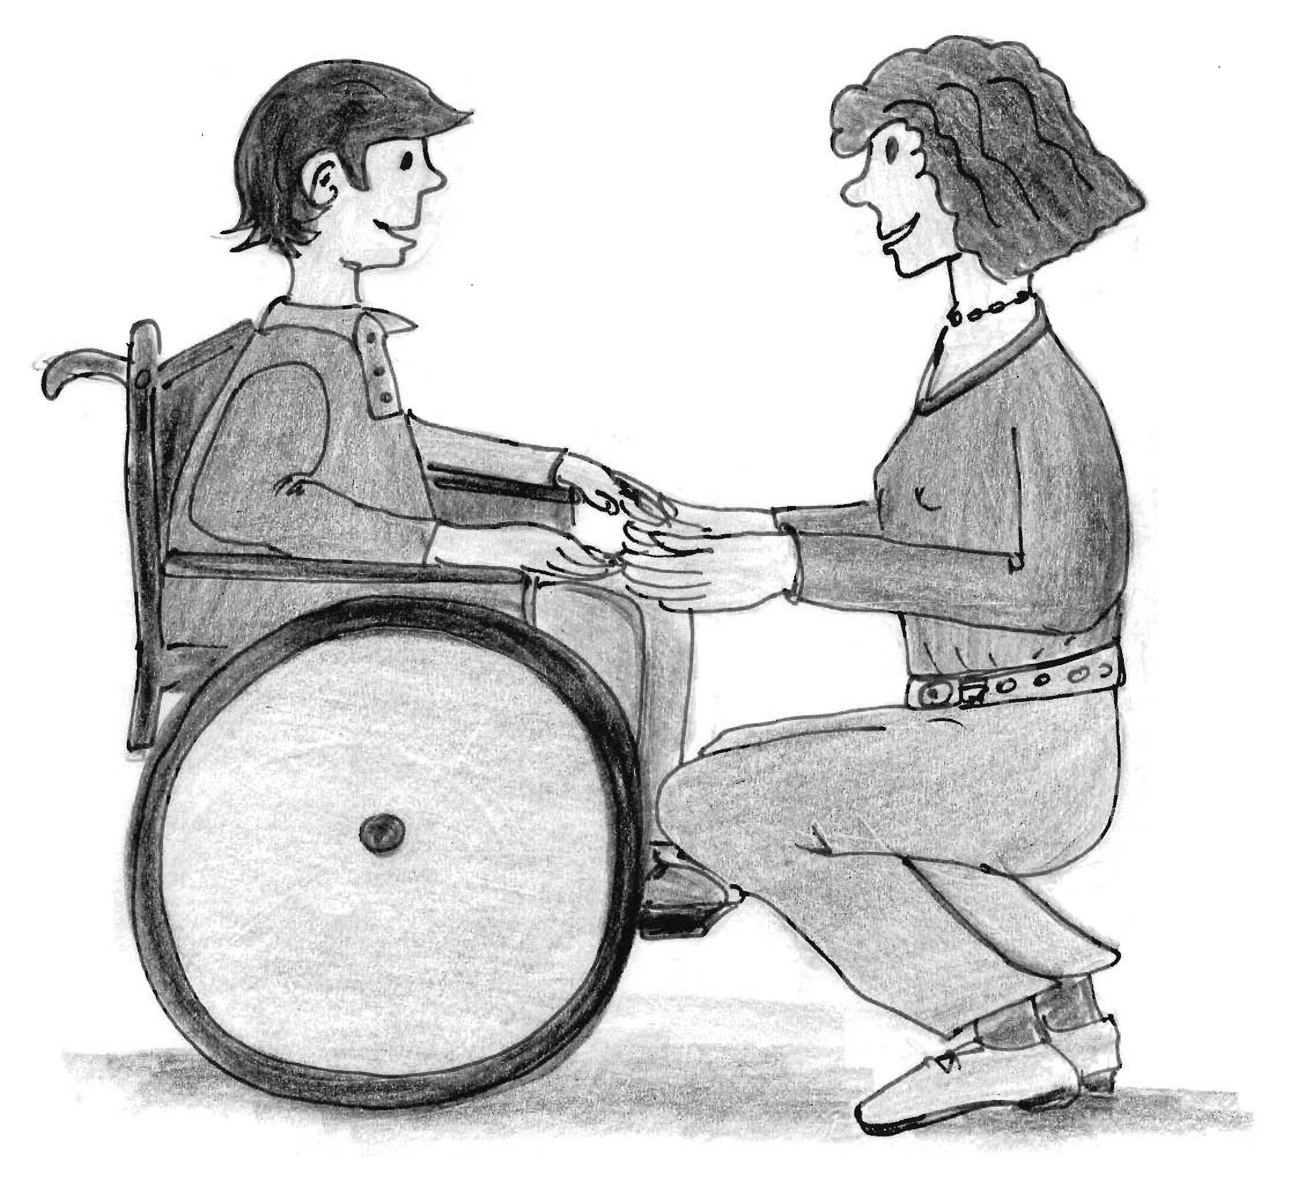

Talk to me, not about me.
Look into my eyes but not from above.

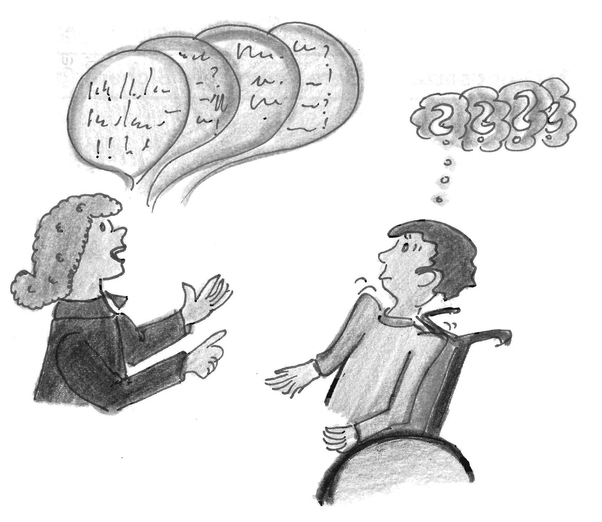

Talk slowly and be patient

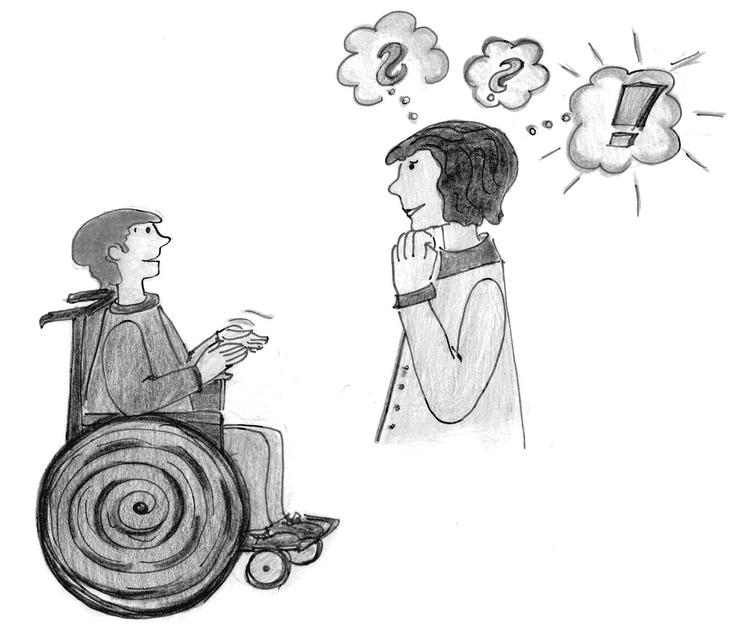

Help me to express myself.
Sometimes I express myself with technical support.

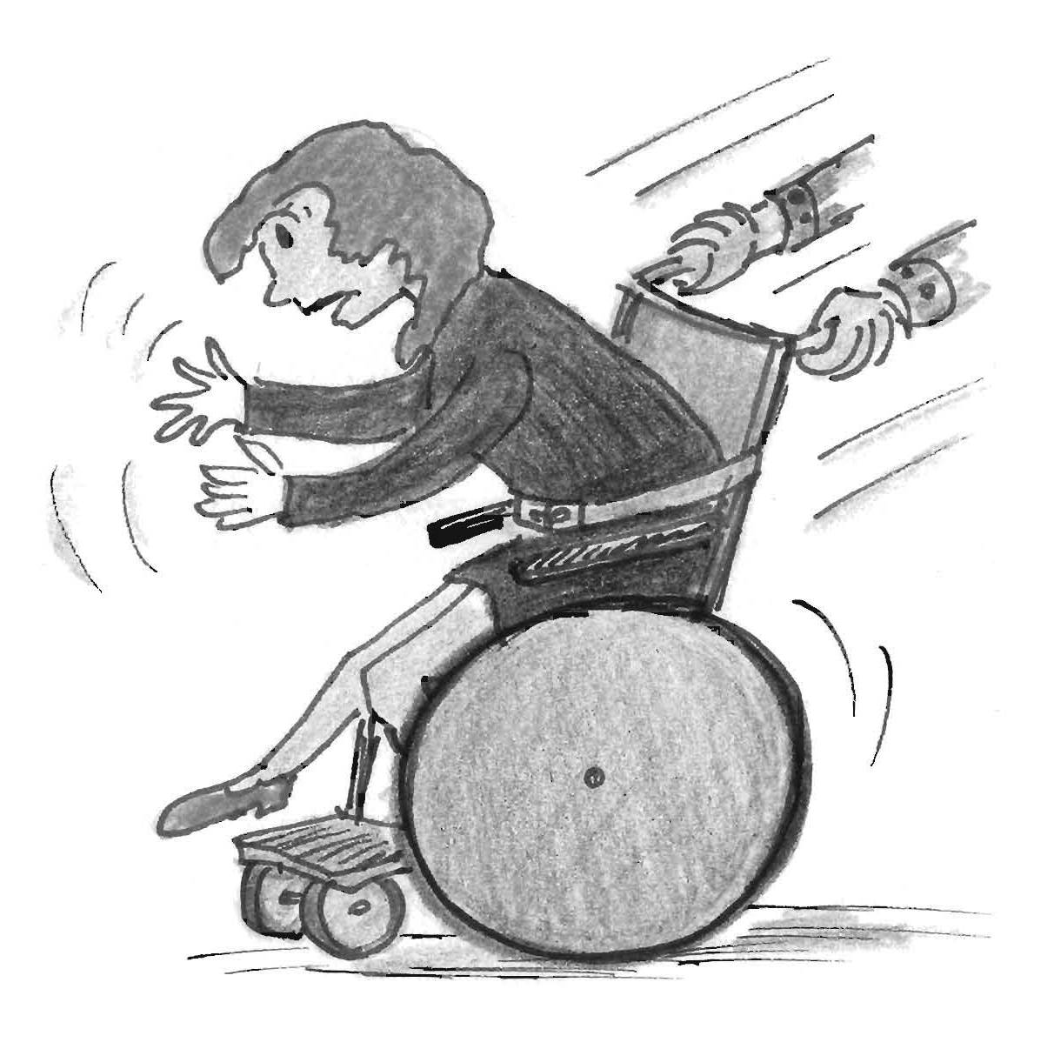

Don’t move my wheelchair without telling me.

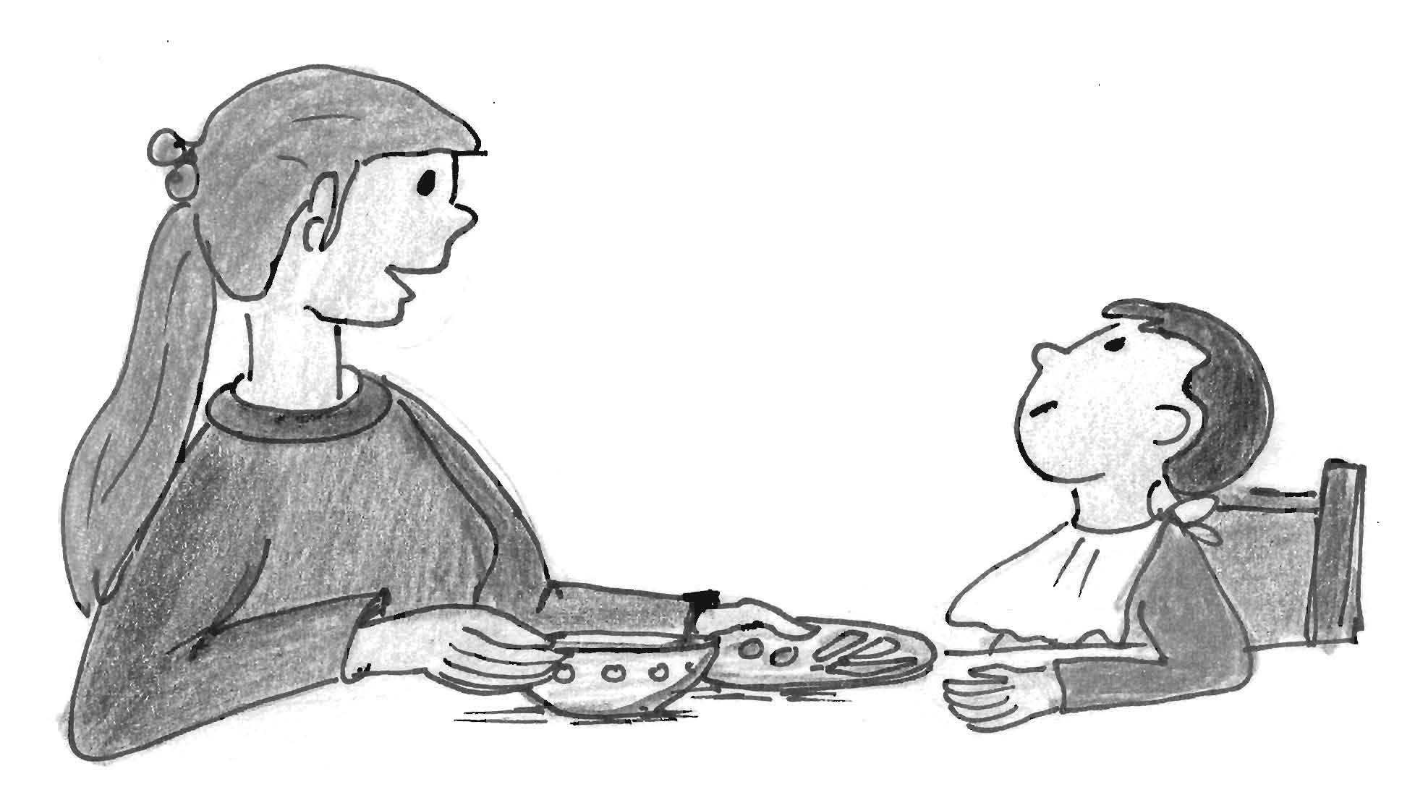

Ask me what I would like to eat.

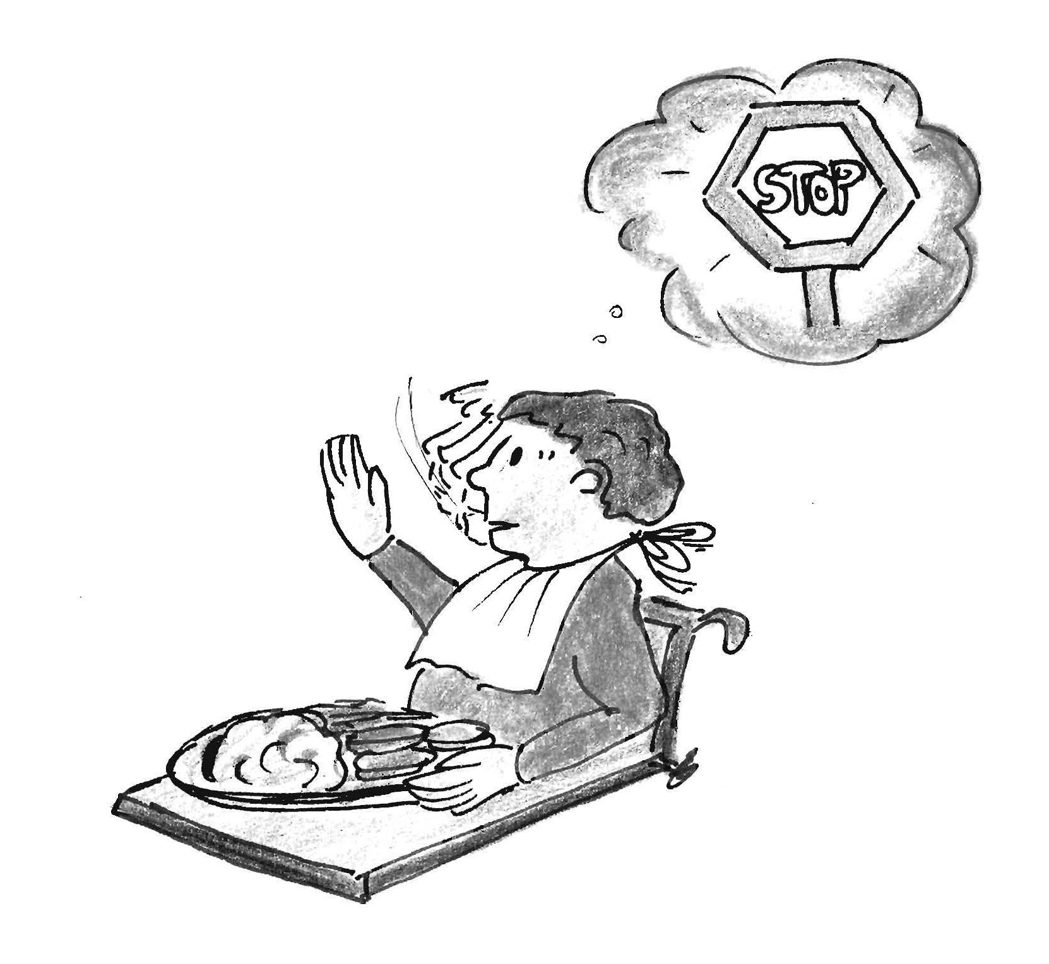

Sometimes I am not hungry or prefer small portions.

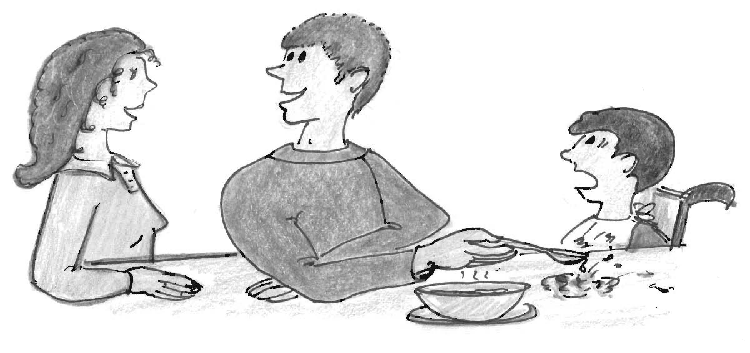

Talk to me when you are spoon-feeding me and don’t speak with others when doing so.

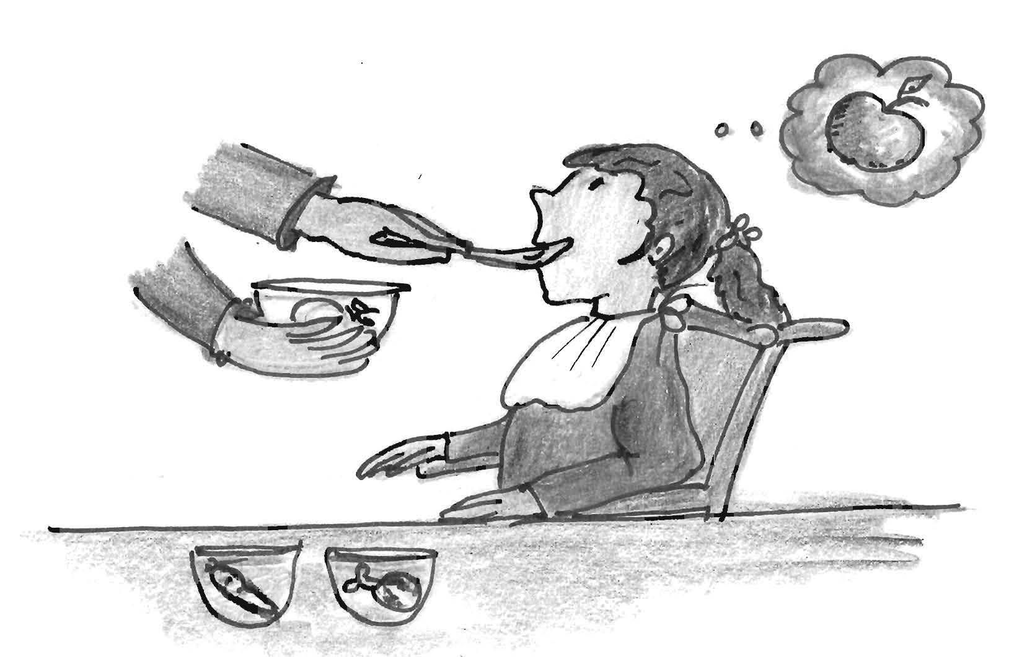

Although I eat mashed food I want to taste different flavours and nit all flavours mixed together.

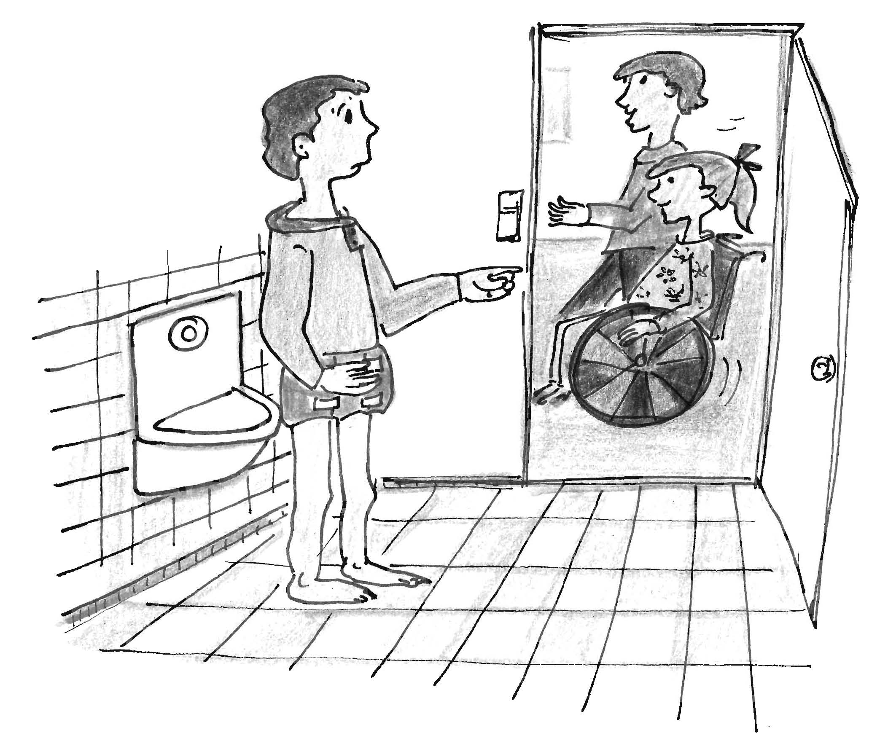

Close the door!

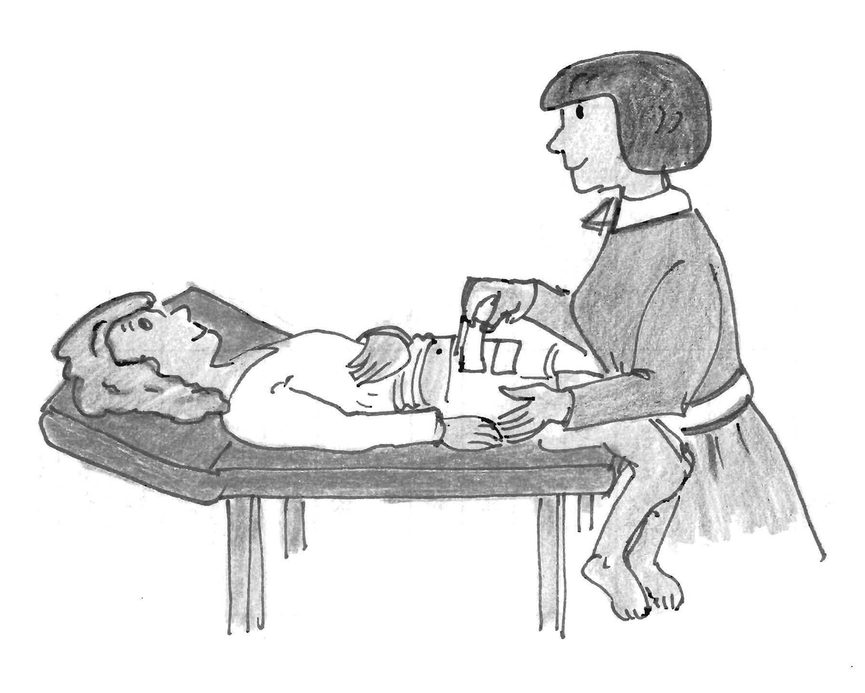

Smile at me while opening my diaper.

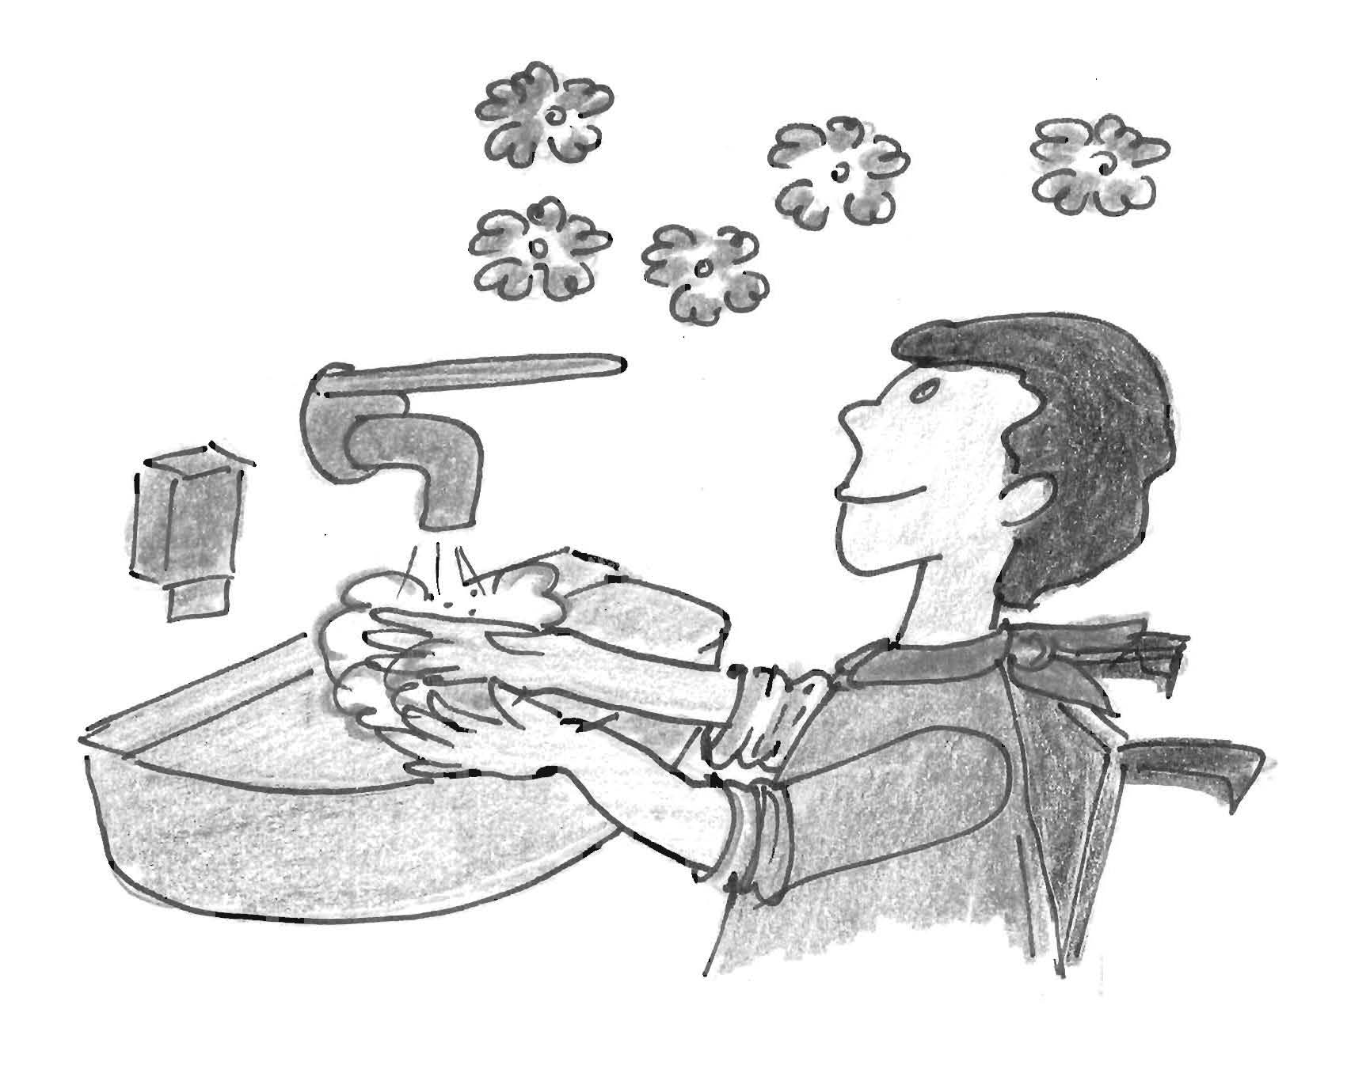

I feel fresh when my hands are clean.

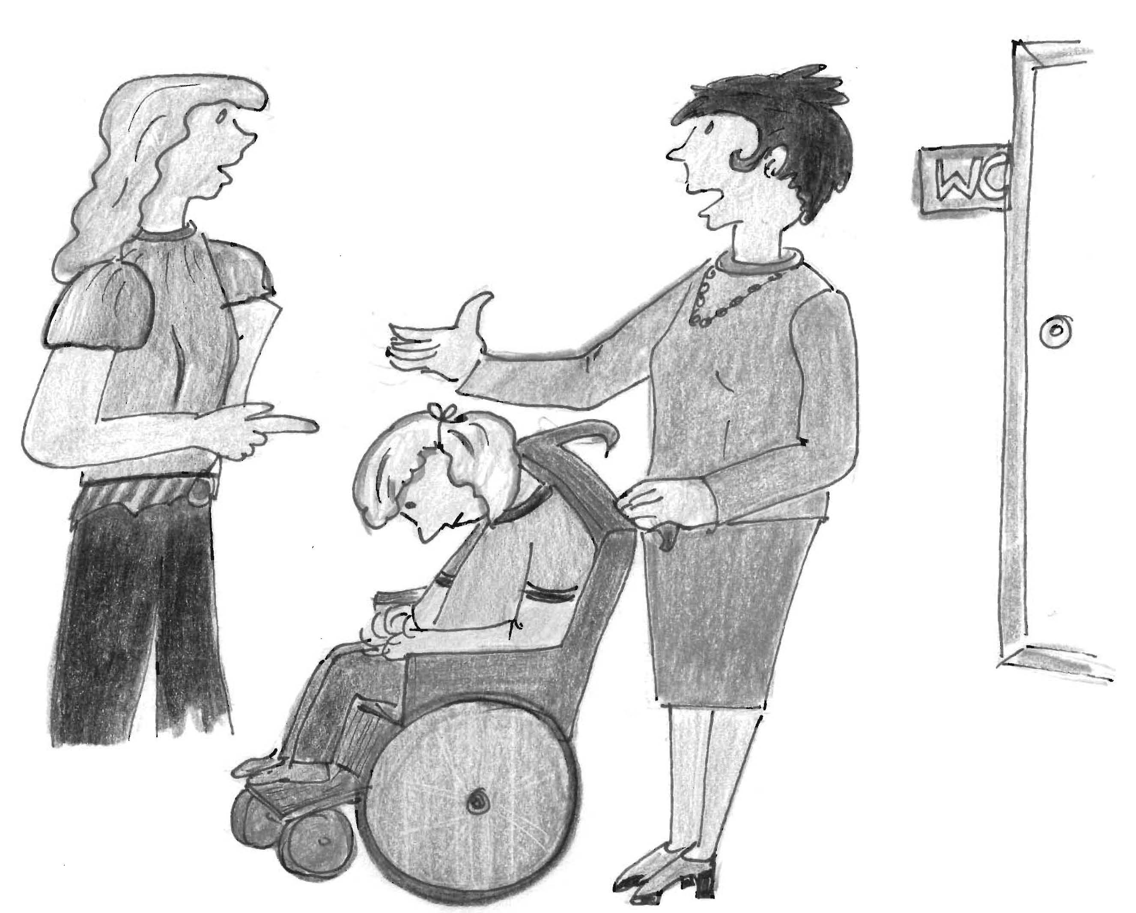

Please don’t give detailed reports when returning with me from the bathroom.

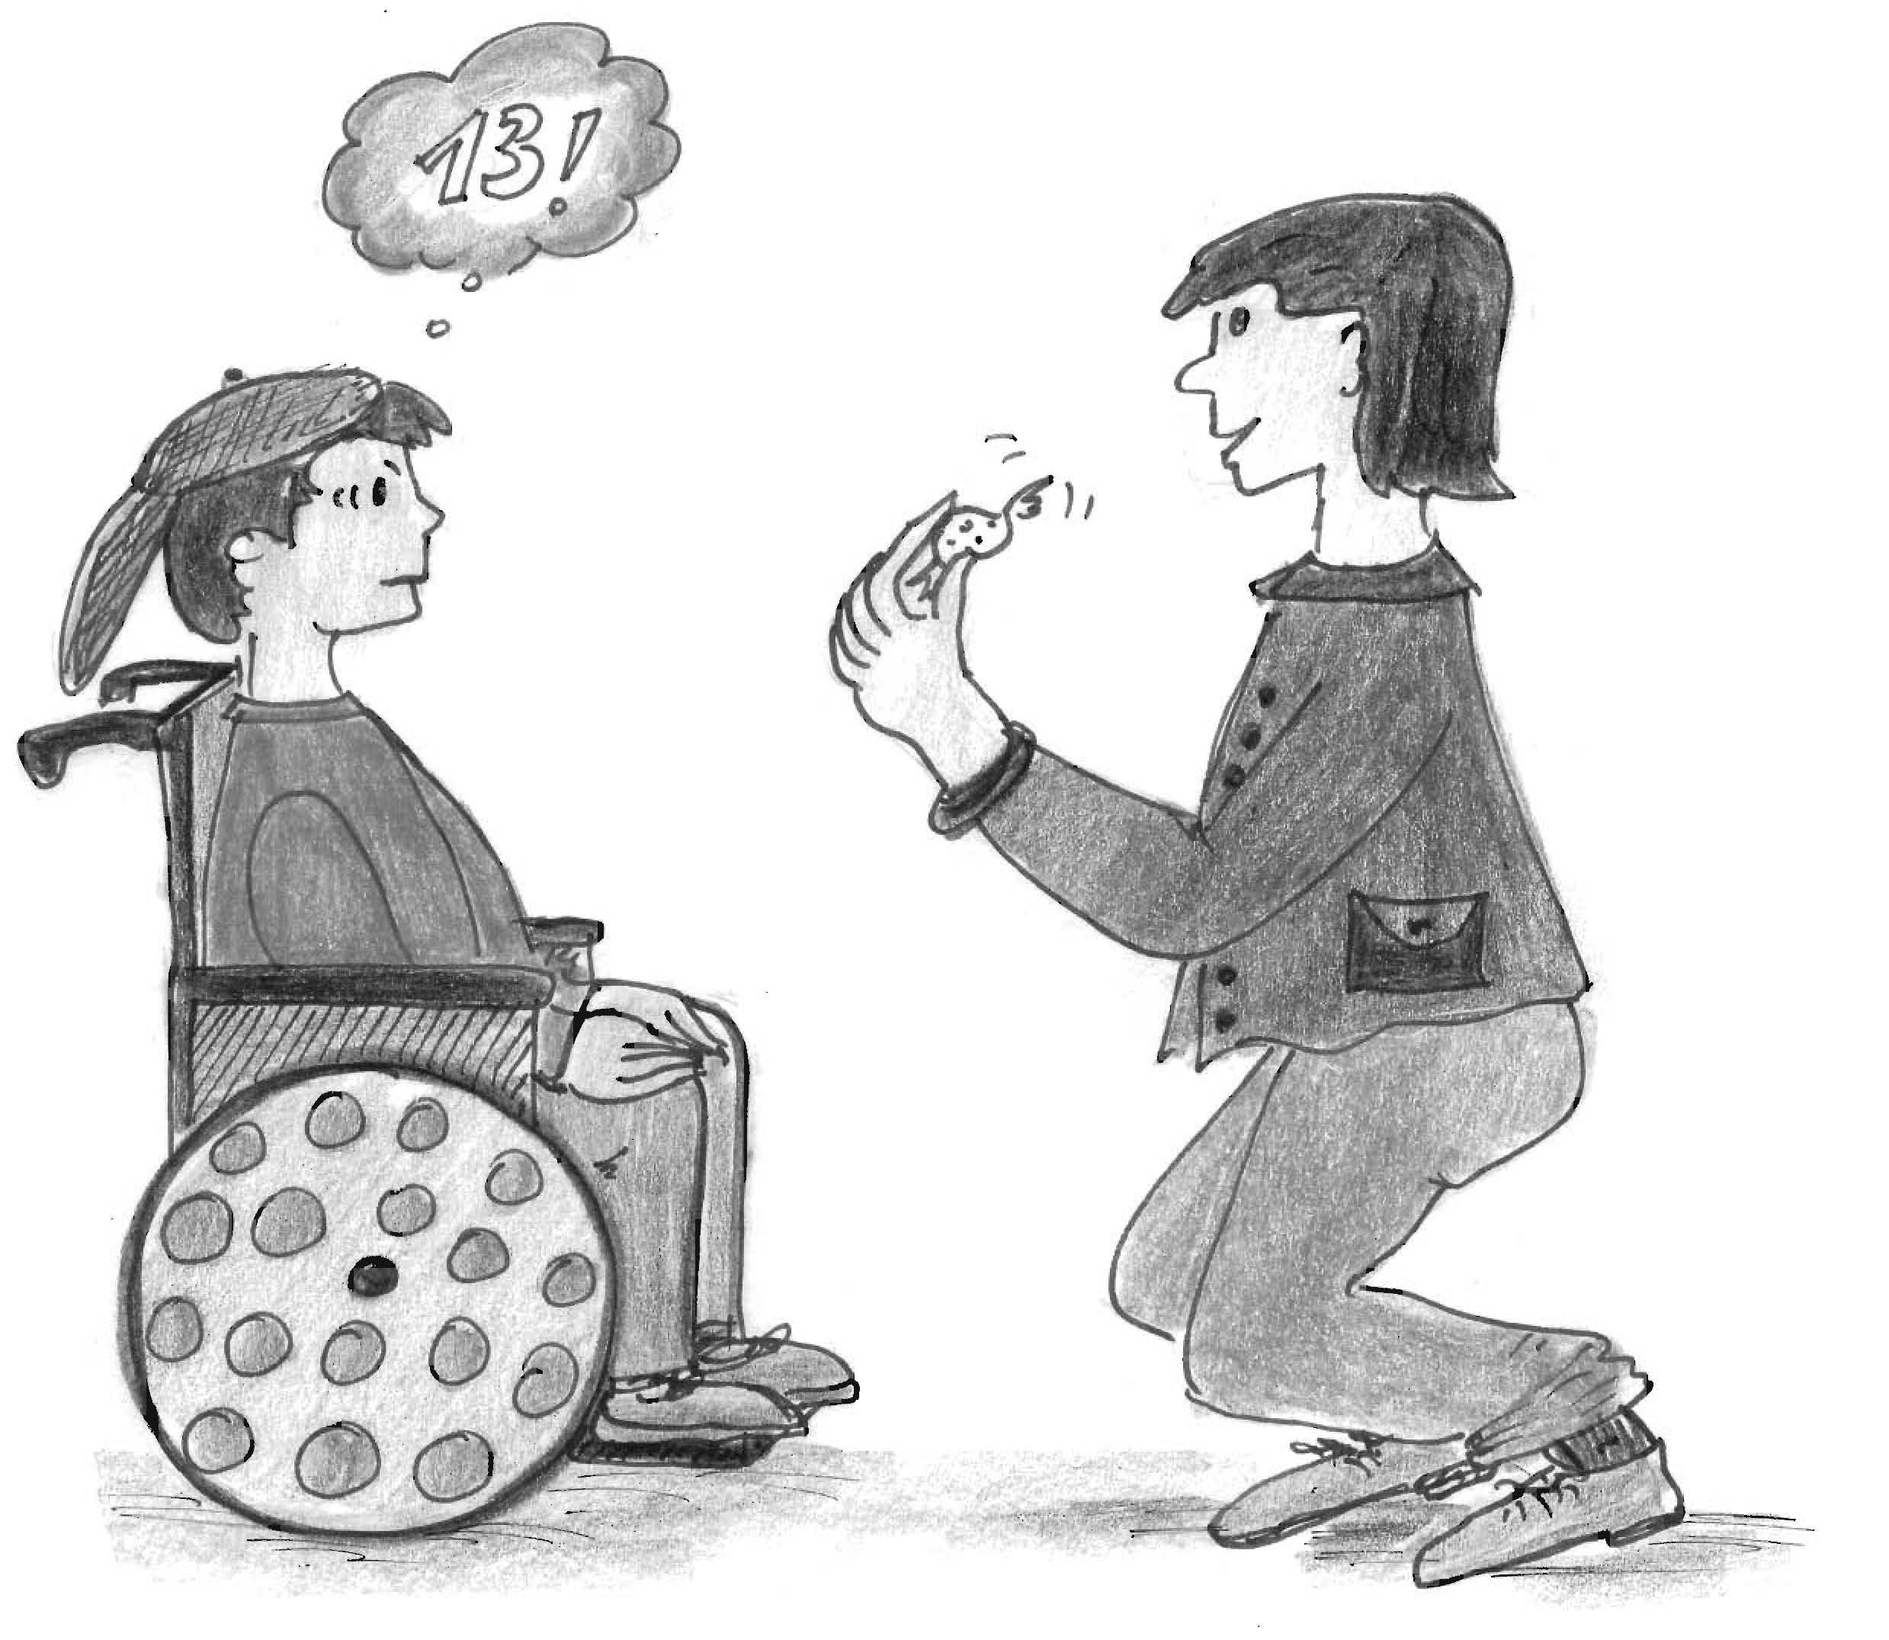

Do you know how old I am?
Please treat me accordingly.

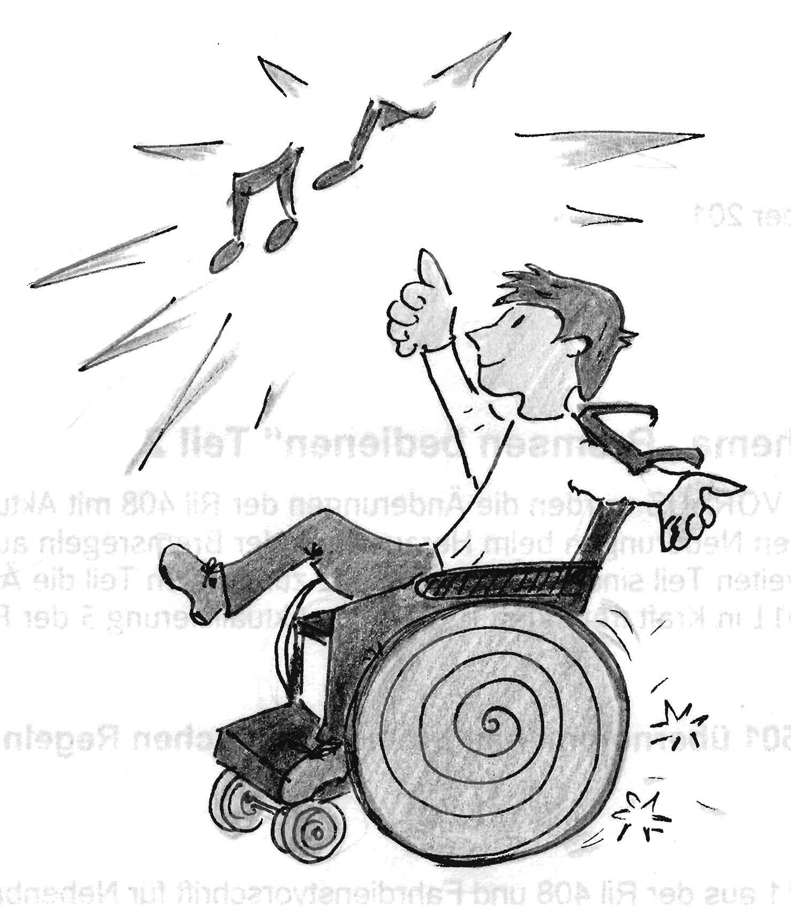

I like cool music

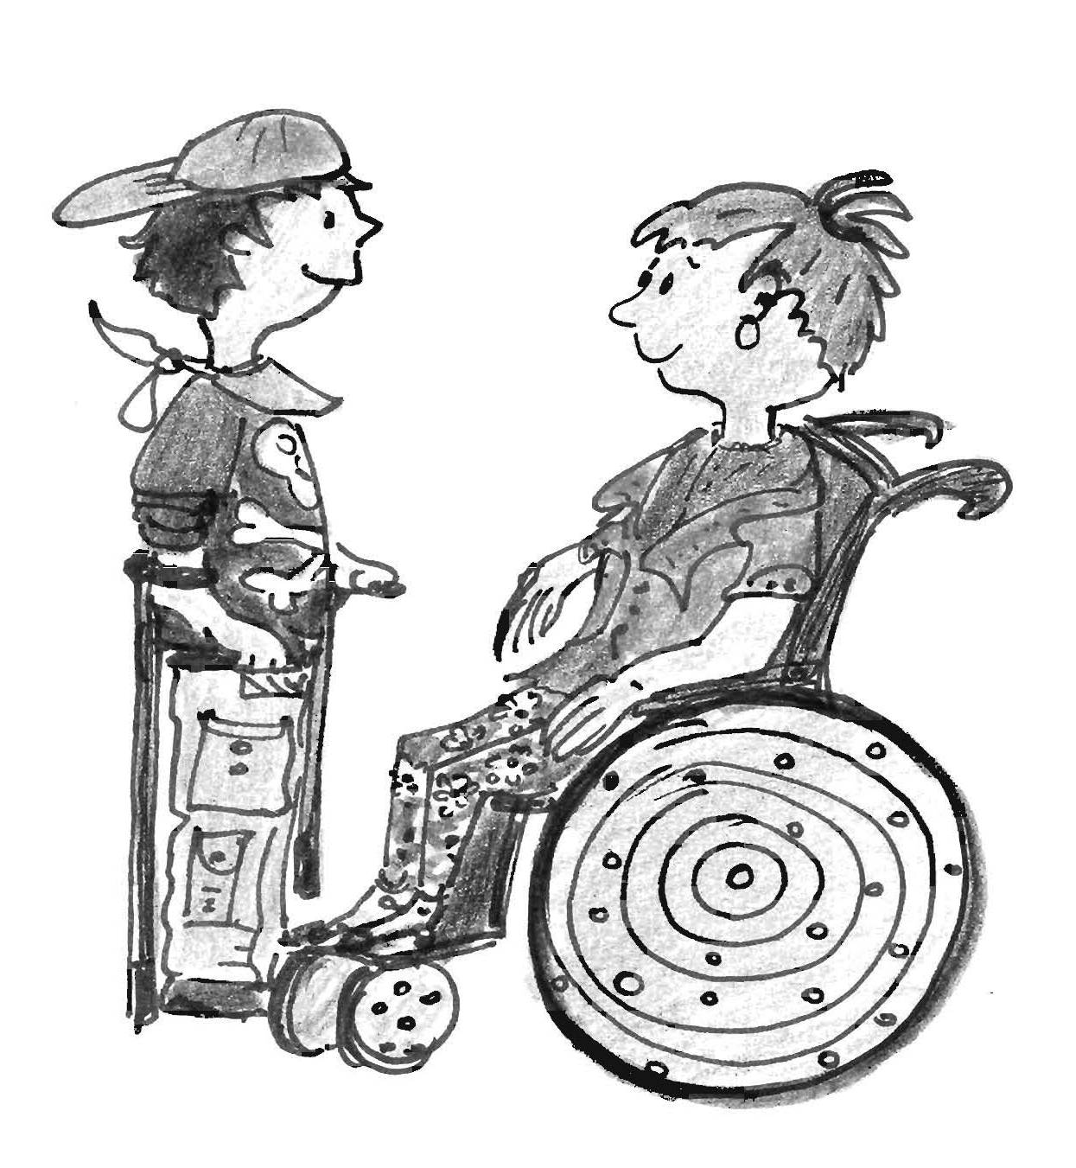

A cool outfit is important to me.

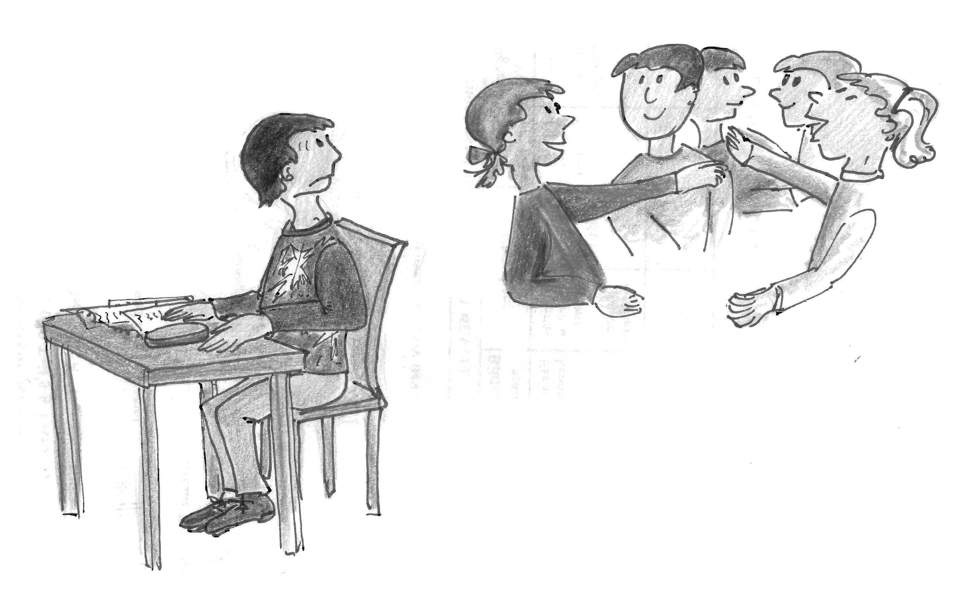

One-to-one mentoring is all right bit I like to be with my mates as well.

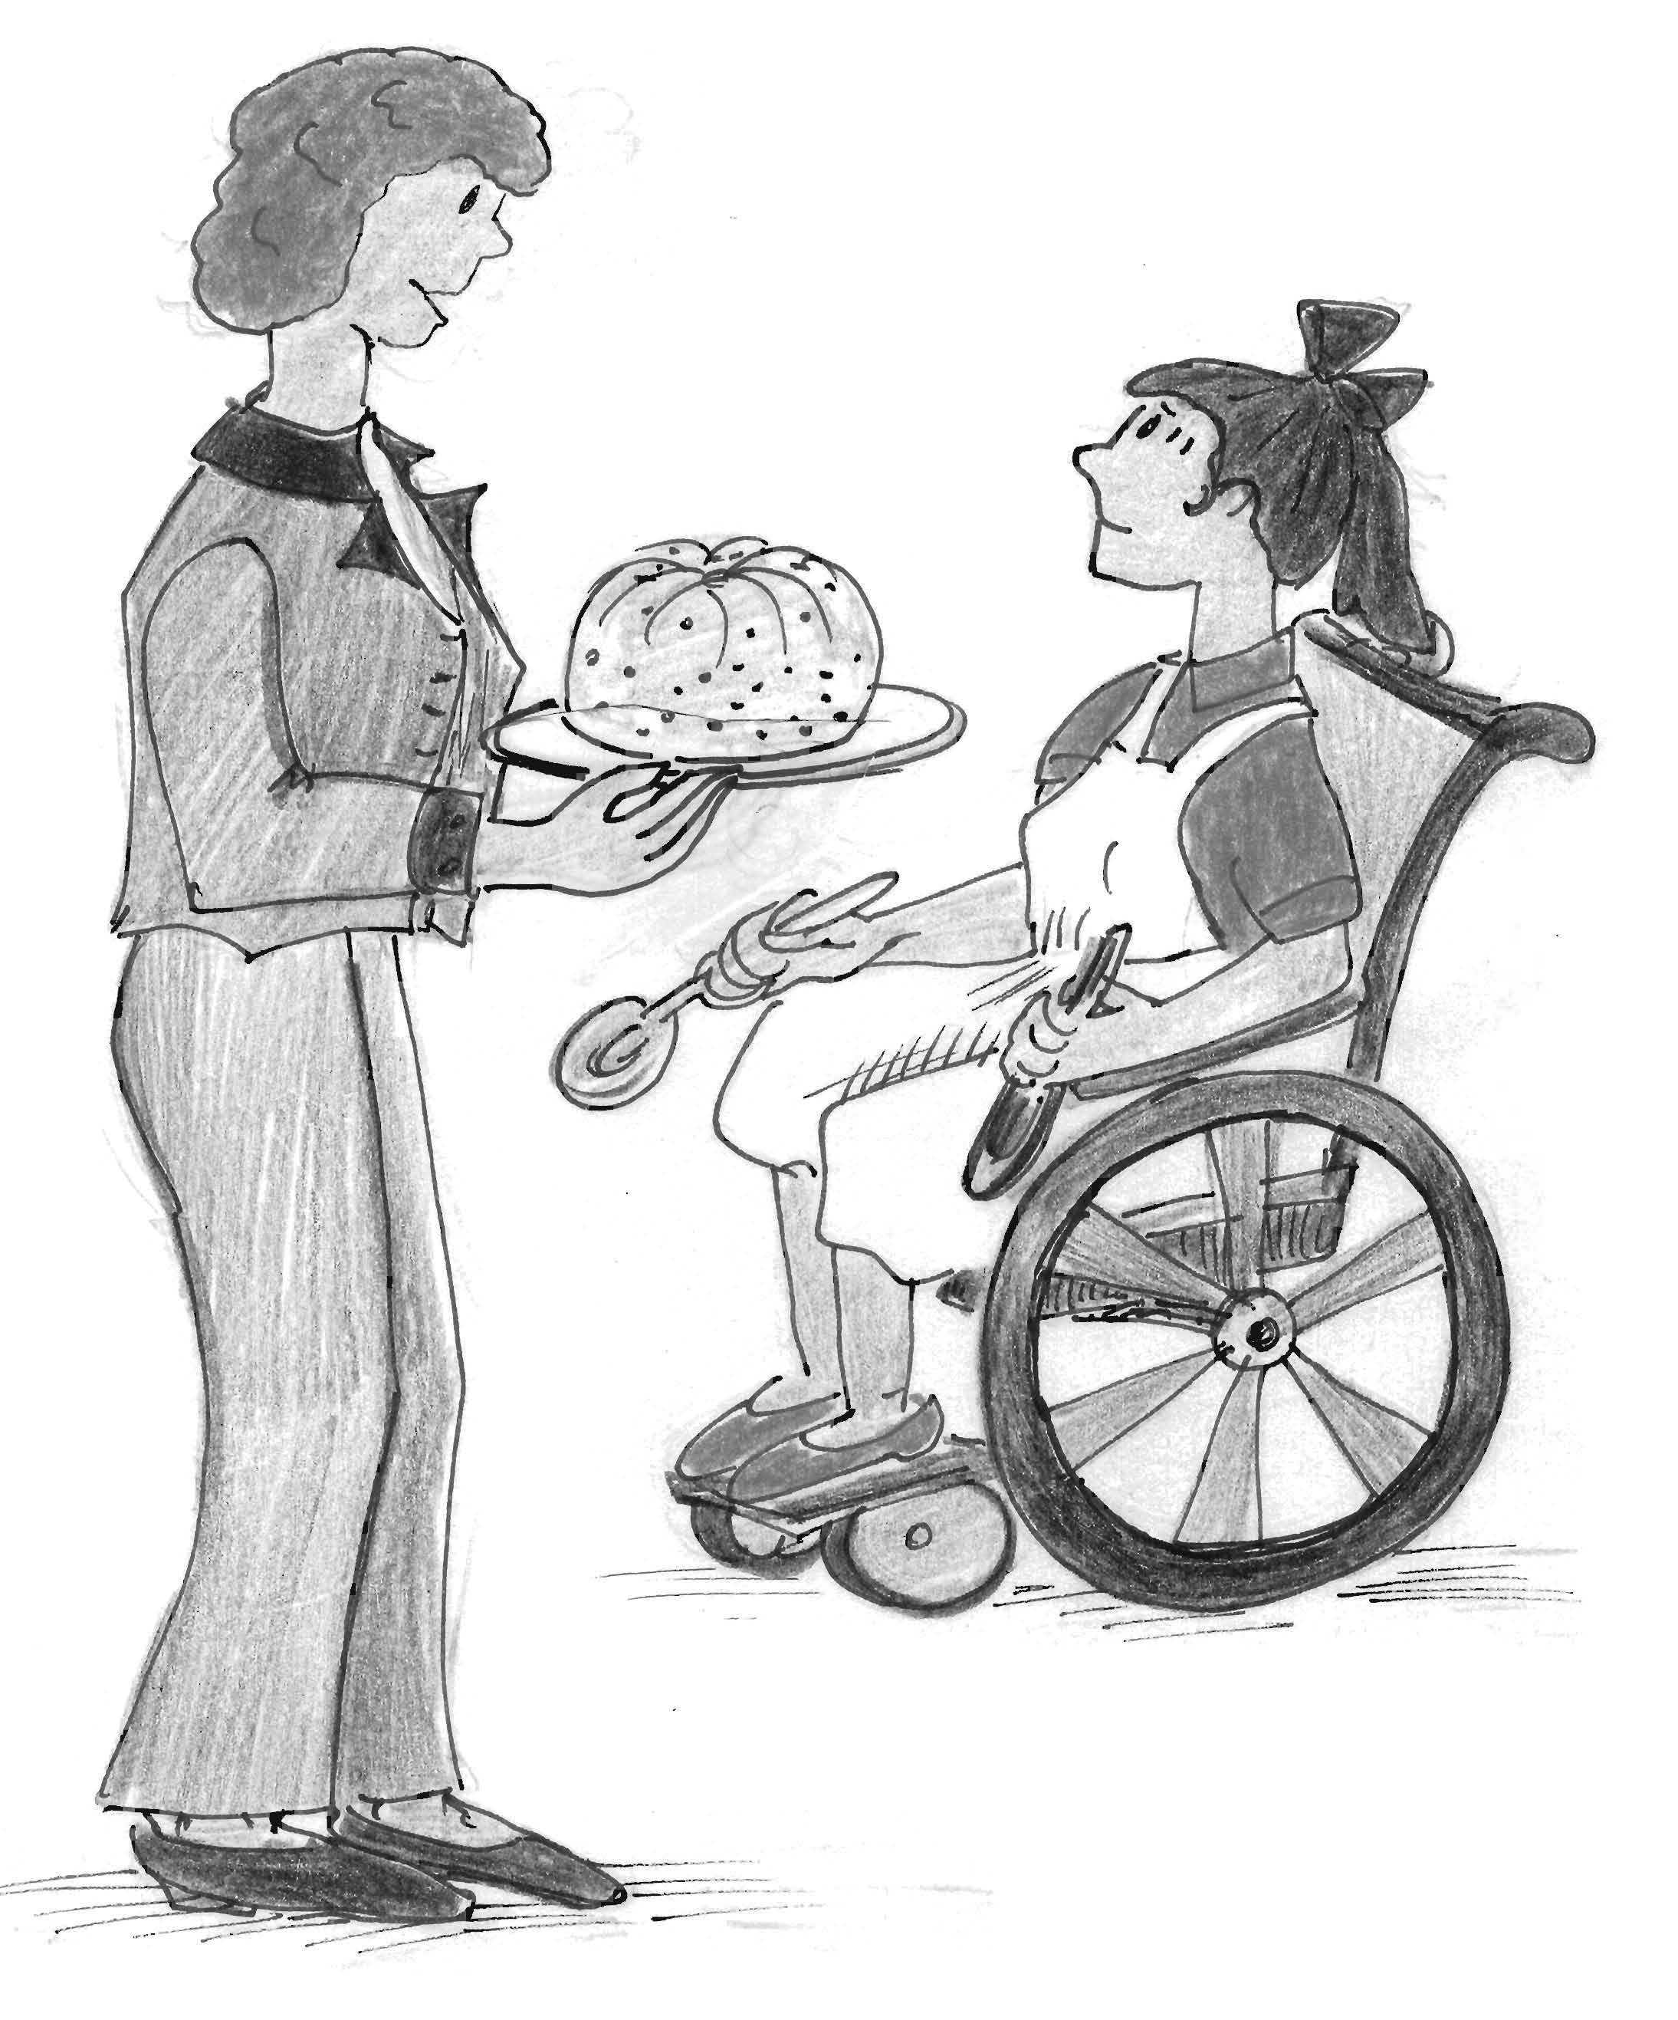

Oh, is the cake finished already? But I intended to help you.

Please give me
the chance to join
even if it takes longer
and doesn’t look perfect.

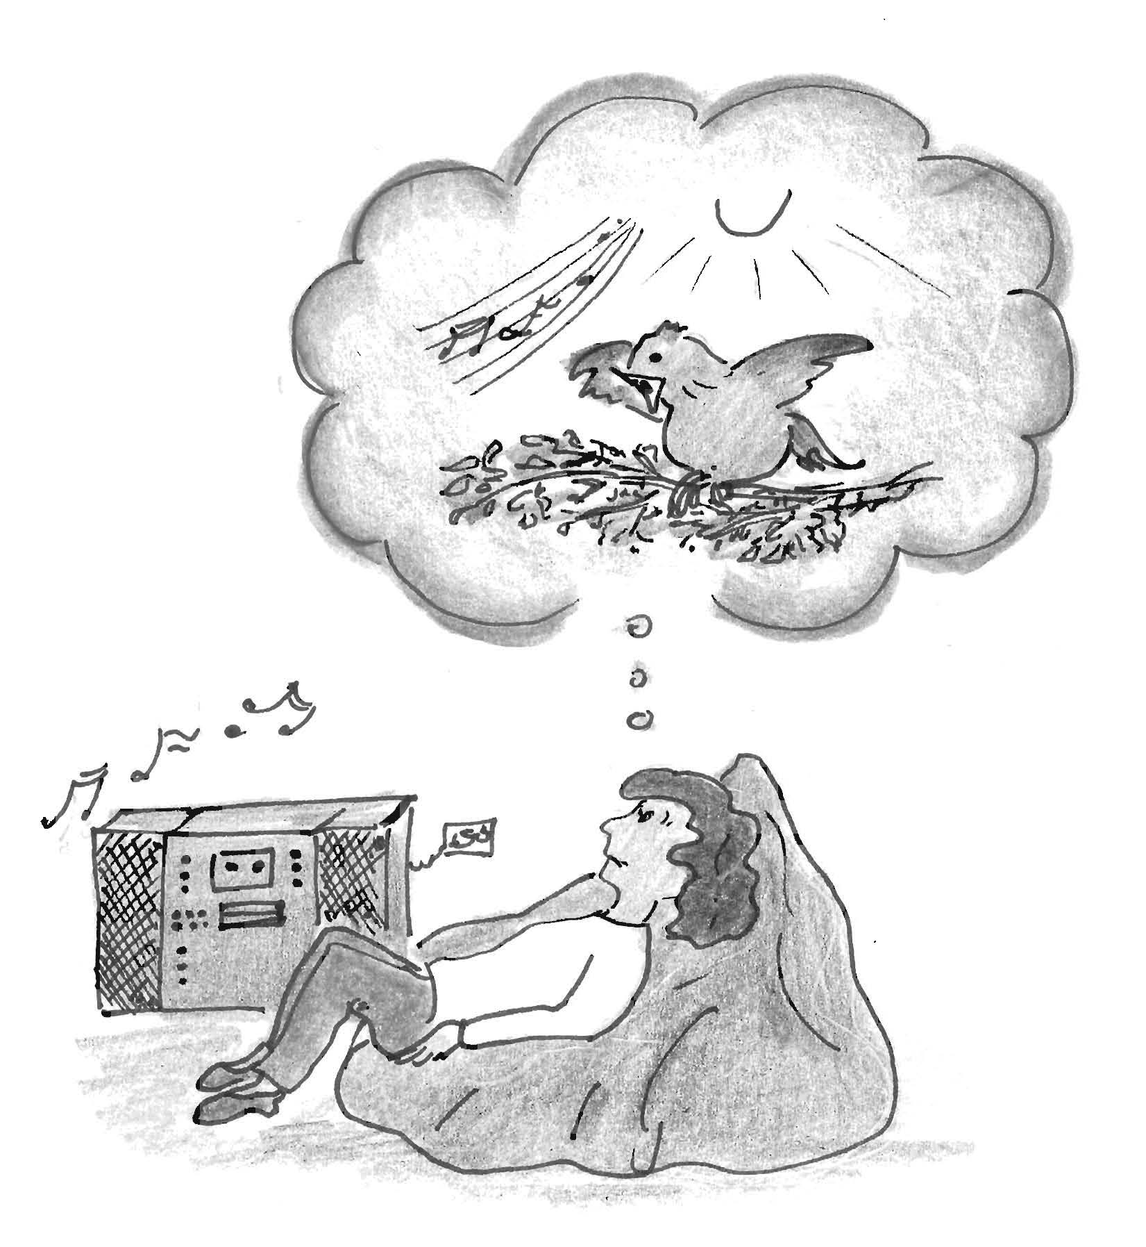

Is this really all I can except of live?

Take me to the real world.

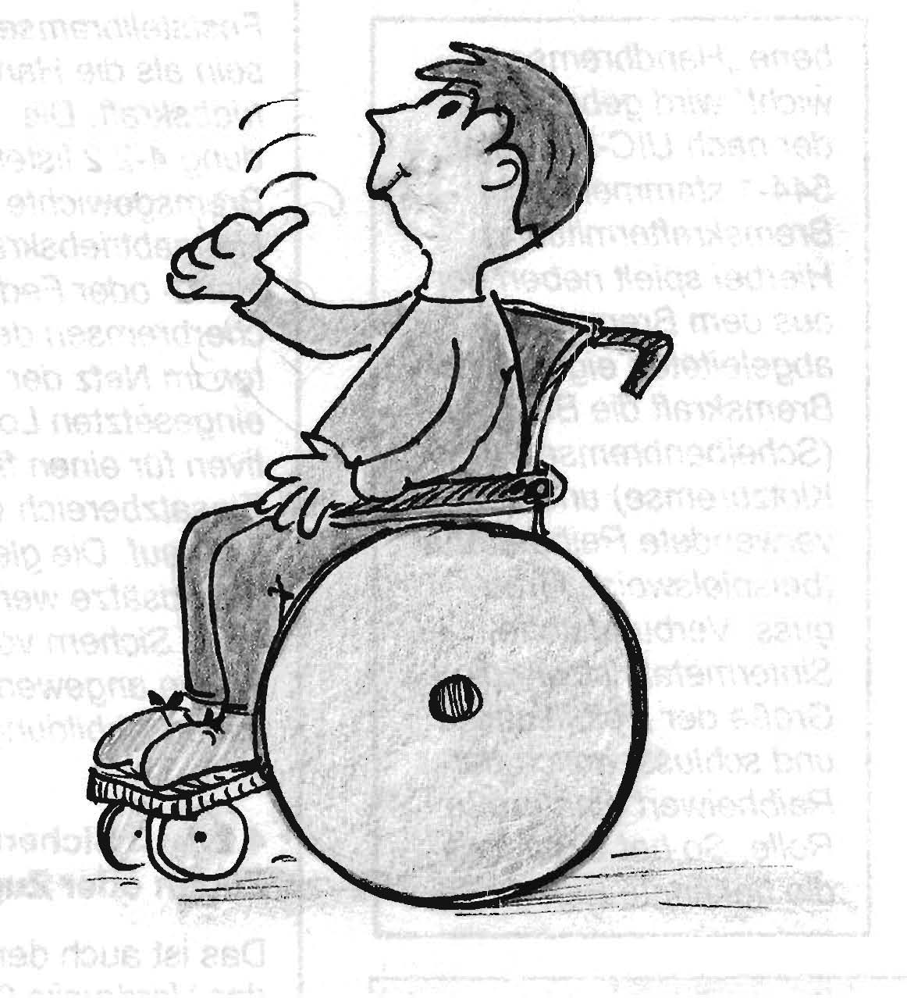

If you don’t know
what I want, treat me
as you would like to be treated.
Trust, that I understand you.
.

Editor:

Fritz-Felsenstein-Haus e.V.
Karwendelstr. 6-8
86343 Königsbrunn

Graphics:

Roswitha Zerluth

Text:

Gerda Dörsch
Petra Wesinger
Sabine Willi
Beate Wohlfarth

Layout and print:

Halil Özcan

Thomas Wild

ViSdP:
Sokrin Dr. Renate Menges





