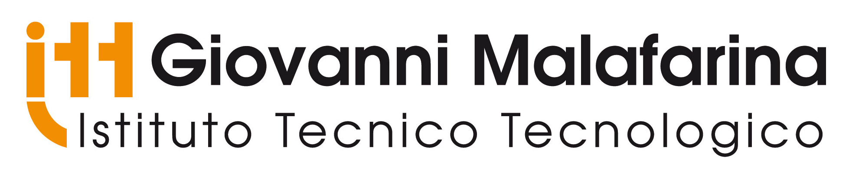

Erasmus+ Strategic Partnership
2017-1-DE03-KA219-035460_3
Erfahrungen mit "Gentle Teaching". Vielfalt braucht Vielfältiges
Gentle teaching in ITT Malafarina

2. floor gentle teaching experience for the students

3. floor collecting diverse methodes to put on a database at school.

4. floor collecting things form internet.

SEN Cases by Maria Antonietta Battaglia
ITT G. Malafarina

Thanks to Gentle teaching project, we expect to reach the best practice guidance by sharing experiments, knowledges, advices and practices. Generally our students are from low-income families so they do not have a chance to visit or recognize other schools, cultures and countries without this kind of international projects.
According to the inclusive approach we developed we shall improve peer relationships in the schools by sociable and enjoyable way, using the approach suggested by Gentle Teaching method. We offer disabled and Sen tutorship, migrants' tutorship, etc to favor integration. We have 17 bes students (uncertified sen)+ 7 dsa students ( certified specific learning needs) for a total of 24 complessive individualized sen plans. Then we have 10 disabled students whose learning plans are built according to a commission's (sanitary, psychologist, social assistant, disabled support teacher, headmaster) report. Then we have about 27 foreign students from Europe, Asia, South America and Africa plus other 10 students who have double nationality since one of their parents is foreign. In short for each of them according to their profile an individualized learning approach is chosen and if necessary for migrants further classes are assured.
We shall enlarge the students' team that is going to travel to students who are involved in peer to peer methodology in order to help disabled or problematic students

What are SEN?
A student or young person has special educational needs (SEN) if he or she has learning difficulties or disabilities that make it harder for him or her to learn than most other students and young people of about the same age. Many students and young people will have special educational needs of some kind during their education. Early-year settings, schools, colleges and other organizations can help most students and young people overcome the barriers their difficulties present quickly and easily. A few students and young people will need extra help for some or all of their time.
So special educational needs could mean that a student or young person has:
- learning difficulties
- social, emotional or mental health difficulties
- specific learning difficulty with reading, writing, number work etc
- sensory or physical needs communication problems - in expressing themselves or understanding what others are saying
- bad medical or health conditions.
- uneasy feelings caused by bullying, problems at home, parents arguing, loss of a loved one, sudden poverty.
These problems may affect the way a student learns directly by forcing him/her to miss or drop out of school, or indirectly by changing his/her behaviour. Students and young people make progress at different rates and have different ways in which they learn best. Teachers take account of this in the way they organize their lessons and teach. Students and young people making slower progress or having particular difficulties in one area may be given extra help or different lessons to help them succeed.

How schools can act
Schools place great importance on identifying special educational needs (SEN) early so that they can help students and young people as quickly as possible. Once it has been decided that a student has SEN, staff working with him/her should take account of the guidance in the Special Educational Needs and Disabilities Code of Practice (2015). The approach may include:
- an individually-designed learning programme
- extra help from a teacher/tutor or learning support assistant
- being taught individually or in a small group for regular short periods
- drawing up a personal plan, including setting targets for improvement, regular review of

Definition of Disability

According to The World Health Organisation (WHO):
An impairment is any loss or abnormality of psychological, physiological or anatomical structure or function. A disability is any restriction or lack (resulting from an impairment) of ability to perform an activity in the manner or within the range considered normal for a human being. In Khmer culture Disability is the loss of one or more of the senses. What does this mean? You have seen that some people in your community have difficulties that other people do not have. For example, you have seen some people have difficulty seeing. Some people have difficulty hearing, speaking, learning or moving around in the same way as other people. Some people show strange behaviour, or often have fits or have no feeling in their hands and feet. Such difficulties are called disabilities.

Aims of the schools
Developing an innovative methodology through an Individual Education Plan is a systematic way to monitor and assess the progress of a student with special needs. An IEP includes a description of the difficulties faced by the student, a plan of action to overcome these difficulties, clear goals for the student to achieve and a time frame, specific activities and actions to help the student achieve the goals. We shall evaluate the student's progress offering flexible educational pathways in order to help the students to understand their own strengths, talents and self-esteem. A LESSON PLANNING and a continuous MONITORING and a final assessment and evaluation wll be provided. We shall adopt a therapeutic approach according to the Gentle method by introducing visual arts, games, music and riding. The project offers the peer advocacy for the students with SEN. This applied system for the students with SEN would continue after the project period. It's important not to be "overly helpful" when no help is needed. Why? Because just like you, kids with special needs like to be as independent as they can be.Being friendly to kids with special needs is one of the best ways to be helpful. As you get to know them, they may help you understand what it's like to be in their shoes. And you'll be helping fill a very special need, one that everybody has — the need for good friends.” : Mary L. Gavin

