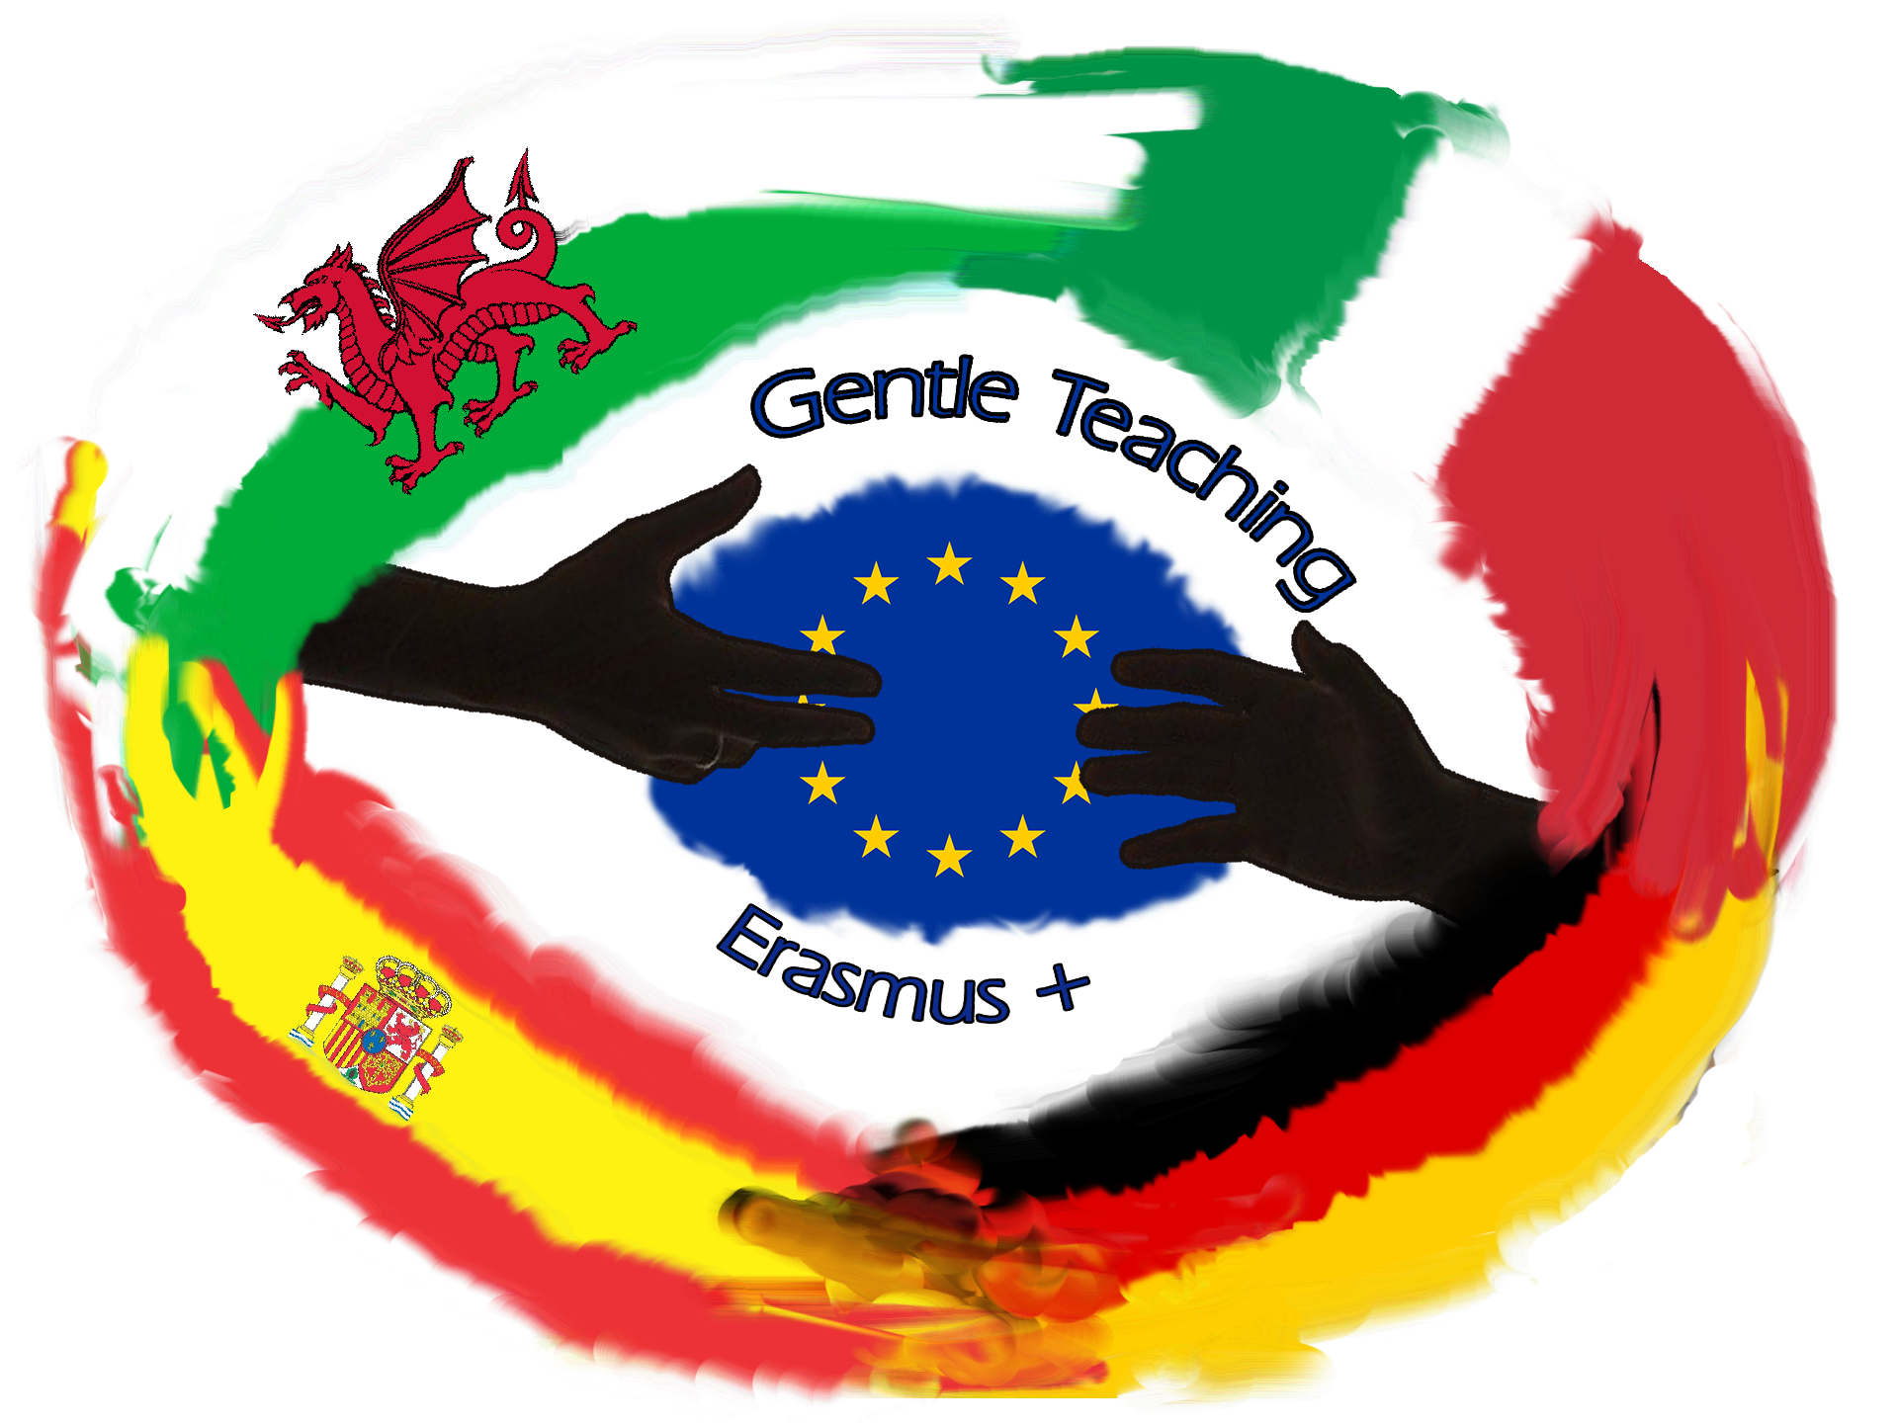
• Erasmus +
• Co-funded by the
• Erasmus+ Programme
• Of European Union

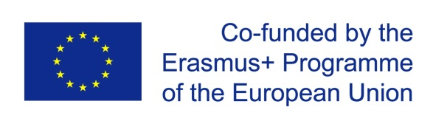

PROGRAMME
3rd Exchange of Students
20-24 May 2019
ERASMUS+ PROJECT
The Gentle Teaching Experience
the diverse need diversity
2017-1-DE03-KA219-035460
CO-FUNDED BY THE EUROPEAN UNION

Date | Location | Activity | timetable
May 19 Sun | 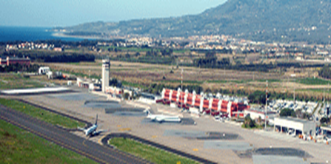 | Arrivals | 10:40  21:10  23:00
May 20 Mon | 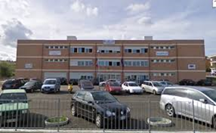 | Welcome  students Creative Workshop with plaster molds I  coordinators: Recap of project’s activities  Ping Pong Sports Workshop  Lunch time  Creative Workshop with plaster molds II  Rehearsal for Gentle Day  Partners’ presentations on principles | 9:00-9:30  9:30-11:00  9:30-12:00  11:00  12:00  13:00  14:00  15:00
May 21Tue | 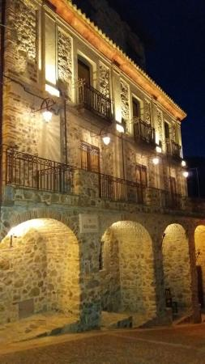 | Musical Workshop  Traditional workshop itinerary in Petrizzi | 8:00-09:30  09:30-16:00
May 22 Wes | 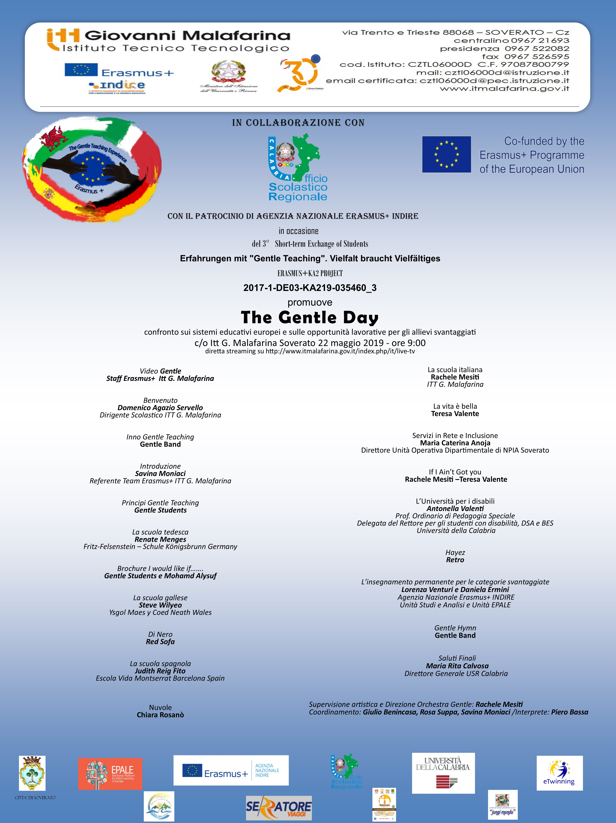 | Gentle Day: Conference on the different Educational Systems in Europe and on job opportunities for Sen students  Brochure Delivery | All day long
May 23 Thu | 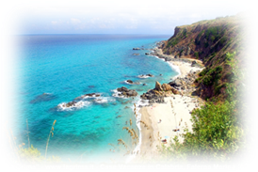 | Cultural Sightseeing at Tropea- Pizzo | 8:30-19:00
May 24 Fri | 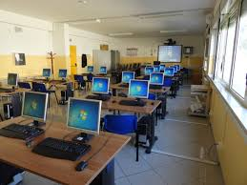 | Students: Creative Workshop with clay masks  Students: Digital workshop  Coordinators: planning the next mobility  Evaluation  Certificates Delivery | 8:00- 9:00  9:00-10:00  8:00-10:00  11:00  12:00
May 25 Sat | 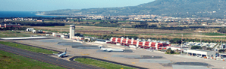 | Lametia Airport Departures | 09.15  11.25  16:00

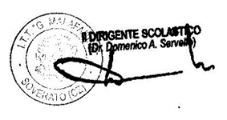
Soverato, 22/03/2019

