Koristamine Roosi Koolis ( Cleaning in the Roosi School )
AIM: the student can follow the work order according to the images.
The student can choose the right tools for every cleaning.
The student finishes his/her job.
There was difficulty, initially, to find the right tools.

Cleaning was a longer process and the students needed a break inbetween.
For some students, the outcome of the activity was not important, for example the dust was not all gone etc.
Cleaning jobs need consistency and completeness. It is important to explain to the students that every job is important and needs to be finished.

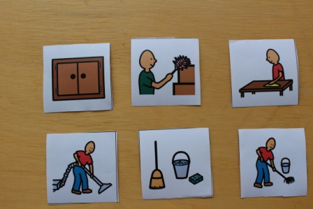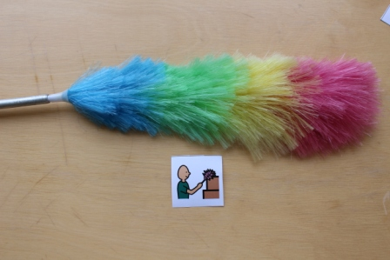

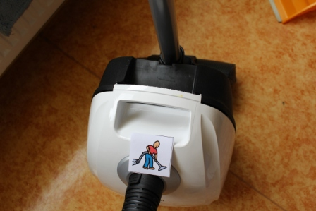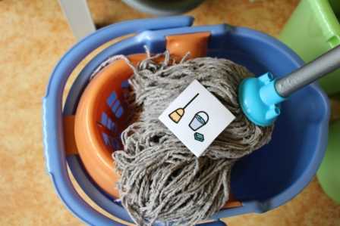
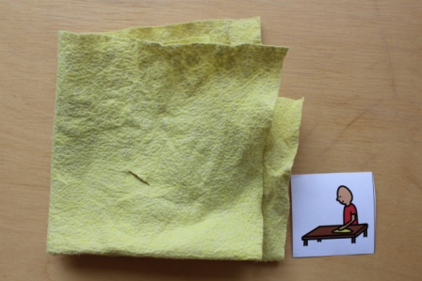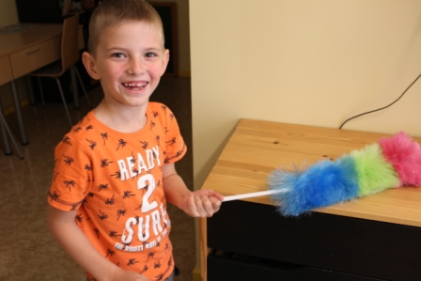
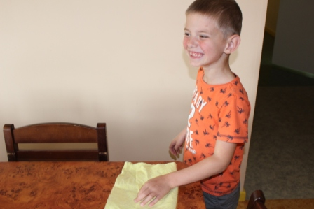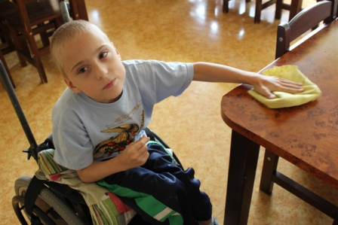

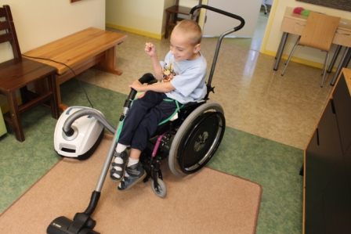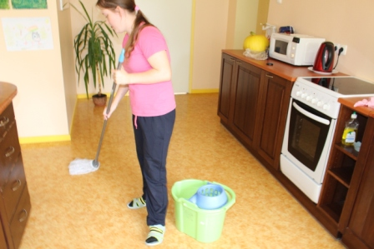

And the house was clean

