THE ADVENTURES OF E&S in TURKEY
It was a summer morning. E&S waked up early. He started preparing to go Mersinbeleni. His best friend, F&N was with him. They departed from Italy. They were on the boat. The sun was shining in early morning, but it was getting dark in the afternoon.
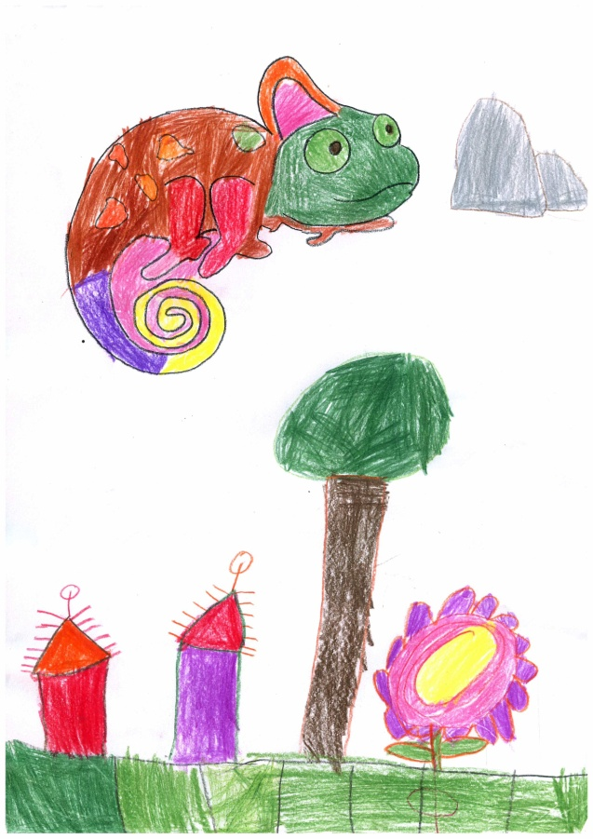
Drawn by Elif YILDIRIM
E&S and F&N were getting hungry. They had a break, ate something and went on their way. The waves were getting bigger and bigger. It was so hard to travel by boat. Suddenly, the boat was overthrown. E&S and his friend had to fight against the waves. F&N could not swim. He was about to die. Fortunately, E&S rescued him. They went on their way.
Finally they arrived in Mersinbeleni. They found a house. When they knocked the door, a child opened it. As she was afraid of them, the child screamed. E&S and his friend, went away from there. While they were going on their way, a group of people gathered around them. It was getting crowded and the people were talking among themselves. Hasan, the son of village chief, joined them and satisfied their curiosity. He said: ‘They are cururu frogs, the last type of motilium family. They can speak with people.’
The people were shocked and started to ask questions. E&S had to answer all of the questions.
Hasan took them to his house. He served food for them. Then, Hasan showed around the village to his guests. He introduced the green hills and blue streams, nice quiet homes and lovely people. E&S and F&N liked the village. But it was night and they had to go back.
There was circumcision ceremony in the willage. Hasan and his guests set off to join the ceremony but it was snowing. The ceremony was outside the village.
While they were walking, they heard a noise. It was raw. Hasan shouted. E&S and F&N were trying to jump. However the raw was increasing.
Hasan saved himself and looked for E&S and F&N. But he couldnt find them. He was terrified. All villagers were looking for them. Ahmet, the richest man in the village found E&S. They rescued E&S altogether. All people were interested in E&S but forgot F&N.
E&S asked his friend. All of them started to look for F&N. Even though they left no stone unturned, they couldnt find. The snow was increasing. E&S was too sad. He felt guilty. The snow stopped next morning. Hasan and E&S was still looking for him.
One week passed. Finally, Hasan found F&N. When Hasan found him, F&N wasn’t able to speak as he had been so cold. F&N was coughing a lot. Hasan’s mother cared him for two weeks. F&N was getting better.Finally he recovered. All of them were happy.
One day, his teacher called Hasan asked him to read a poem for April 23rd, National Sovereignty and Children’s Day celebrations. Hasan was very happy. He shared his happiness with E&S and F&N. They were surprised and asked for explanation.
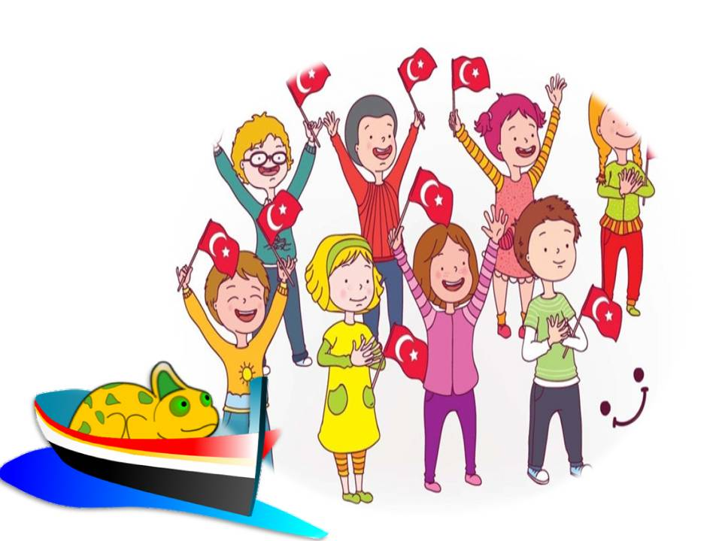
Hasan: ‘National Sovereignty and Children's Day is a national holiday in Turkey, always celebrated on 23 April. The holiday commemorates the first opening of the Grand National Assembly of Turkey at Ankara in 1920.
The founder of the Turkish Republic, Mustafa Kemal Atatürk, dedicated 23 April to the children of Turkey to recognise that children are the future of the nation.
To mark National Sovereignty and Children's Day, school children participate in week-long ceremonies marked by singing and dancing performances in sports fields across Turkey, culminating with a large performance in the national soccer stadiums.
A unique way the day is celebrated is that children take over the government of Turkey for the day. Children replace the normal members of the Grand National Assembly and hold a special session to discuss children's issues and even sign executive orders relating to educational or environmental policies.’
E&S and F&N were impressed.
One day, Hasan’s uncle was died. His family hand out food for poor people. E&S and F&N did not understand this. Hasan stated : ‘ in Turkey, if someone dies, the relatives distribute food for people after 52 days. It is our custom. It is a kind of remembrance and pray‘
The time passed, E&S and F&N had to leave this country. Hasan and his family were too sad.
They sad good-bye to each other drearily. E&S and F&N had a family in Turkey. They were off to Portugal with nice memories.
Which advantures are waiting for them in Portugal?

