Frosinone
History of Frosinone:
Frosinone is a city of 46,120 inhabitants (2017), in the Lazio region, in Italy. It is located on a hill above the Sacco river, in the south-east of the province of Rome, in the Latin Valley.
The singularity that Frosinone exudes today is due precisely to the survival of its Volscian origins, a culture originating in Italy that was in the central territories from the 13th century BC until 386 BC, when the Romans conquered the city. The mixture of roots and cultural influences are felt in the eclectic architecture of Frosinone, a city that has been expanding around a hill from which the green plain of the territory can be seen and connects the historic center.

Places to visit in frosinone:

-Museo Archeologico Comunale:
It is located in the historic center of Frosinone, in the highest part of the city, between the alleys that frame the Cathedral of Santa Maria Assunta, from where the old bell tower is located, which can be accessed through guided tours, organized by the Museum .

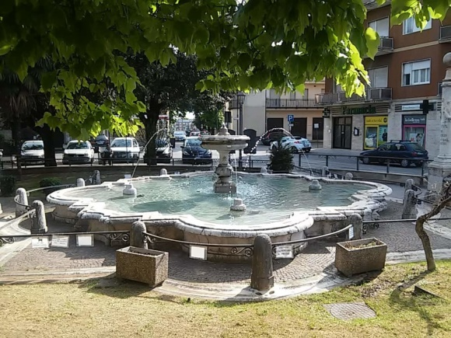
-Fountain Livio de Carolis:
Carolis Fountain is a monumental fountain in the city of Frosinone.
It is located in Piazza della Madonna della Neve.

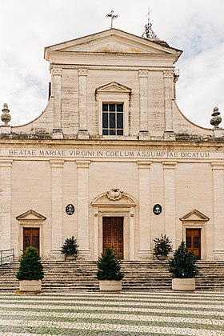
-Frosinone catedral:
The Cathedral of Santa Maria Assunta is located in the historic center of Frosinone, in piazza Santa Maria. The facade, with reflections, is preceded by a stone staircase. It is divided into two sections.
CAMPANILE

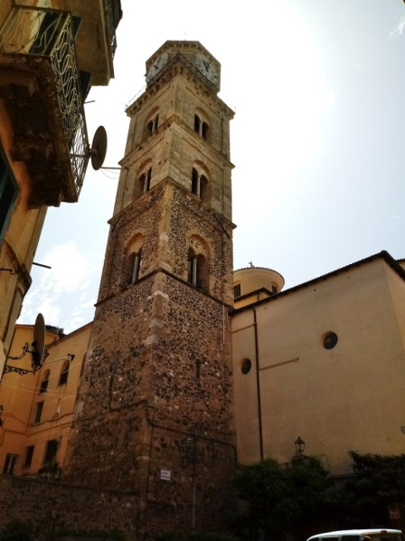
The construction certainly dates back to the middle ages considering its relevance to the church of Santa María, documented from the first half of the 12th century. With more than 40 meters high, the tower has a square base on which there are 3 orders of mullioned windows on all four sides. On a frame with blind arches is the conoration structure with an octagonal base that contains the clock and is topped by a dome. While the last two orders of mullioned windows and the top present a regular curtain in square blocks, the base and the first order of mullioned windows are built entirely with heterogeneous materials.

ARCHEOLOGICAL MUSEUM

The Municipal Archaeological Museum of Frosinone is one of the most important Civic Museums in the homonymous province. It is located in the historic center of Frosinone, in the highest part of the city, between the alleys that frame the Cathedral of Santa Maria Assunta, from where the old bell tower is located, which can be accessed through guided tours,organized by the Museum.
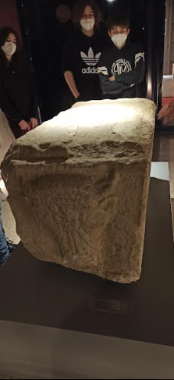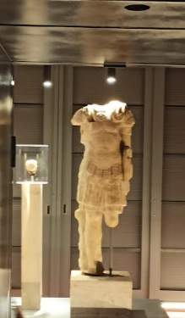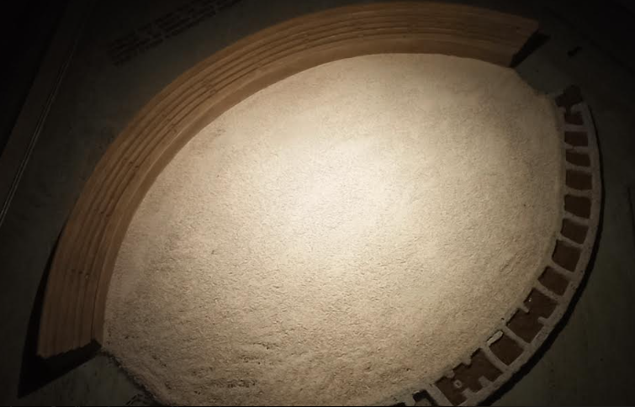

WHAT IS THE SYMBOL OF FROSINONE?
Il campanile is the symbol of Frosinone because it is seen from all around the plain. Lazio is one of the twenty regions that make up the Italian Republic.

