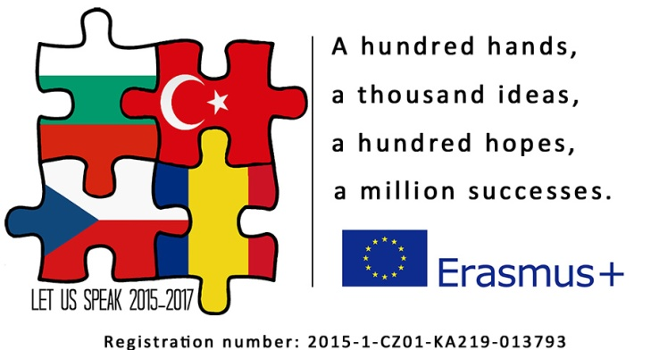

Project meeting report

1. Starting to create the assessing method for speaking based on national curriculums of each country.
- IO1 – Turkey is responsible for completing the guide, other countries will send their parts until 15th January to Turkey and upload them to Twinspace.
- IO2 – Czechs are responsible for completing the book of speaking tests, other countries will send two tests until 15th January to Turkey and upload them to Twinspace.
- each country will test two groups of 15 students using prepared tests until the end of January and will upload all the assessor´s and interlocutor´s mark sheets in one pdf file on etwinning

2. Preparing the description of Progressive Speaking and Communicative Method and gathering the material for making the first set of speaking tests

3. Specifying the upcoming activities (Pass it further, TV News)
Pass it Further
The activity in which students will start making a story and will pass it further to another country for further development. Technically, students will record an audio file and with other 3 things in the box they will pass it to another country. This way it will continue going around all countries.

The aim of this activity is to give the students a chance to improve their speaking abilities. Moreover, they will have to come up with a storyline, a plot and main plan of the story and show their creativity. They will learn new competences such as recording and editing the sound and narrating the story.

- the length of screenplay is about 9 - 10 minutes long
- there must be 9 – 12 characters
- it must follow basic rules of storytelling
- each part of the story can take place in a different period of time (past, present, future)
- each part of the story can be written in a different form (fantasy, love story, detective story…..)

How is the news created?
Students will learn how the news is created and consequently the students will create TV news on their own in order to increase their speaking ability. In the first part of this activity students will visit the local TV station and will watch the preparation, shooting, editing and broadcasting of the news. In the second part, they will prepare TV broadcasting about the life in the town (local news for citizens, sport, weather, nature, culture). Students will capture the video, edit it and post it on the project pages as well as youtube.com. The teachers will create 2 CLIL lesson plans in each school which will be used in Geography and Biology as the teaching material and the final video will be used in English lessons, too.

News format:
- the total length of the news is about 15-20 min.
- included topics are sport, weather, culture, nature, school and local news

4. Preparing the list of team-building games for the 1st and 2nd team-building camp, Bulgaria and the Czech Republic will give basic information about the camp (arrival, accommodation, timetable, food, budget)

- 1st team-building camp in Bulgaria
- Date – 13th – 18th
- Accommodation and food –
- Train tickets –
- The Bulgarians will ensure medical supervision for the whole stay
- Team-building games, communicative games –
- the set indicator is 15 games during one camp
- the list of games
- ….
- ….
- …

- 2nd team-building camp in the Czech Republic
- Date – 23th – 27th May
- Accommodation and food –
- Train tickets – same price
- The Czechs will ensure medical supervision for the whole stay
- Team-building games, problem solving –
- the set indicator is 15 games during one camp
- the list of games

- ….
- ….
- …

6. Explaining the processing the games during the the 1st team-building camp

- due to team building games this number of teachers is needed because the 1st group of the teachers will lead the students’ teams, the 2nd group will prepare the following activities and will evaluate the results of the games and write the methodical description.
- The Czechs will ensure medical supervision for the whole stay.
Students will not be staying in families but they will be accommodated together for the greater use of speaking.
- the number of participants is set according to the size of the school; to ensure working in one classroom

Realization
The realization will take place in a Czech school. This camp will focus on problem-solving team-building games by doing them inside and outside school. It has been proven many times that students learn a language faster and more efficiently by playing games. By playing games, we´ll catch pupils´ attention to solve the task and speaking will become a secondary problem. This way we can easily lower their fear.

In the 1st project meeting the collection of communicative team-building games will be prepared. During the camps teachers will verify and evaluate these games by testing them on the participants. The participants will be put into mixed groups of 6 members in order to boost their attempts at using English, to motivate them to overcome the communicative barriers and to make them feel they are an important link of the team. The teachers will take turns in leading the teams in which they become tutors, they will be ready to give any help where needed. After each day the dialogue with the participants and teachers will be held and evaluating sheets filled in to get the relevant view of the games.

The successful games will be processed and described methodically by the rest of the teachers. This way we will reach the set indicator of 15 games during one camp. The rest of the games will be posted on the project websites to be at hand for other teachers. Even though the games will be chosen deliberately to support speaking and communicative abilities they will cross the borders of other subjects such as PE, Craft, Biology, Geography, as well and this way will extend the students basic skills in those subjects. In addition, other activities are planned to get the participants feel the different culture, history, nature beauties etc. of the host country. These will also support speaking but this time the students will face the challenge using English in real time and in real situations such as: asking the way in the city, buying things/tickets, using timetable of means of transport, ordering fast food, requesting information in the Tourist Center etc. Each country will prepare different kinds of situations.

After finishing the camp the host country will be responsible for processing and completing the 1st part of the "The Mega Book of Team-building Communicative Games. The completed part will be sent to CZ in a pdf format. The Czech Republic takes responsibility for the book as a whole.

This book will be created as the result of four team-building camps which will take place in October 2015, May 2016, September 2016, May 2017. It will consist of 4 parts supporting the communication games, problem-solving games, cooperation games and creativity games. There will be 60 games in the book from 4 camps. The games will be provided in a detailed description including the aim, procedure, things needed, level of difficulty and other important factors in the book. The high-quality pictures will be taken for the visual support and will be used for printing the book.
The games will be used as the teaching material in English lessons as well as in other relevant subjects. It will be posted on the project websites in a pdf file and will be easily available for pedagogical and non-pedagogical public.

7. Project meeting in Romania

- Date – June 20th-23rd
- Accommodation and food –
- Train tickets –

7. Explaining how the monitoring will be carried out
- all the project activities are monitored with feedbacks, done by students and teachers, the concrete time is set which follows our timetable of project activities

8. Making a record of the meeting

Participants´ signature:

Date 16th-17th Decemeber 2015, Třinec

