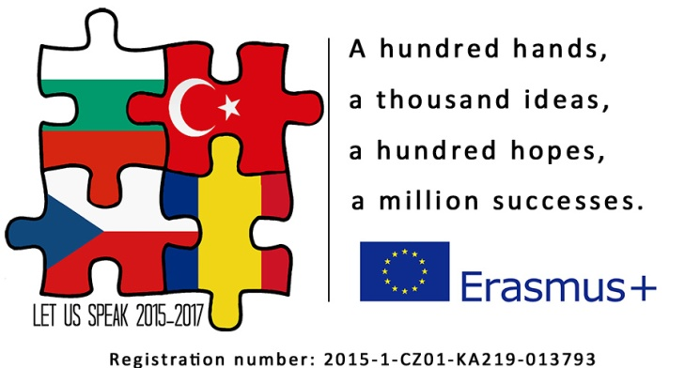

Programme info

Monday

  - Meeting point at hotel reception
9.45 – 10.45 Welcome speech at Elementary School of Peter Bezruč, Tour of School
11.00 – 12.30 Seminar: Speaking Assessment- part 1
12.30 – 13.30 Lunch at the hotel´s restaurant
13.30 – 15.00 Seminar: Speaking Assessment – part 2
16.00 – 18.00 Afternoon leisure programme – guided tour in Ironworks

Tuesday

- – 10.30 Seminar: Speaking Assessment
10.35 – 10.45 Coffee break
10.45 – 12.15 Seminar: Speaking Assessment
12.15 Lunch at the hotel´s restaurant
16.00 – 22.00 Afternoon leisure programme – Concert of Musical School in Protestant Church
- Welcome party

Wednesday

9.00 – 10.30 Seminar: Speaking Assessment
10.35 – 10.45 Coffee break
10.45 – 12.15 Seminar: Speaking Assessment
12.15 Lunch at the hotel´s restaurant
16.00 – 18.00 Project meeting for coordinators, creating intellectual outputs O1, O2
18.00 – 22.00 Afternoon leisure programme – free time

Thursday

9.00 – 10.30 Seminar: CLIL
10.35 – 10.45 Coffee break
10.45 – 12.15 Seminar: CLIL
12.15 Lunch at the hotel´s restaurant
16.00 – 18.00 Project meeting for coordinators, creating intellectual outputs O1, O2
18.00 – 22.00 Afternoon leisure programme – optional: wellness/restaurant

Friday

9.00 – 10.30 Seminar: CLIL
10.35 – 10.45 Coffee break
10.45 – 12.15 Seminar: CLIL
12.15 Lunch at the hotel´s restaurant
16.00 – 22.00 Afternoon leisure programme – A Game of Bowling – mixed groups

*The timetable of leisure programme can be changed according to unpredictable circumstances.

