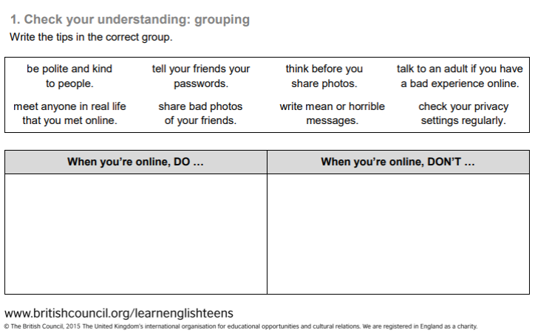
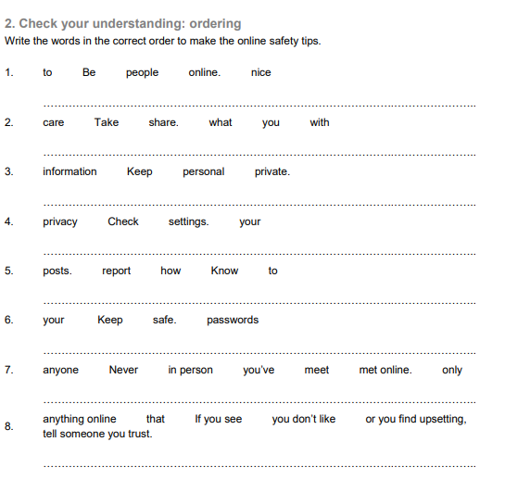
Internet Safety Quiz
1. It is safe to give my school name over the internet. True/False
2. Watching videos on streaming sites like Youtube and Metacafe is safer than downloading them from file sharing sites. True/False
3. If someone online tells you they are in 6th grade and their name is Katie, they are probably how old?
a. 12 b. 13 c. 35 d. There’s no way to tell!
4. Your best friend asks for your password to your favorite game site so he/she can help you score game points or cash. He/She promises to keep it safe and secret. Is it safe to agree?
a. Yes, it’s OK. b. No, it’s not OK.
5. If you have been talking on the Internet to a person for a long time, and they want to meet, which is okay to do?
a. Meet them, as long as you bring a friend.
b. Meet in a public place.
c. Tell someone where you will be before you go.
d. Ask your parent or guardian first and have them go with you.
6. If someone online sends you a message that is mean or makes you feel uncomfortable, you should:
a. Erase them from your friends list.
b. Delete the message.
c. Insult them back
d. Tell a responsible adult.
7. You are talking to someone online, and they know some of the same people you know. Since they have many of the same friends as you, is it ok to give them your phone number if they ask?
a. Yes b. No
8. It is okay to send someone online your picture when:
a. They send you theirs first.
b. You send them an old picture.
c. As long as you don’t send them your address too.
d. Only if a parent or guardian is with you and says it is okay.
Choose the correct words or phrases:
- You should always/never check your privacy settings.
- It’s/It isn’t a good idea to write down your password.
- Make sure you always/never use your birth date as a password.
- It’s very important to clear/share your browser history.
- Don’t use/Use a nick name instead of your real name.
- Always/Never tell a parent or instructor about any message that is scary or inappropriate.
- Never/Sometimes share personal information, such as addresses, phone numbers, campus names, or locations.
- Never/Sometimes share personal photographs online or by email.
- Never/Sometimes agree to meet anyone from a chat room in person alone.
- Never/Always respond to an email or message that is a threat.
- Download/Do not download pictures or any other files from an unknown source.

MORE:
https://learnenglishteens.britishcouncil.org/uk-now/video-uk/online-safety-tips

