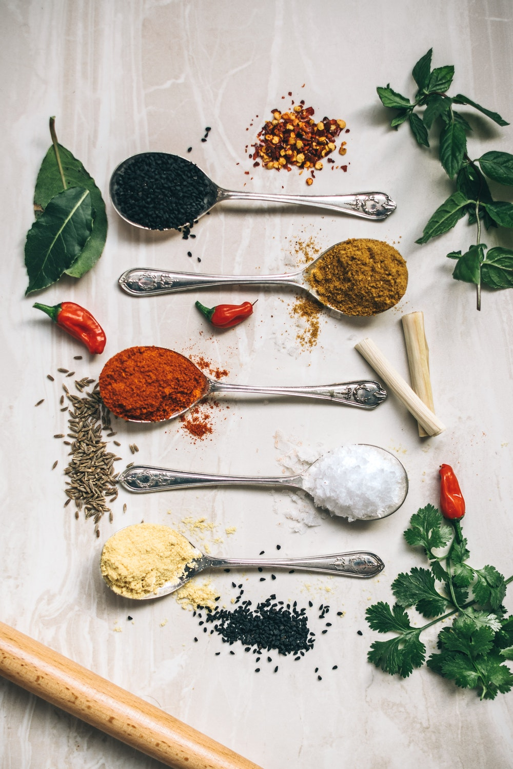
ROMANIAN
COOKBOOK
SALADS SOUPS
MAIN COURSES

CAKES
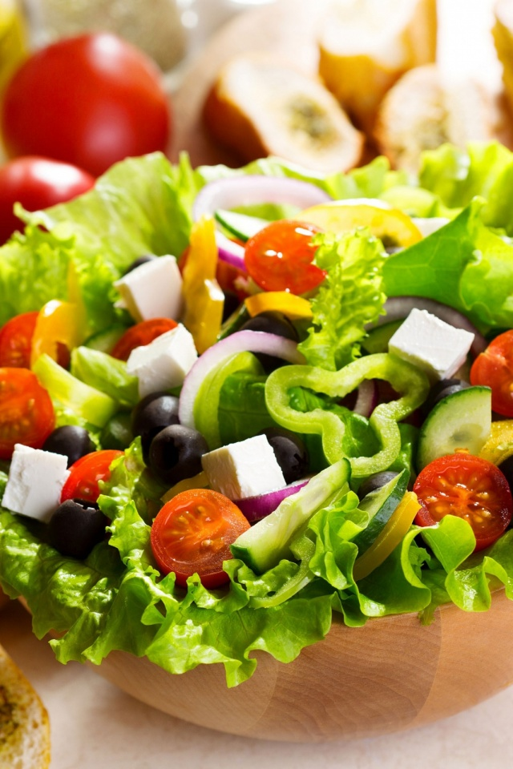

SALADS

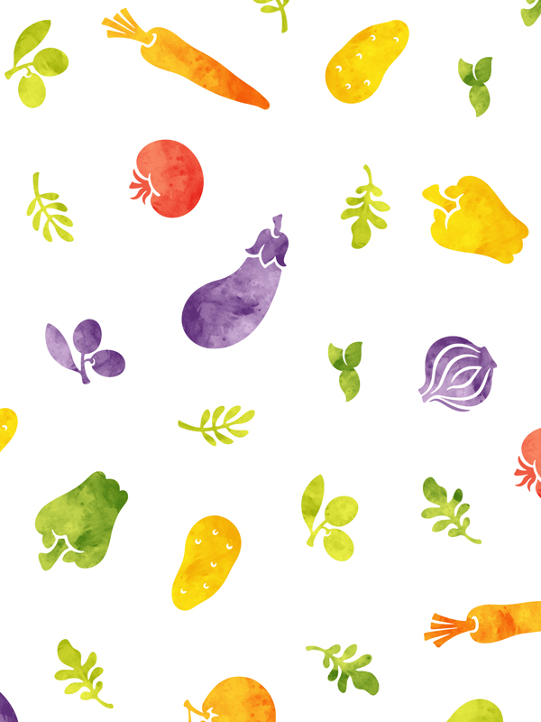
LETTUCE SALAD – SALATA VERDE

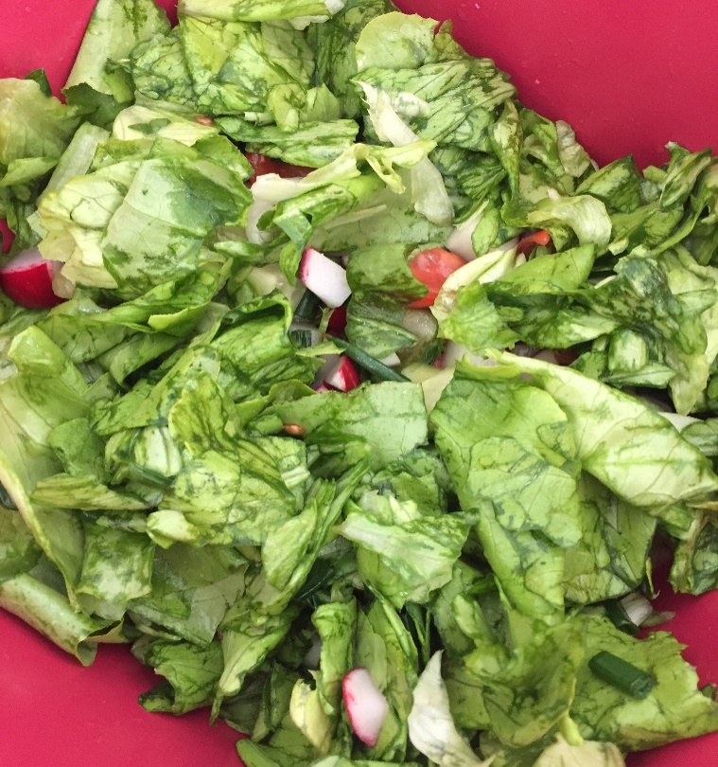

- 1 lettuce
- 3 green onions
- 6 radishes
- lemon juice
- olive oil
- salt, pepper

Clean the lettuce and the other vegetables. Then we cut all the ingredients, add the lemon juice, the olive oil, the salt and the pepper. We mix them all and then serve it along with roast meat or french fries.

POTATO SALAD – SALATA DE CARTOFI

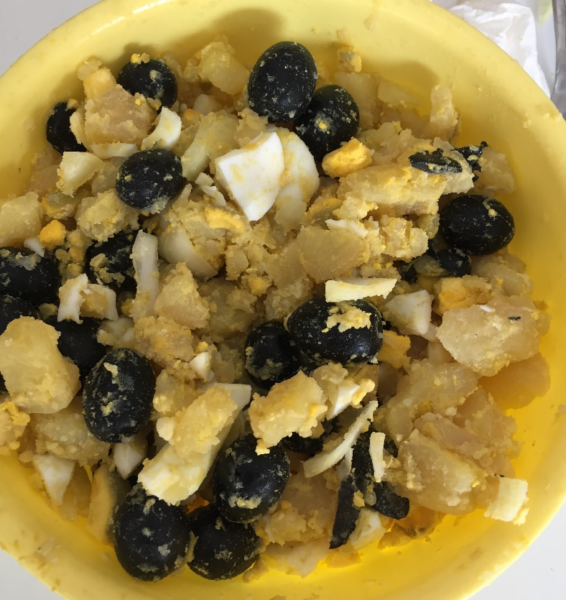

- 5 potatoes
- 1 onion
- 100 g black olives
- 3 boiled eggs
- 150 g pickles
- salt
- pepper
- olive oil
- vinegar

First, we boil the potatoes and the eggs. After the potatoes are boiled, we peel and cut them in slices. We peel the eggs too and add them over the potatoes. Then we add the black olives and the pickles, add olive oil, salt, pepper, vinegar and mix together.

SUMMER SALAD – SALATA DE VARA

- 4 tomatoes
- 4 cucumbers
- 1 onion
- 300 g cheese
- salt
- pepper
- olive oil
- vinegar

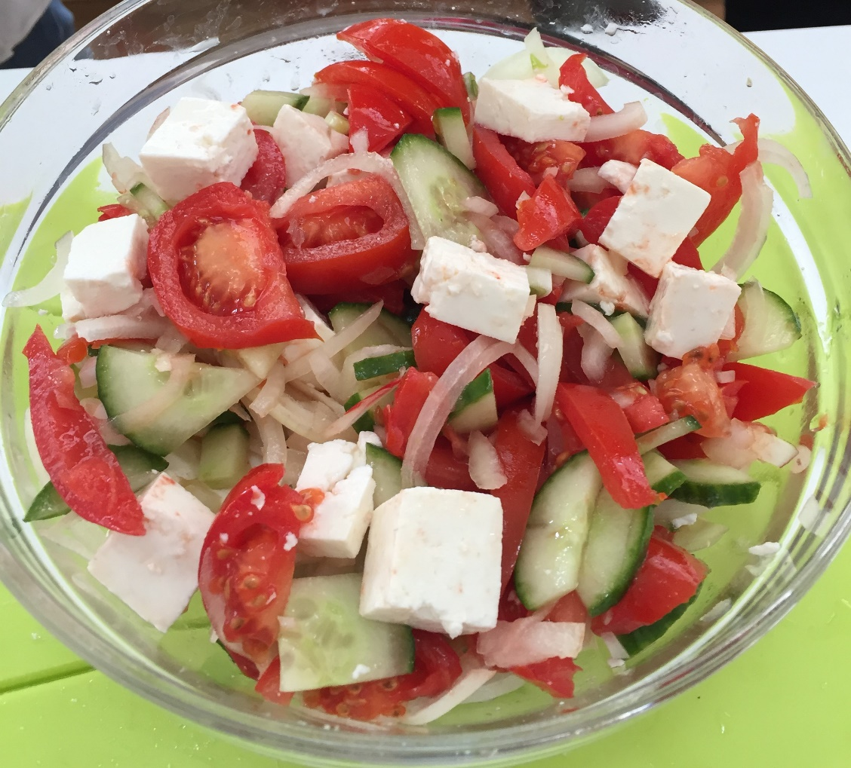

Wash the vegetables and then cut them in large slices. Cut the cheese in small squares and add the olive oil, the vinegar, the salt and the pepper. Mix them together and serve it simple or next to some steak.
BAKED PEPPER SALAD – SALATA DE ARDEI COPTI

- 10 red peppers
- salt
- olive oil
- pepper
- vinegar
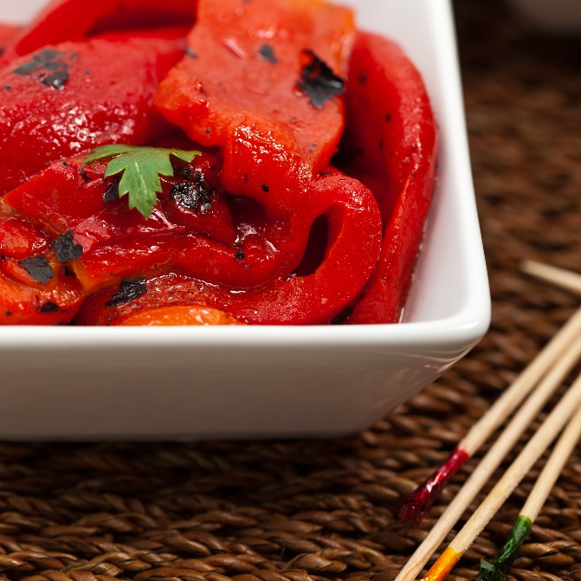

We bake the red peppers on the grill until the peel becomes black. After they are done, we put them in a large bowl whit cold water and we peel off their skin, seeds and stiks. We can let them as they are, or we can cut them in strips, mix them with salt, pepper, vinegar and olive oil. We can serve the salad like that or next to meat or rice.

CABBAGE SALAD – SALATA DE VARZA

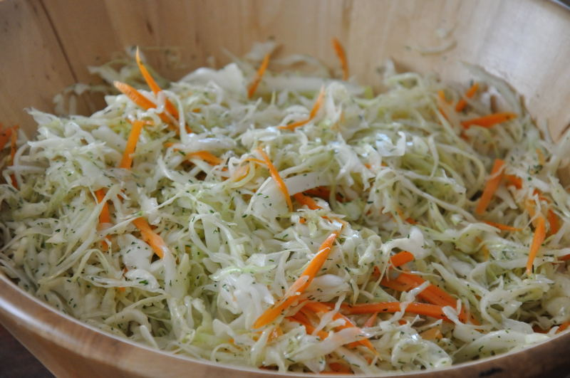
- 1 white cabbage
- 1 carrot
- 1 bunch of dill
- salt
- pepper
- olive oil
- vinegar

We cut the cabbage in halves, then we cut them in small strips. Peel the carrot and we scrape it, we rub the cabbage with salt, then we add the carrot. We cut the dill and add it in the bowl. We add the pepper, vinegar, olive oil and mix them together. We can serve the salad alone or as dressing for steak or mashed potatoes.

SOUPS

CHICKEN DUMPLING SOUP – SUPA CU GALUSTE

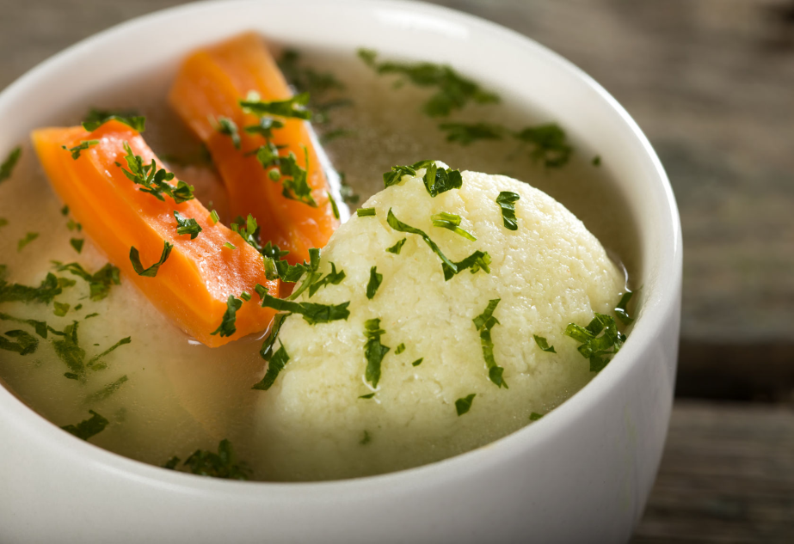
- 1 chicken
- 2 carrots
- 2 onions
- 1 celery
- 1 egg
- 50 g semolina
- salt, baking powder
- parsley

We cut the chicken into pieces and put them to boil with salt. While the meat boils, we clean and cut the vegetables into large pieces. We add the vegetables in the pot and let them boil together. Meanwhile, we prepare the dumpling composition: we beat the eggs with salt and some baking powder and then we put the semolina; after that, with a teaspoon dipped in the soup, we make the dumplings. We let them boil for 15-20 minutes and then we sprinkle the chopped parsley. We serve it warmly.

TRIPE SOUP – CIORBA DE BURTA

- 2 kg of beef tripe
- 1 kg of beef bones
- 3 carrots
- 15 garlic cloves

- 6 yolks
- 400 ml of sour cream
- salt, pepper, bay leaves
- vinegar and chili pepper for serving

We cut the tripeinto large pieces and we boil it with beef bone, salt, pepper and bay leaves. Once the tripe is boiled, we cut it into "noodles" of about 8-10 cm. We clean the carrots and cut them in small slices. We put the yolks in a large bowl and squeeze the cream.We dilute the mixture of cream and yolks with hot

soup,added gradually, stirring well every time. We continue to add the hot tripe soup until we feel that the bowl mix is ​​hot.The mixture of cream and yolks is poured into the soup pot, stirring quickly. After we strain the soup, we check again the level of seasoning.
MEATBALL SOUP– CIORBA DE PERISOARE
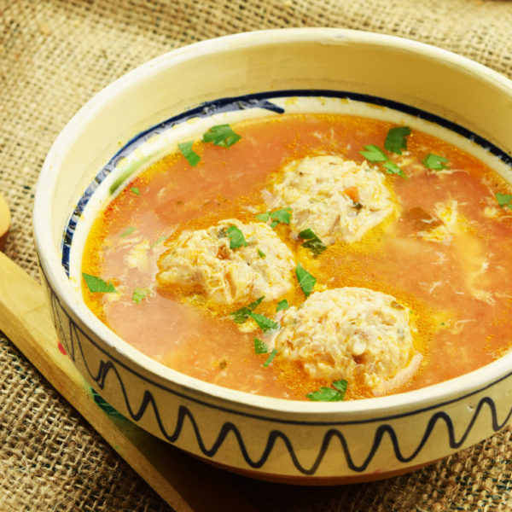

- 500 g of minced meat
- 2 carrots
- 2 onions
- 1 celery
- 500 ml of tomato paste
- lemon juice or vinegar
- 1 egg
- salt, pepper, thyme, dill
- rice, a teaspoon of oil

We clean and cut the vegetables in small slices and we put them in a large pot, to boil. Meanwhile we prepare the composition for the meatballs: we mix the meat with the egg, the small onion sliced very small, salt, pepper oil and thyme into a bowl, then we form small balls and leave them aside until we add them to the soup. Add the meatballs in the soup and wait for them to boil, then add the rice, tomato paste and lemon juice. When the soup is ready, we close the fire and sprinkle the chopped dill and the dried thyme. We can serve soup with sour cream.

NOODLE SOUP – SUPA CU TAIETEI

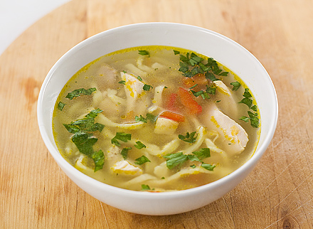
- chicken meat
- 2 onions, 2 carrots
- 1 celery
- 2 eggs
- flour
- salt, pepper, parsley

The cleaned and washed vegetables whole, boil with the meat in cold water with a spoonful of salt.When the chicken soup is ready, the chicken and the vegetables are removed from the soup and if the soup is cloudy, it can be squeezed. Mix the eggs with about 2/3 of the flour, obtaining a dough as well as for flour dumplings. Gradually add the remaining flour, until the dough becomes compact without being too strong. Just as above we need to be careful not to put all the flour if you do not have to. In both cases, the dough is tightened in the form of a ball and left for 30 minutes, wrapped in plastic wrap. After we have waited, cut the noodles into fine strips and put them in the soup and let them boil. Finally, add the parsley cut and serve the soup.
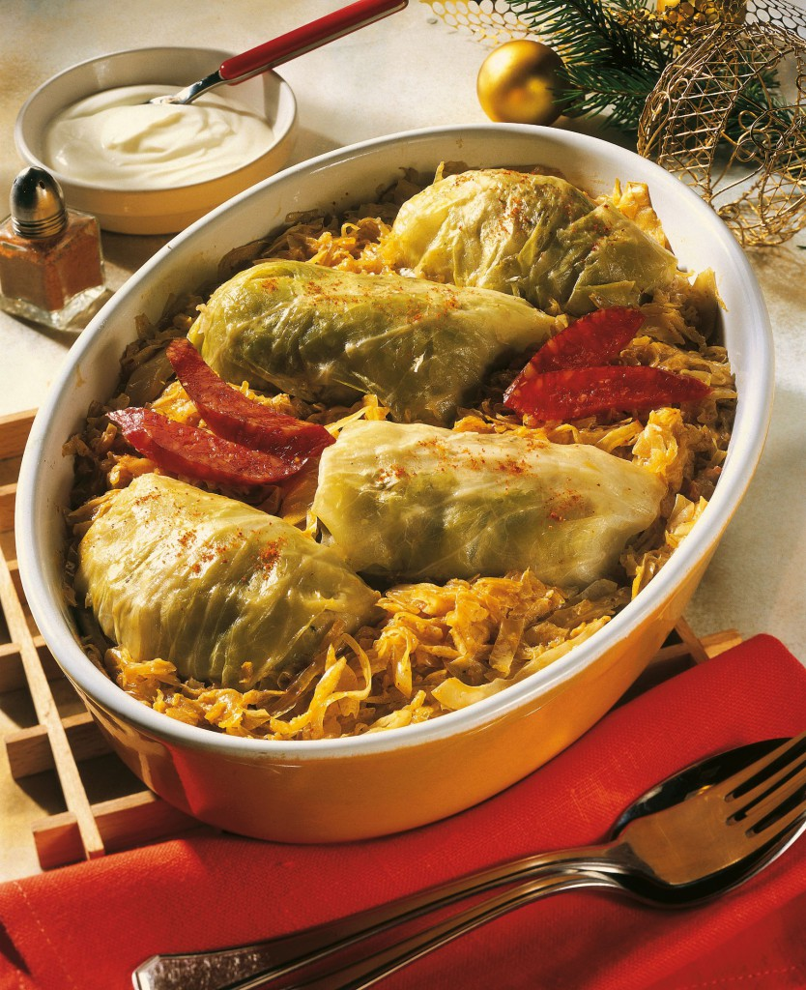
MAIN
COURSES

FILLED CABBAGE LEAF ROLLS
SARMALE

- 1 kg of minced pork meat
- 1 onion
- 100 g of rice
- 1 egg
- 1 tablespoon oil
- tomato paste
- salt, pepper, thyme, dill
- 70 sour cabbage leaves
- sour cream and chili pepper for serving

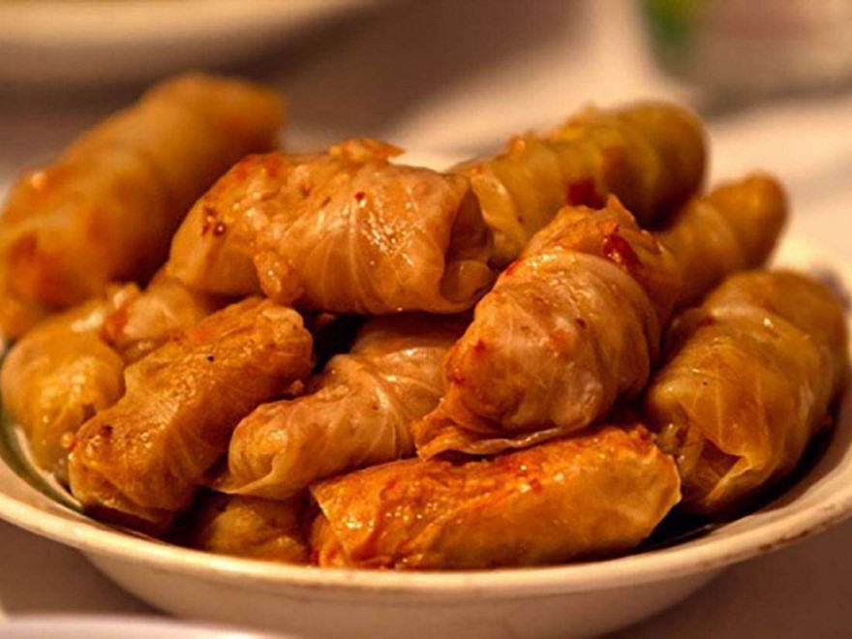
We mix together the meat, rice, egg, sliced onion, tomatoes paste, oil, salt, pepper, thyme and dill into a bowl. We choose the cabbage leaves and put the composition in every leave and then we furl it in small pieces. We put to boil the filled cabbage leaves into a large pot and put it into the oven about 2 hours. When are done, we can serve them with sour cream and chilipepper.
BEANS WITH SMOKED HAM- FASOLE CU CIOLAN

- 500 g of dried white beans
- 2 carrots
- 2 onion
- 1 celery
- 300 ml of tomatoes paste
- salt, pepper, thyme
- 3 bay leaves, parsley
- 50 ml of oil
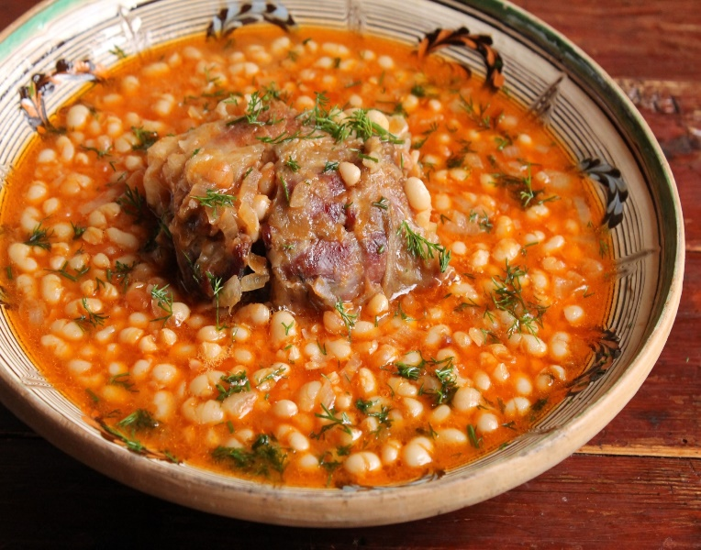

Dry beans must be soaked in cold water for at least 8 hours. At this time change the cold water three times.The ham is placed whole with a bone in a large pot and covers well with cold water. If the water drops it will need to be completed. We boil the soaked bean. We drain the bean of the water in which it was soaked and put it in a large pot. We cover the beans with cold water and put them to boil. Since it start to boil wetiming 15-20 minutes after which we drain the water. We put the beans back in the pot and pourover it the hot juice in which the ham was boiled. We clean and chopthe onion, the celery and the carrots. In a frying pan, we put the onions and the carrots in 2 tablespoons of oil on low heat and we temper them.After that, we add the vegetables over the beans. We add also the tomatoes paste and the bay leaves. We cooked the food until the beans became soft and pasty.At the end, we add the choppedparsley.
PORK JELLY - PIFTIE

- 3 pork legs
- pork ham
- 2-3 tongues pork
- 2-3 tablespoon of salt
- 1 teaspoon of pepper
- 15 garlic cloves

All pieces are thoroughly checked and parsed. Wash with cold water and rub well with a harder brush or with the knife. After rinsing we put them in a pot of cold water and left them for 30 minutes. We threw cold water and put another fresh one and let them to boil. In the pot already placed on the fire we put 2 teaspoons of salt, pepper and chopped garlic. From the moment it begins to boil we reduce the fire to a minimum and let boil for 3-4 hours. Attention, the liquid in the pot decreases and must be completed every 60 minutes! Do not dilute it too much because you risk not stopping it after cooling. Now we clean and chop the rest of the garlic and put it quickly in the pot with hot soup. We mix well and wait for about 5 minutes to leave the flavor. Everything happens with the fire off. With a spatula, we gathered and drained all the solid pieces of the pot. We put them in a casserole and left them for 10 minutes to cool. We put the clean pieces of meat directly into the serving bowls. We can also use small, individual shapes and overhang in plates after finishing. The clear soup we carefully poured over the pieces of meat in the bowls. We let them cool. In a few hours they can be eaten!

SOUR CABBAGE WITH SAUSAGES
VARZA CU CARNATI
- 2 sour cabbages
- 200 ml of tomatoes paste
- 2 onions
- thyme, pepper
- bay leaves
- oil, dill
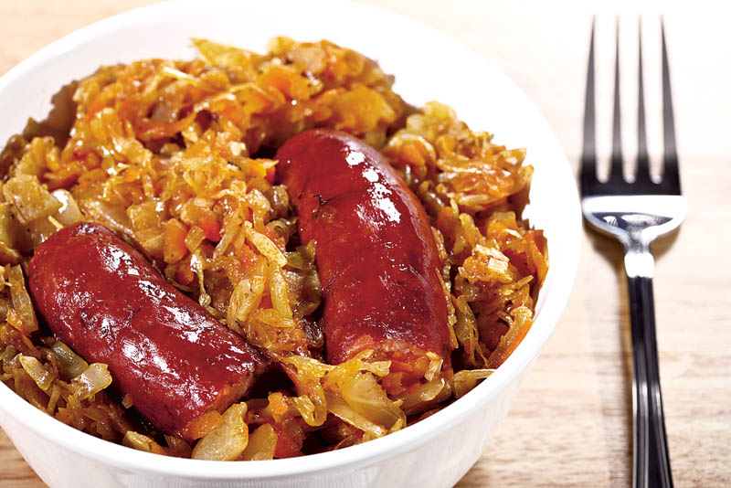
Cut the sausages into the right pieces and fry them in small heat. Cut the onion and put them in a saucepan that can withstand the oven. Cook the cabbage thoroughly, sprinkle with salt and leave for 15-20 minutes to soften. When the onion is ready and obtain a golden color, add the cabbage. Let the cabbage on the small fire, with the lid put, stirring occasionally to keep it free and put a cup of water. When the cabbage is pricked, add the sausages, spices and another cup of water. Let for a few minutes on the stove, put the bay leaves, the thyme and the dill, then we place the cabbage in the oven at an average temperature of 30 minutes.
NETTLE FOOD
MANCARE DE URZICI

- 2 kg of nettle
- 1 onion
- 5 garlic cloves
- 2 tablespoons of flour
- 500 ml of water
- 3 tablespoons of oil
- salt, pepper
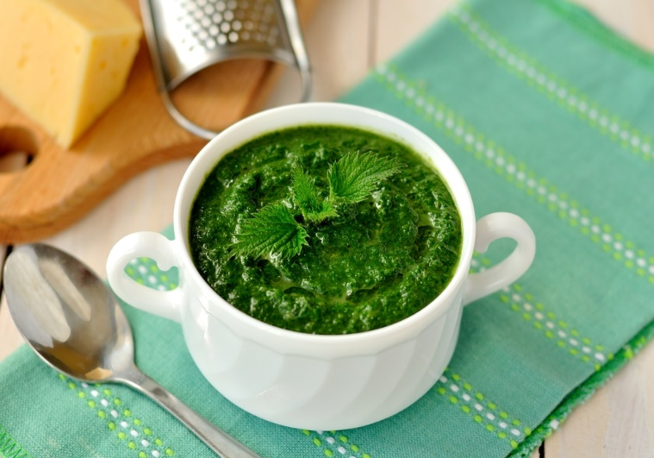

We crush the garlic cloves.We chop the onion.We scraped as finely as possible the stinging nettles.Prepare a bowl that puts the roasted nettles and add the flour.We prepare a saucepan in which we put the oil. Add the onion, mix and simmer until it becomes glassy.We put the water in which it boiled the nettles, stir and let it boil. Add the composition mixed with flour and homogenize.Boil over low heat until the juice drops, stirring often so it does not stick.Put the crushed garlic.Season with salt and ground pepper.Mix and boil for 3 minutes.

CAKES
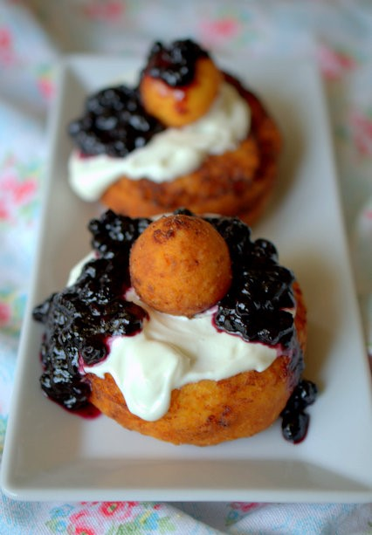

DOUGHNUTS WITH JAMAND SOUR CREAM
PAPANASI

- 450 g of fresh sweet cheese
- 100 g of sugar
- 2 eggs
- lemon peel
- vanilla essence
- 300 g of flour
- 5 g of baking powder
- sour cream, fruit jam

In a bowl we put the fresh cheese, sugar, eggs and flavors. Mix with a fork then add the flour mixed with baking powder. We knead the dough with hand until we have all the flour incorporated.From the dough, break 11 large balls and 11 small balls. In the middle of the big ball we form a hole with the index finger.In a saucepan, we put about two or three fingers of oil, then fry the doughnuts until they turn brown.We take them on absorbent paper and let them cool. Place a spoonful of sour cream and a spoonful of fruits jam on top and place the small ball in the middle.
CHEESE PIE – PLACINTA CU BRANZA

- 1package of pie sheets
- 1 kg of cottage cheese
- 6 eggs, 100 ml of milk
- 5 tablespoons of sugar
- 3 sachets of vanilla sugar
- 1 cup of oil for paper and tray

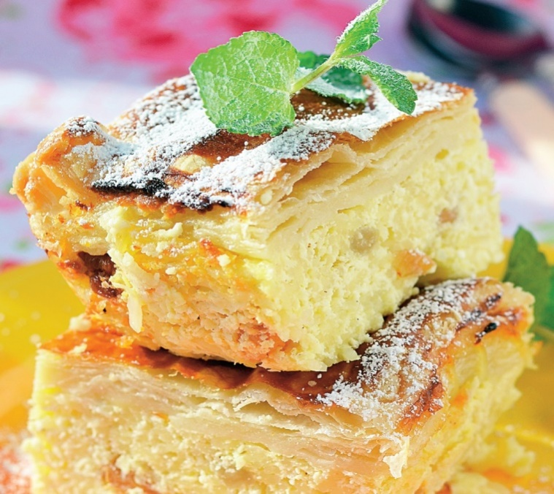

The pie sheetsare unpacked and are counted, then divided into three parts, made up probably of 4-5 sheets. Three piles of sheets are created. We bit the cheese with fork, mix with eggs, sugar and vanilla sugar. It can even mix. Place the base layer of the 4-5 sheets in the greased pan with a little oil each one with very little oil, then pour half the amount of cheese, put another 4-5 sheets, grease with oil, the rest of the cheese and the third part of the sheets, anointed with oil. Cut the pie and grease with the beaten egg mixed with milk, then sprinkle sugar. Bake for about 30 minutes or until it is tender.
SALAD FRUIT – SALATA DE FRUCTE
- 2 apples
- 3 bananas
- 10 strawberries
- 1 pineapple
- 3 kiwis
- 2 oranges
- mint leaves
- honey

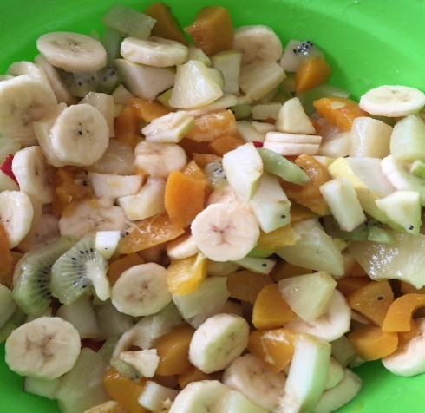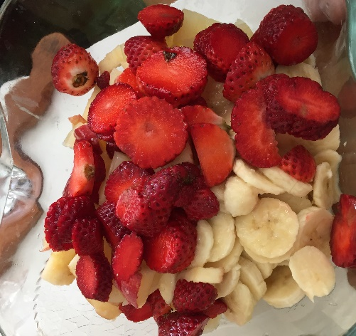

Clean an orange of peel, separate the segments and clean off any white peat remnants. Cut the pieces of orangeand remove any seeds. Place it in a large bowl.Remove thebanana skin and slice it to pieces. We squeeze half of orange juice, taking care not to pour the kernels in the bowl. Clean the pineapple and cut it into cubes, then put it in the bowl, over the other fruits. Decry the kiwi fruit and slice. The strawberries are cleaned and cut in the same way as kiwi fruit.Cut into four the apples and remove the kernel core. Then slice ​​each piece thin and addtheminto salad. Add honey over the fruits. Add the chopped mint leaves and mix them.Let the salad cool for half an hour.

SWEET BREAD - COZONAC

- 1 kg of flour
- 250 grams of sugar
- 450 gr of milk
- 5 eggs
- 60 gr of yeast
- 300 g of butter
- 500 gr of nuts
- 150 gr of chocolate
- 30 gr of lemon peel
- rum essence

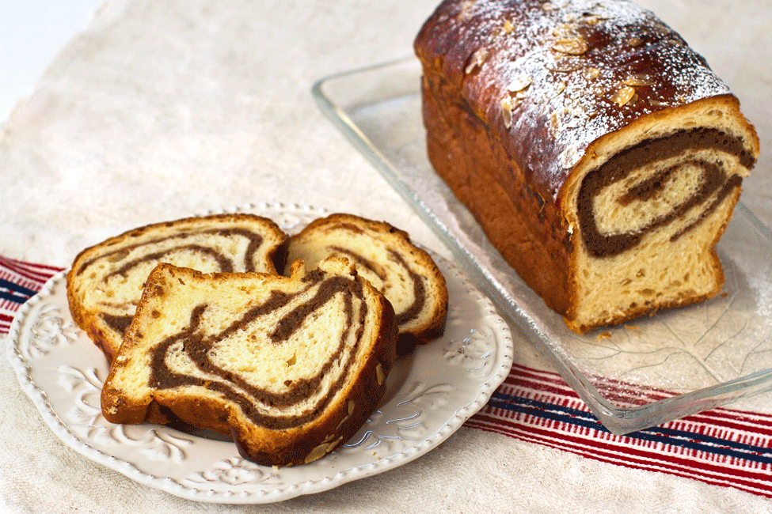
Mix the yeast with 100 ml of milk and three tablespoons of flour. Allow the composition to grow until it doubles its volume.Boil the milk together with the sugar, and the rum then mix until it dissolves.The yolks rub with salt.Put the flour in a bowl and pour it in turn, stirring well, the yolks, the milk together, the melted sugar and the butter. Stir well until a consistent, elastic dough is obtained.The composition obtained is left for about an hour.Then take a piece of dough, spread well, put on the chocolate walnut cream, raisins and the rum The obtained roundabout is cut in two by its length and the two parts thus obtained are knitted and anointed with the egg.Then place it in a pre-packed form and leave it for about two hours.When the dough has grown, the tray isplaced in the oven for about 45 minutes - 1 hour at 160 degrees.

RAISIN COOKIES - FURSECURI

- 200 g of butter
- 150 g of powdered sugar
-3 eggs
- 380 g of flour
- 1 teaspoon of baking powder
- 1 teaspoon of vanilla extract
- 1 salt of salt
- 100 g of raisins
- rum essence

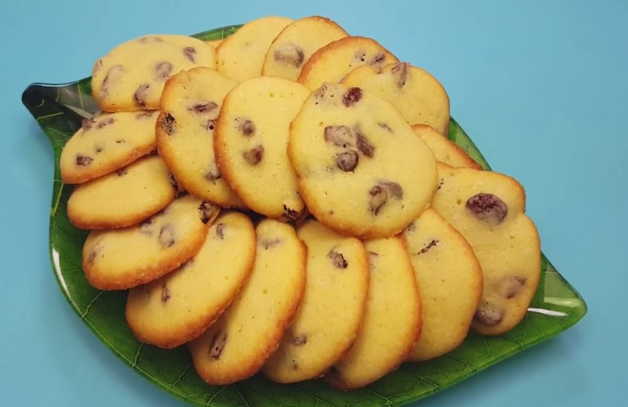

We mix the raisins with rum.In a bowl we mix the butter (at room temperature) with sugar, vanilla extract and salt. Gradually, add the eggs and mix until we get a homogeneous composition. Add the flour mixed with the baking powder and mix well. We add the raisins (+ rom) and mix. The obtained composition is placed in a position provided with a round top.In a taped paper tray with baking paper we turn the cookies with the distance between them. Put the cookies in the preheated oven at 180 C, for about 10-12 minutes. Let the cookies cool down completely and then place them on the plate.

POFTA BUNA!
Hyvää ruokahalua!
καλήόρεξη!
Labu apetīti!!
Bom apetite!!

STUDENT NAMES:
- Creanga Mihai – 8th
- Coman Alin – 8th
- Iosif Amalia – 7th
- Sirbu Miruna – 7th
- Capatana Elena – 7th
- Popescu Andreea – 7th

