Final evaluating questionnaire for students who participated in YEMA project weeks

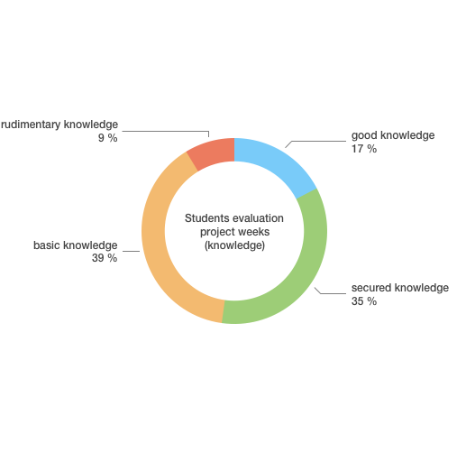

The diagram clearly shows that the majority of the Ingolstadt JMS School students participating in the survey had gained good and secured knowledge about the contents of the six project weeks. However, 48% finished with basic and rudimentary knowledge. The questionnaire was handed out at the end of the project without preliminary recapitulation. This could explain the results.
23 students of year 8 participated in the test.

