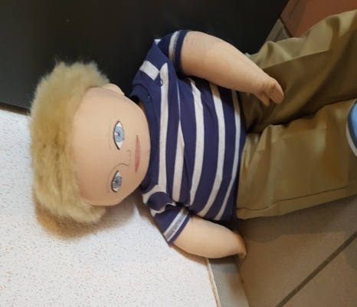
Jonas profile

Name : Jonas, boy
Years : 7

Family : He has a little sister Daphné who is 3 years old and an older brother Tom who is 13. In his father’s home, he shares his room with his sister.
Cultural background : He speaks french and russian because his parents’ father are russian. They lived in Russia but since few weeks they come in France because his grand-father is very sick and has to be recovered.
His mother doesn’t work to take care of the kids. His father works in a factory near to the house.
Where he lives : He lives in Bagnols sur Cèze. His parents are divorced and it makes him sad. So he lives a week in a house with his mother and his step-father and the other week in a flat with his father.
Likes/dislikes/difficulties : At home, he likes play videos games and tablet. He also likes play outside, construction games and playmobil.
At school, he likes mathematics and sports and make him happy. But sometimes it’s difficult for him to do it because he is overweigt. Reading, stay focus on an activity and social relationships are difficult for him.
He is moody when he lost a game, when we laught about him and when he does mistakes.
Food preferences : His favourite food are pastas, french fries and cakes. But he doesn’t like vegetables.
Fears : He is afraid of the dark.
Physical perticularities : He has blond hair and bleu eyes. He is the taller of his class.

Recent story : Jonas loves party such as Easter ou Christmas. He also loves celebrate his birthday. But now it’s going to be difficult because his parents are divorced and he couldn’t celebrate his birthday with the two of them. So children, how can we help him to celebrate his birthday as usual ?

