Lilly
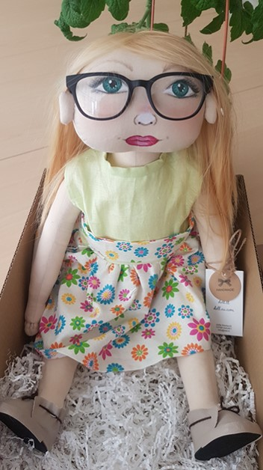
Family: lives with her father and mother. Has two sisters.
Nationality: Lilly was born in Lithuania. Her mom and dad are Lithuanian. In family they talk in Lithuanian.
Likes/differences: likes calm games, but plays active games with good friends. She also likes flipping though books and listening to tales while reading.
Doesn’t like to speak in front of a crowd. Doesn’t like attention, but likes to work while staying unseen, because she’s shy.
Favorite food: Likes to eat pasta, fish, mashed soups, ice cream.
Doesn’t like – tomatoes, porridges.
Fears: Afraid of the dark, anxious about not having friends.
Physical individuality: She is 4 years old now, bright hair, green eyes. Wears glasses.
History: Lilly likes to play with friends, but only with ones, who she knows well. When she doesn’t know anyone in a group, she won’t dare to approach and speak to them, so she feels very lonely. Lilly wants to make friends and play with others, but isn’t brave enough. How do you make friends? What would you suggest to Lilly?

