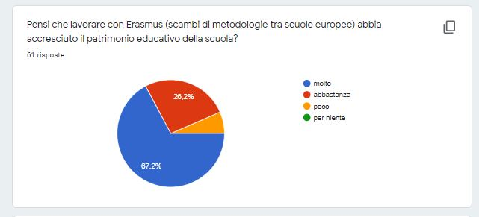
Do you think that working with Erasmus (exchange of methodologies among European school, has enhance the professional heritage of school?
67% a lot, 26,2% quite a lot,

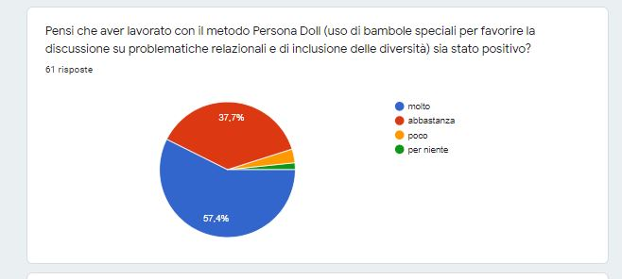
Do you think that it has been positive to have worked with Persona Doll Methodology (using special doll to promote and foster relationship, inclusion, etc.)?
57% a lot, 37,7% quite a lot

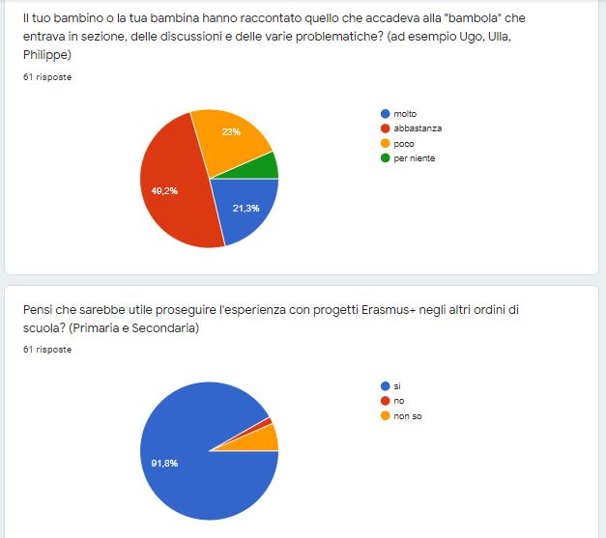
Does your child tell you what happened to the “doll” when she came into the class?
49,2% quite a lot, 23% a little, 21,3% quite a lot,

Do you think it is useful to go on working with Erasmus activities in the primary and secondary school?
91,8% yes

