COUNTRY | LITHUANIA
MONTH/YEAR | NOVEMBER-DECEMBER-2020
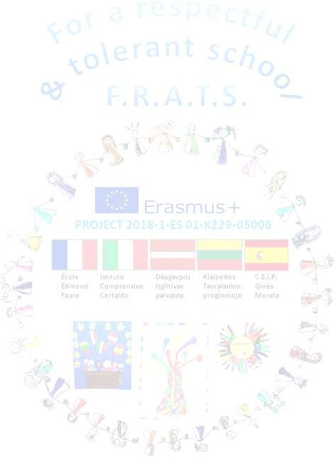
The timeline was changed because COVID-19 The project was extended. A new timeline - September 20 July 21- was created
 | Activity description |  | Status(completed, in process/not com.) | Evidences | Uploaded to e-twinning (yes/no)
 |  | A-CHILDREN/TEACHERS/FAMILIES ACTIVITIES
1- | Good mate rules: how to take care of the others; respect of the others. |  | Completed | Stories, pictures, | Yes
2- | “Under the same sun” activity with the help of families |  | Completed | Pictures, video | Yes
3- | Christmas cards |  | Completed | Video, pictures | Yes
 |  | B- PROJECT TEAM ACTIVITES
1- | Coordination of the different activities in the classes. Preparation of the materials |  | Completed | video | Yes
2- | Organizing videoconference with Italy |  | In progress |  | Yes
 |  | C- INTERNATIONAL COORDINATION
1- | “Under the same sun” coordination |  | Completed |  | Yes
2- | International day of persons with disabilities |  | Completed |  | Yes

PROBLEMS | IMPROVEMENTS | OTHERS
Due to Covid-19 our team was not able to  participate to videoconference. | We will meet next month

