Ines story
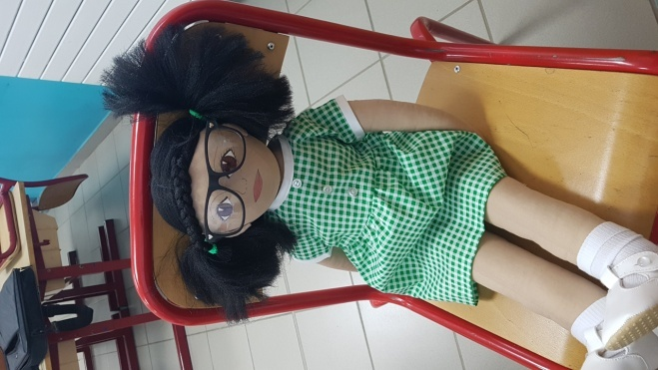
Name : Ines, girl
Years : 7

Family : She has got no brother or sister. She lives with her mother and her dad. She helps her mother all the time. As they have few money, her mother mades her clothes or she wears clothes which are given by people. Sometimes, the others children laught of her because she doesn’t wear like them. She feels different so she is shy.
Cultural background : She speaks French and Portuguese because her father is Portuguese.
His mother works as a cleaner. His father doesn’t work because he doesn’t speak French very well.
Where she lives : She lives in Avignon in a mobil-home on a land.
Likes/dislikes/difficulties: At home, she likes reading and playing with dolls. She also likes pick flowers and stay outside dreaming.
At school, she is very applied and she listens very well her teacher. She works very well. Sometimes, she is rejected by the others because they think she is to reasonable. She loves going at school but since soon, she has to wear glasses and the others are laughing of her. It makes her sad. She has a single friend with who she plays all the time.
She loves being with her cousins and playing with them. They live in a big house. Ines wish have a house like them and she would like live with them. She also likes seeing her grands parents. She doesn’t see them often because they live in Portugal.
Food preferences : She eats all expect cheese.
Fears : She is afraid of being alone when her friend isn’t at school. She also fears of breaking her classes or stuff because its cost a lot and her parents don’t have a lot of money.
Physical particularities : She has brown hair and brown eyes.
Recent story : She has difficulties to speak to the others but she wants to do because she wants the others stop laughing of her.

