COUNTRY | LITHUANIA
MONTH/YEAR | MARCH-APRIL-2021
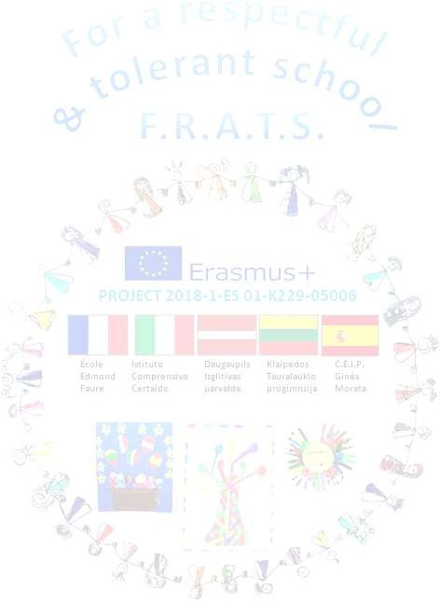
The timeline was changed because COVID-19 The project was extended. A new timeline - September 20 July 21- was created
 | Activity description |  | Status(completed, in process/not com.) | Evidences | Uploaded to e-twinning (yes/no)
 |  | A-CHILDREN/TEACHERS/FAMILIES ACTIVITIES
1- | Autism’s day |  | Completed | Photos
2- | Earth day |  | Completed
 |  | B- PROJECT TEAM ACTIVITES
1- | Organizing the online final event in June |  | In progress
 |  | C- INTERNATIONAL COORDINATION
1- | Plan a glossary of our project in our national language |  | In progress
2- | Translating and uploading Persona dolls profile, stories and activities to etwinning |  | In progress

PROBLEMS | IMPROVEMENTS | OTHERS

