OUR DOLLS
LITHUANIA
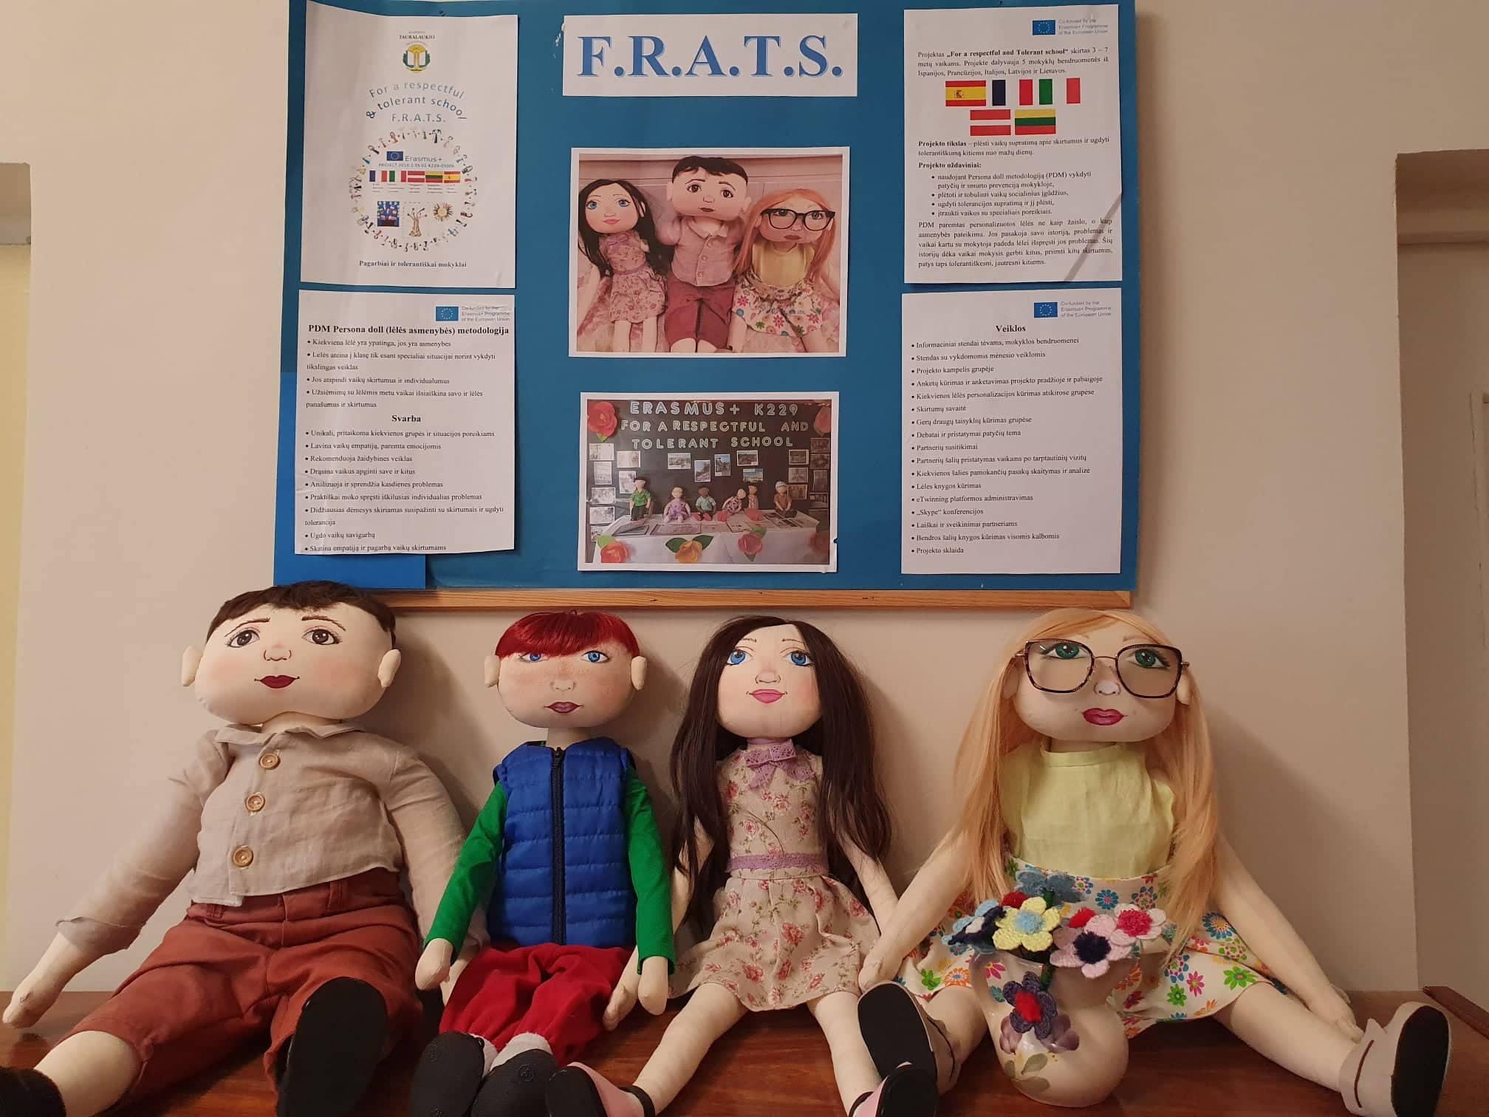

Lilly
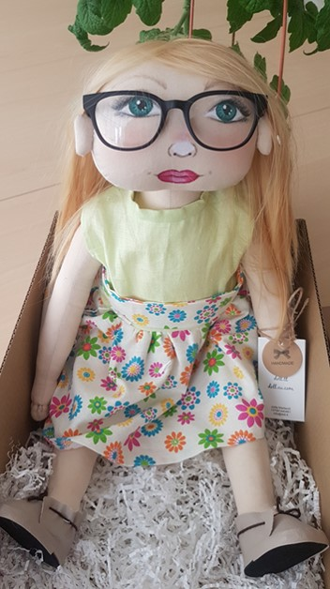
Family: lives with her father and mother. Has two sisters.
Nationality: Lilly was born in Lithuania. Her mom and dad are Lithuanian. In family they talk in Lithuanian.
Likes/differences: likes calm games, but plays active games with good friends. She also likes flipping though books and listening to tales while reading.
Doesn’t like to speak in front of a crowd. Doesn’t like attention, but likes to work while staying unseen, because she’s shy.
Favorite food: Likes to eat pasta, fish, mashed soups, ice cream.
Doesn’t like – tomatoes, porridges.
Fears: Afraid of the dark, anxious about not having friends.
Physical individuality: She is 4 years old now, bright hair, green eyes. Wears glasses.
History: Lilly likes to play with friends, but only with ones, who she knows well. When she doesn’t know anyone in a group, she won’t dare to approach and speak to them, so she feels very lonely. Lilly wants to make friends and play with others, but isn’t brave enough. How do you make friends? What would you suggest to Lilly?

Lilly's story

Lilly has two good friends in the class who play and keep company with her. She tells them about herself, her weekends and feels confident.
When Lilly's friends are ill and don't come to the class, she feels unhappy and spends her free time alone, because she is afraid to come up and speak to others.
During the whole month children and their parents were preparing presentations about their pets. Today is the day when they have to show the work. Already at home Lilly pleads her mother not to take her to the kindergarten. Her mother encourages her, but Lilly is still worried. When presentations begin she sits with friends and repeats: "I don't want to", "I'm afraid", "What if they laugh". When it is time for Lilly's presentation, she doesn't go to present. After her teacher encourages her, she stands up and in a shivering voice presents her pet. Everyone listens in silence, no one laughs, although Lilly still feels anxious, because she thinks she got something wrong.
What do you think, Why? What could you do to make her feel better? How could you encourage her?

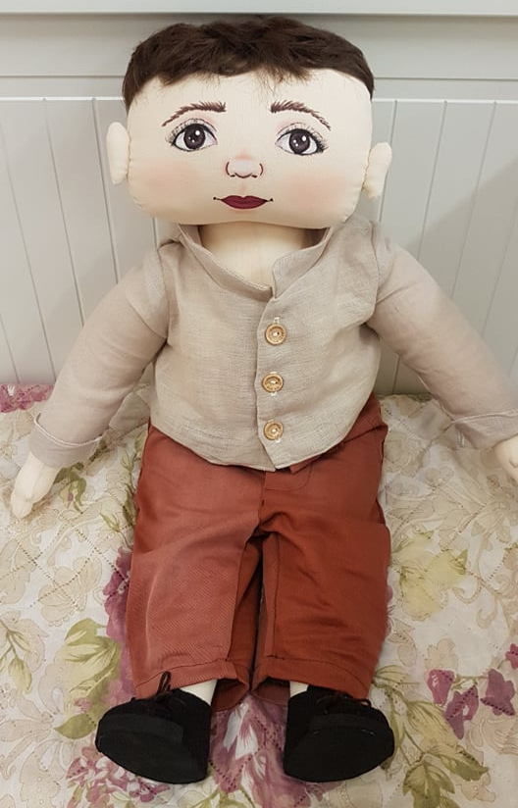
Doll Etan
Family: lives with his father and his mother. Has an older brother.
Nationality: Eric was born in Lithuania. His parents are Lithuanians. They speak Lithuanian between themselves.
Likes/ differences: likes being with friends, playing active games, running, helping grownups. Likes to eat a lot.
Doesn’t like being laughed at. Doesn’t like tabletop games, educational activities done on or by the table.
Favorite food: likes dishes from meat, sweets.
Doesn’t like – curd, pasta.
Fears: afraid of insects, being alone.
Physical individuality: now he’s 5 years old, dark hair, brown eyes. He is of heavy build.
History: Etan really likes running, but often when running he trips over his friends or objects and falls over. Etan really wants to make friends, but sometimes he shows his emotions too strongly and hurts his friends, sometimes – without intention. Friends avoid Etan because they fear that he will hurt them and they also laugh at him because of his obesity. Then Etan feels bad because he is clumsy due to his obesity.

Etan story

One Wednesday Etan came to the kindergarten happy, in a good mood, talked to friends. During the morning circle listened to teacher's stories, actively participated in activities. After the activities, kids were getting ready to go outside. Etan was happy, that he‘d get to go outside, from the joy he hugs his friend too strongly and makes him fall over. The friend gets angry, because it wasn‘t fun for him, that Etan hugged him without a warning and the other kids got frightened when they fell over. Etan always tries to be nice, so apologizes to his friend nicely and promises to try not to do this again.
Etan being in a hurry trips over other kids. The kids get angry that he‘s fat and always trips over things. Firstly, Etan tries to apologize to everybody, but the kids start laughing at him, calling him names. The boy asks his friends to stop doing that, but they don‘t listen to him and keep laughing. Etan starts to cry. His friend’s words hurt him. One boy comes closer to Etan, pushes him, says that Etan is fat, and always blocks the way. Etan gets angry and starts pummeling his friend. He gets angry because he always tries to be good, to apologize after hitting his friends accidentally, but his friends make fun of him because of his obesity, laugh at him and push him. The teacher splits them apart and, after going outside, gets everyone to sit in a circle and talk.
How does Etan feel?
Why did Etan do this?
Why do other kids make fun of him?

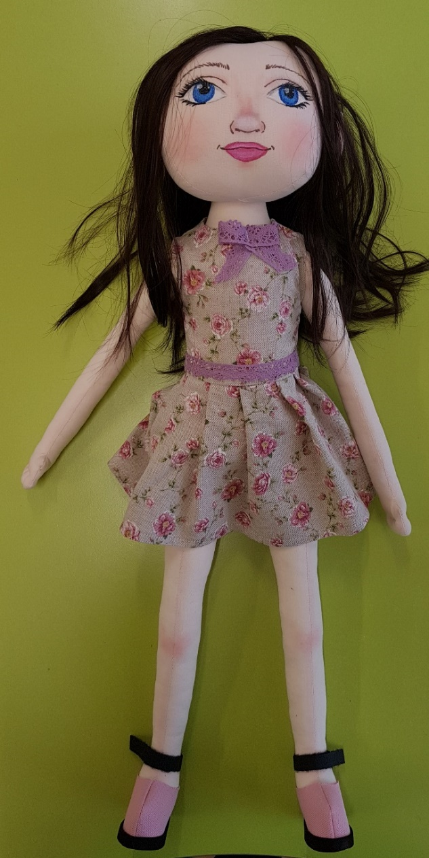
Doll Aretė
Family: lives with her parents. She’s the only child.
Nationality: Aretė was born in Lithuania. Her mother is Russian, farther – Lithuanian. Between themselves they talk in Lithuanian. Her Russian grandparents live nearby. She spends a lot of time talking to her grandparents in Russian
Likes/ differences: The girl likes to draw. Playing with her cat. She likes spending time with her grandparents.
Avoids noise and rules. Has trouble understanding general assignments. Doesn’t like being with a lot of people. Sensitively reacts to failures.
Favorite food: Likes fruits, salads, buns, sweets.
Doesn’t like – raisins, fish.
Fears: Aretė fears making mistakes. She fears, that her family will find out about them. She’s very afraid of losing her close ones.
Physical attributes: She’s 6 years old now. She has brown hair, light blue eyes. She’s smaller than her peers.
History: The children got an assignment and started working. Aretė didn’t hear the task and was too afraid to ask. She made it differently – wrongly. A boy sitting nearby said: “What did you do?” Now scared, she is afraid to show her work. She hides it.
Doll Aretė story

Monday morning. The children are gathering at the group. Waiting for the start of the activity, they divide into smaller groups. Some of them are playing, others – building. Aretė comes to the group. She doesn’t stop talking about her weekend with her grandparents. She uses a lot of Russian words and sayings in her speech. The children keep minding their own business and don’t start a conversation with the girl.
The activity had started. The children began to work, but Aretė wanted to talk about anything, but that. Finished, everyone is showing the result of their work, explain, why they did it like that. Aretė stays quiet. The educator asks if she did it. Aretė gets angry. Kids nearby keep encouraging her: “Tell her”, “Why are you not saying anything?”, “Just say it in Lithuanian”. She keeps quiet. One boy shouts: “She doesn’t know how to do anything, that’s why shy always quiet”.
Aretė can’t hold her emotions back. She pushes a kid next to her, hits another. She hunches over and stays quiet.
What would you say to Aretė…

Activities with dolls

Children welcomed our dolls with a big curiosity, were a little bit shy. They listen dolls' stories attentively, told about themselves with pleasure and welcomed them as friends.
After they had listened Arete's story, children recommended how to contain animosity. Kids played a game "Traffic-light", which thought kids and Arete to stop and think before doing or saying anything when you are angry.
We thought Arete to show her animosity, but not hurt kids. We learned to breathe, blew balloons and let the air out of them. The game thought kids to let animosity out, so it doesn't blow up like a balloon.

The story of a doll Ethan thought us nice behavior with kids, who are different. We laid out cards and created stories, talked about helping a friend, not laughing at him/her.
We tried to feel what the other person experiences while being laughed at, what we could change in our behavior to make Ethan feel better.
We watched an animated movie, which reminded us that everyone is important, we should help each other and never give up.

https://www.facebook.com/psichologijosnamai/videos/2144138198996477/?t=8

Activities with dolls help us to develop children's social skills, make speak who are too shy to say about their feelings. While helping the dolls, children learn to communicate and to work together, find answers to their questions.

