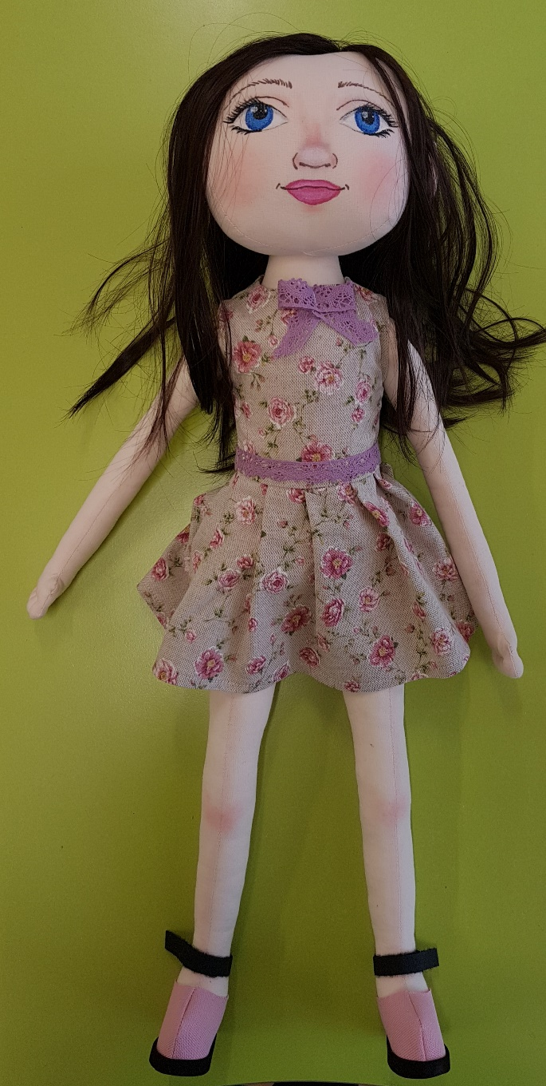
Doll Aretė
Family: lives with her parents. She’s the only child.
Nationality: Aretė was born in Lithuania. Her mother is Russian, farther – Lithuanian. Between themselves they talk in Lithuanian. Her Russian grandparents live nearby. She spends a lot of time talking to her grandparents in Russian
Likes/ differences: The girl likes to draw. Playing with her cat. She likes spending time with her grandparents.
Avoids noise and rules. Has trouble understanding general assignments. Doesn’t like being with a lot of people. Sensitively reacts to failures.
Favorite food: Likes fruits, salads, buns, sweets.
Doesn’t like – raisins, fish.
Fears: Aretė fears making mistakes. She fears, that her family will find out about them. She’s very afraid of losing her close ones.
Physical attributes: She’s 6 years old now. She has brown hair, light blue eyes. She’s smaller than her peers.
History: The children got an assignment and started working. Aretė didn’t hear the task and was too afraid to ask. She made it differently – wrongly. A boy sitting nearby said: “What did you do?” Now scared, she is afraid to show her work. She hides it.

