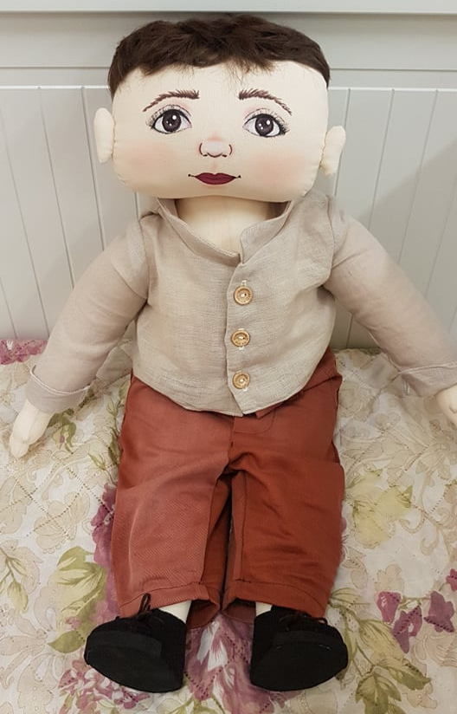
Doll Etan
Family: lives with his father and his mother. Has an older brother.
Nationality: Eric was born in Lithuania. His parents are Lithuanians. They speak Lithuanian between themselves.
Likes/ differences: likes being with friends, playing active games, running, helping grownups. Likes to eat a lot.
Doesn’t like being laughed at. Doesn’t like tabletop games, educational activities done on or by the table.
Favorite food: likes dishes from meat, sweets.
Doesn’t like – curd, pasta.
Fears: afraid of insects, being alone.
Physical individuality: now he’s 5 years old, dark hair, brown eyes. He is of heavy build.
History: Etan really likes running, but often when running he trips over his friends or objects and falls over. Etan really wants to make friends, but sometimes he shows his emotions too strongly and hurts his friends, sometimes – without intention. Friends avoid Etan because they fear that he will hurt them and they also laugh at him because of his obesity. Then Etan feels bad because he is clumsy due to his obesity.

