COUNTRY | LITHUANIA
MONTH/YEAR | FEBRUARY-2021
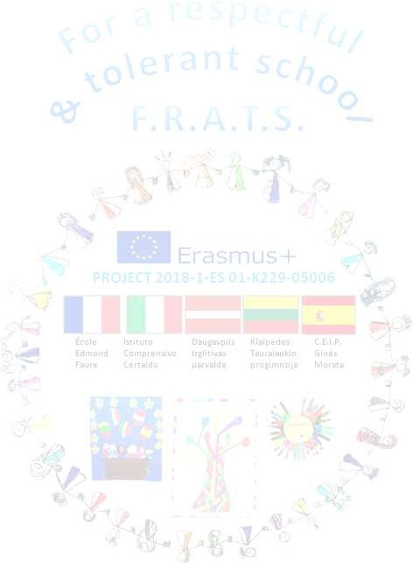
The timeline was changed because COVID-19 The project was extended. A new timeline - September 20 July 21- was created
 | Activity description |  | Status(completed, in process/not com.) | Evidences | Uploaded to e-twinning (yes/no)
 |  | A-CHILDREN/TEACHERS/FAMILIES ACTIVITIES
1- | Valentine’s day |  | Completed | Photos
 |  | B- PROJECT TEAM ACTIVITES
1- | Organizing videoconference with Italy |  | Completed | Photos | Yes
 |  | C- INTERNATIONAL COORDINATION
1- | Plan a glossary of our project in our national language |  | In progress

PROBLEMS | IMPROVEMENTS | OTHERS

