EVALUATION 1st TRAINING EVENT-ALMERIA

Please indicate how much you agree with the following statements
by circling your response using the scale provided, where
1 = Strongly Disagree and 5 = Strongly Agree.

1. The meeting purpose and objectives were clearly stated. *
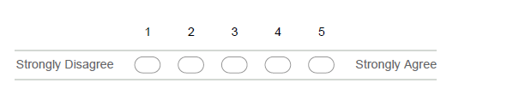

2. Our meeting time was convenient for me. *
.
3. Our meeting place was convenient for me. *
.
4. We shared decision-making at this meeting. *
5. All meeting participants were actively involved. *
6. We used our meeting time effectively. *
7. The meeting contributed to the planned progress of the project. *
8. I am satisfied with this meeting.I enjoyed this meeting. *

Please, write down your comments about these questions
9. What aspects of this meeting were particularly good? *
__________________________________________________________________________________________________________________________________________________________________________________________________________________
______________________________________________________________________

10. What aspects of this meeting were particularly bad? *
__________________________________________________________________________________________________________________________________________________________________________________________________________________
______________________________________________________________________

11. Do you have additional comments about this meeting? *
__________________________________________________________________________________________________________________________________________________________________________________________________________________
______________________________________________________________________

12. What recommendations do you have for improving future meetings? *
__________________________________________________________________________________________________________________________________________________________________________________________________________________
______________________________________________________________________

13. Anything else?
__________________________________________________________________________________________________________________________________________________________________________________________________________________
______________________________________________________________________

