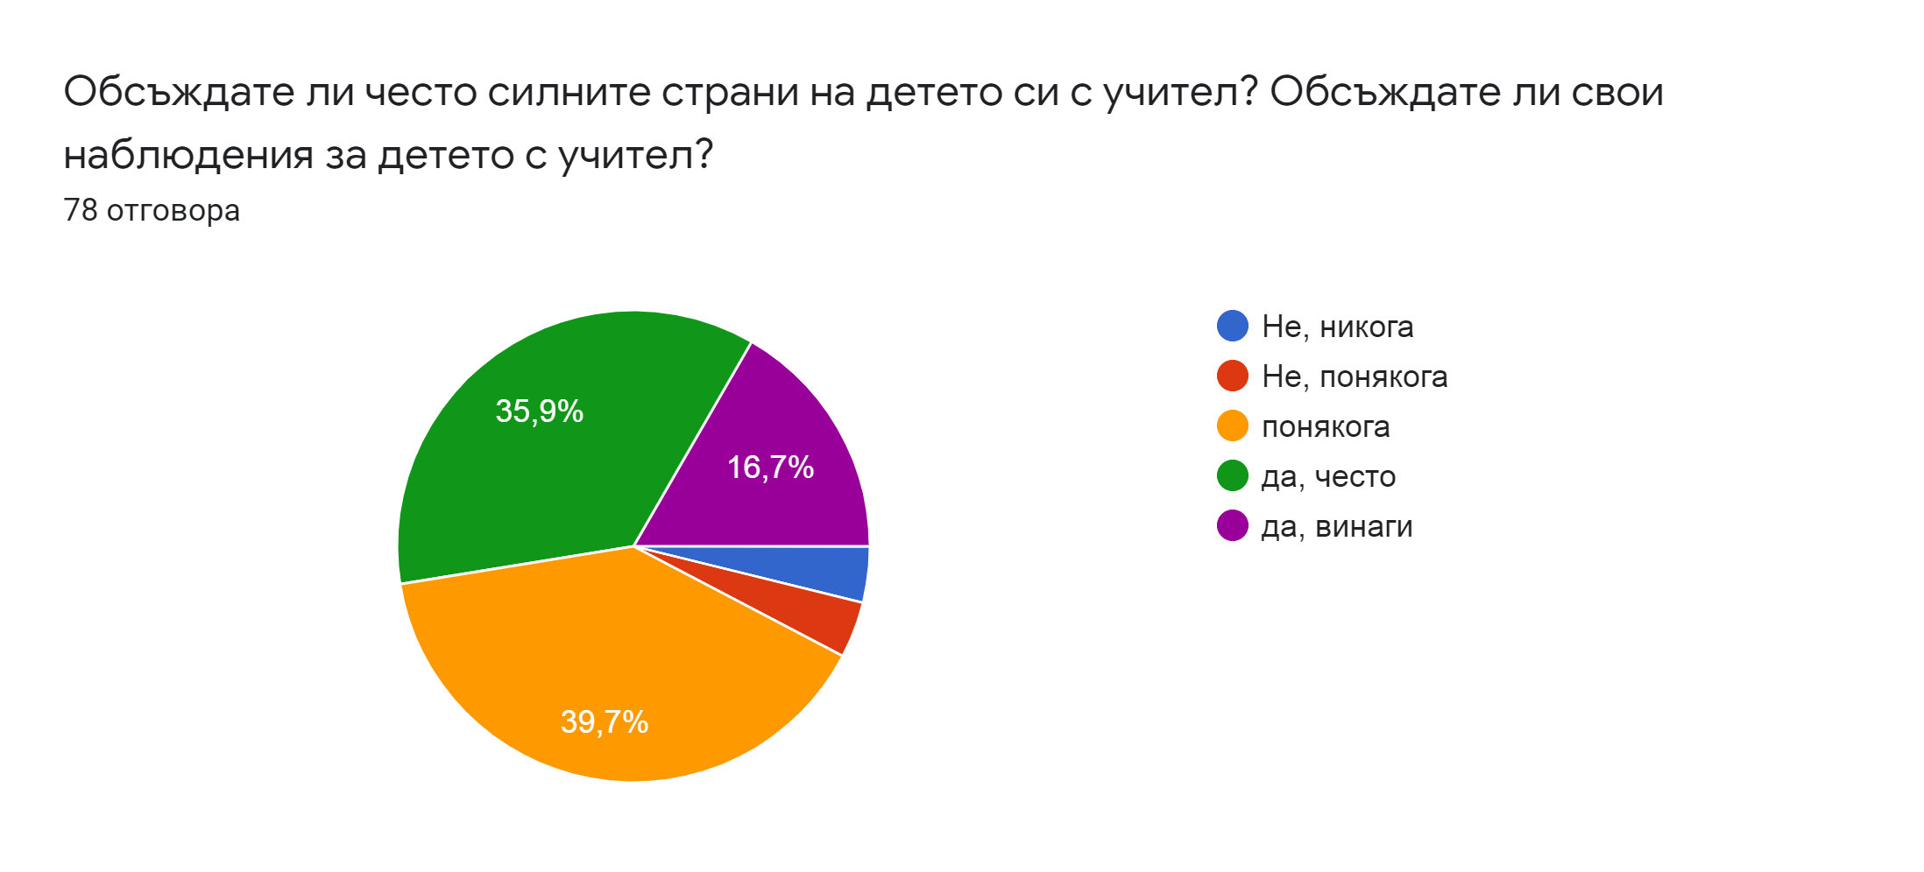
Do you often discuss your child's strengths with group teachers?
Do you discuss your observations with the teacher that are particularly good for the child
o No, never
o No, rarely
o Rare
o Yes, often
o Yes, always
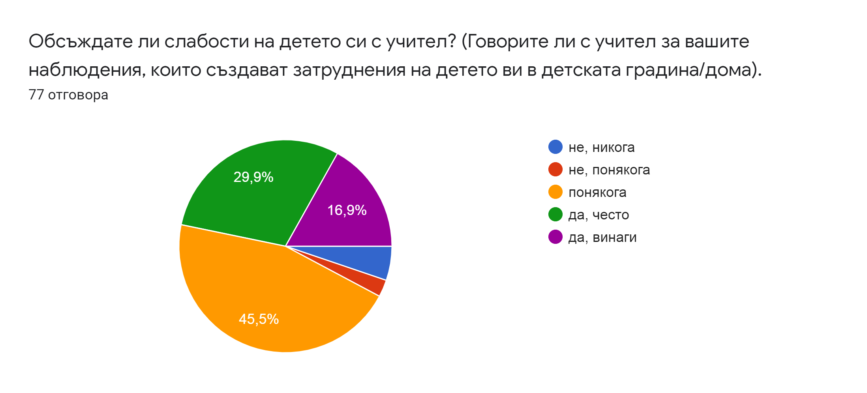
Do you often discuss your child's weaknesses with the group teachers?
Do you talk to your educator about your observations that are causing your child difficulties in kindergarten / home
o No, never
o No, rarely
o Rare
o Yes, often
o Yes, always

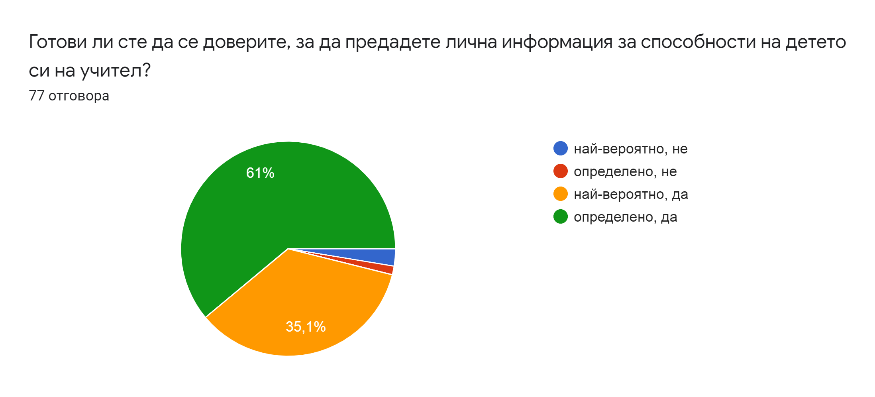

Are you willing to trust to pass sensitive information about your child's abilities to group teachers?
o Most likely, no
o Definitely not
o Most likely, yes
o Definitely, yes
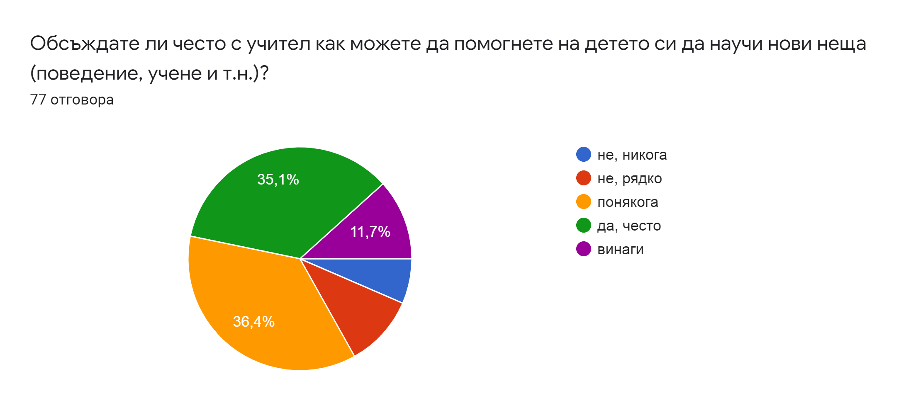
Do you often discuss with teachers how you can help your child learn new things (behavior, learning, etc.)?
o No, never
o No, rarely
o Rare
o Yes, often
o Yes, always

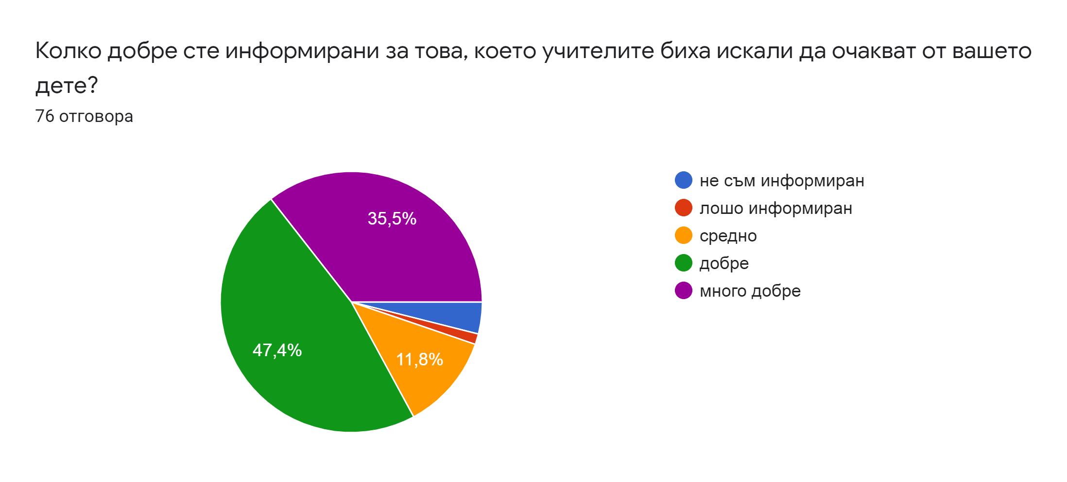
How well informed are you about what educators would like to expect from your child?
o Very bad
o Bad
o On average
o Good
o Very well
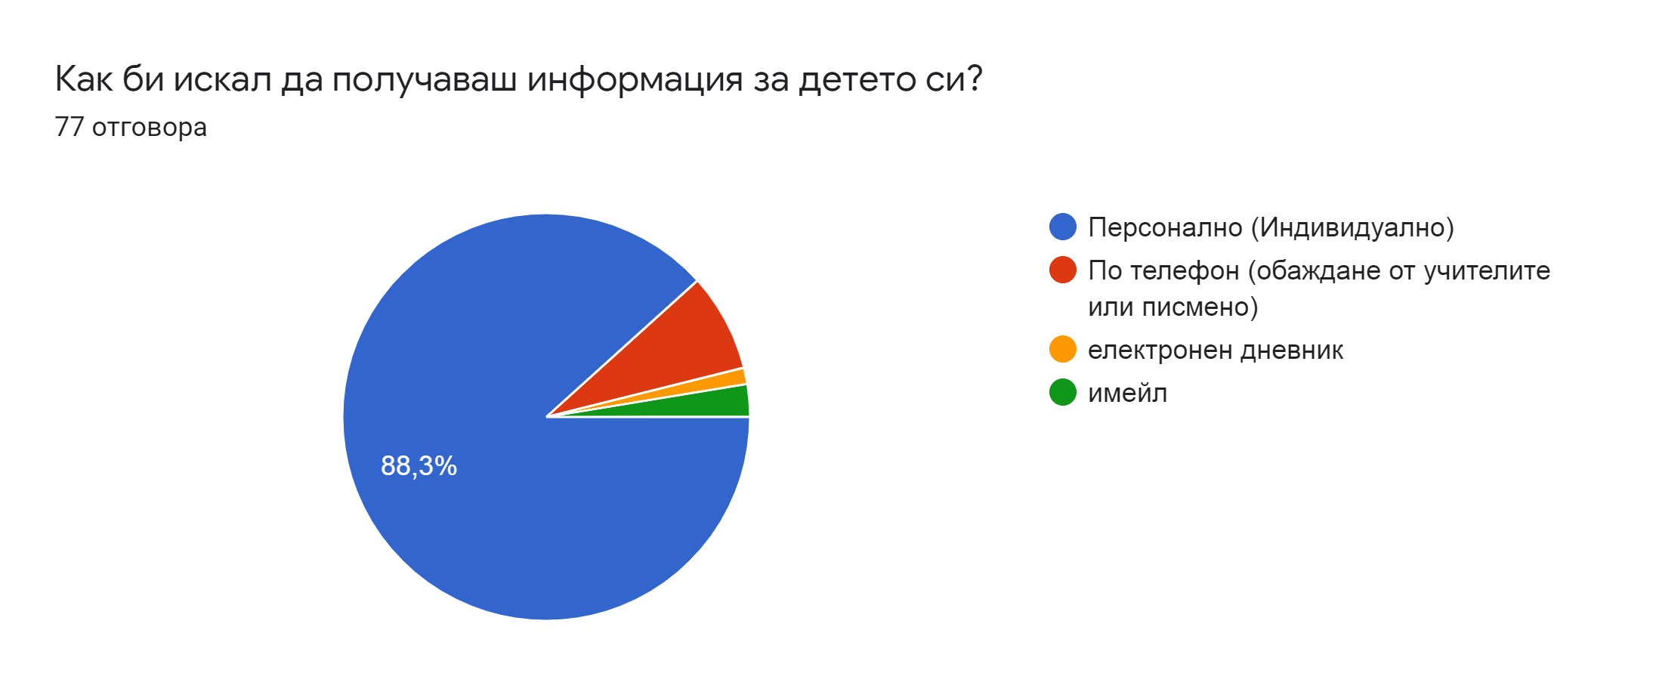
How would you like to receive information about your child?
o In person (Individual talks)
o By telephone (by calling teachers or in writing)
o ELLIS system
o By email

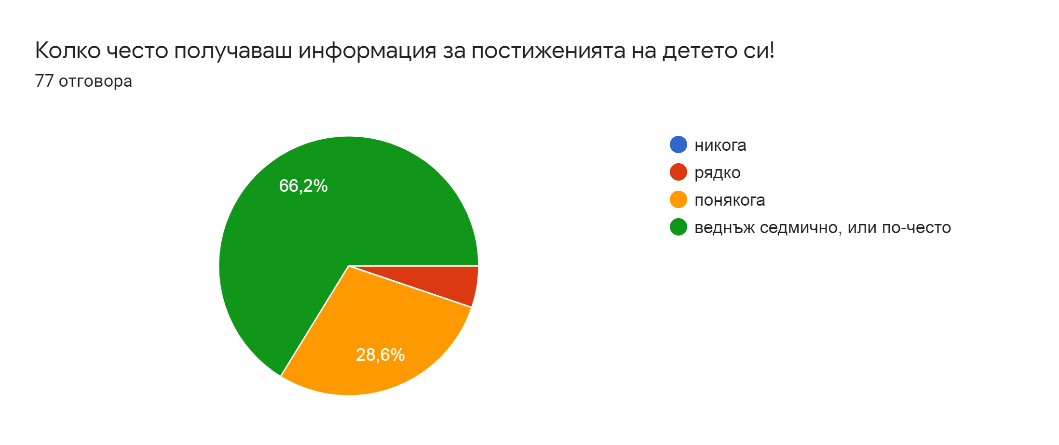
How often do you receive information about your child's achievements?
o Never
o Rare
o Sometimes
o Once a week or more often

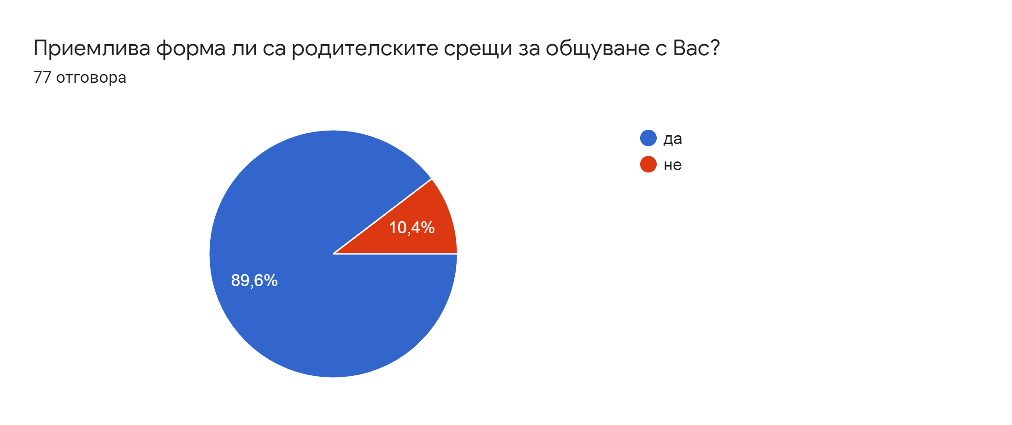
Is the meeting of parents and educators organized in a form of meeting acceptable to you?
· Yes
· No.
Please suggestions on how you would like to work with educators
Individually
My child's teaching staff is wonderful. They inform us, give the best of themselves. I don't think there is anything I would change.
Individually - online or direct contact
From my observations so far I can say that our teachers are exceptional professionals, work well, I have no other requirements
I would like teachers to give me information individually about my child's shortcomings and what I could do at home.
As usual!
Personal, personal meeting between teacher and parent.
Individually
To discuss the needs, rules and achievements of the child.
Individually
I would like to receive information from the teacher every day about how the child's day went, sleep and eat
An electronic diary would be a good idea in the current situation and when there is not enough time for conversations
Individually.
Individually, if necessary
Personal contact when discussing this topic is most important.
According to the situation
Direct connection with a teacher. Assistance and support of teachers to be able to provide a favorable environment for children.
To help as much as I can and with what I can for my child's education
Have a specific day and time for meetings and questions
Through social networks - facebook
If it is necessary to close the kindergartens, to conduct online classes on the teaching materials.
I would like to talk face to face, to discuss the child's progress in kindergarten, to know how he develops, what he lacks, what to emphasize
The cooperation is still fruitful, the personal contact gives the best idea of ​​the child's achievements in the activities and a way should be found for its further implementation.
Daily communication with a teacher about the past day.
I would like to have constant information about everything.
Individually, by phone, by email, all forms and ways of contact are useful.
Teachers and parents communicate freely, to work as a team for good education of the child.
TO RECEIVE INFORMATION EVERY DAY WHEN I COLLECT IT FROM KINDERGARTEN
In person by phone
In our group/kindergarten we have very good communication with the teachers. When they have to comment on something about the child's behavior or requirements, they tell us personally and so we can have a dialogue, with each party giving their opinions and suggestions.
As a parent, I also have no worries about turning to educators to share my views on the child's upbringing and habits.
If possible in person. By phone, meetings or in writing.

