1.Do you often discuss your child's strengths with group teachers?
Do you discuss your observations with the teacher that are particularly good for the child
o No, never
o No, rarely
o Rare
o Yes, often
o Yes, always

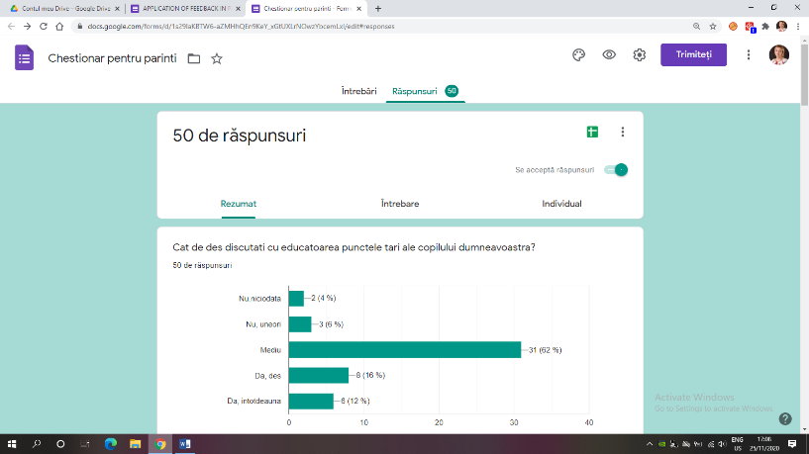

2.Do you often discuss your child's weaknesses with the group teachers?
Do you talk to your educator about your observations that are causing your child difficulties in kindergarten / home
o No, never
o No, rarely
o Rare
o Yes, often
o Yes, always
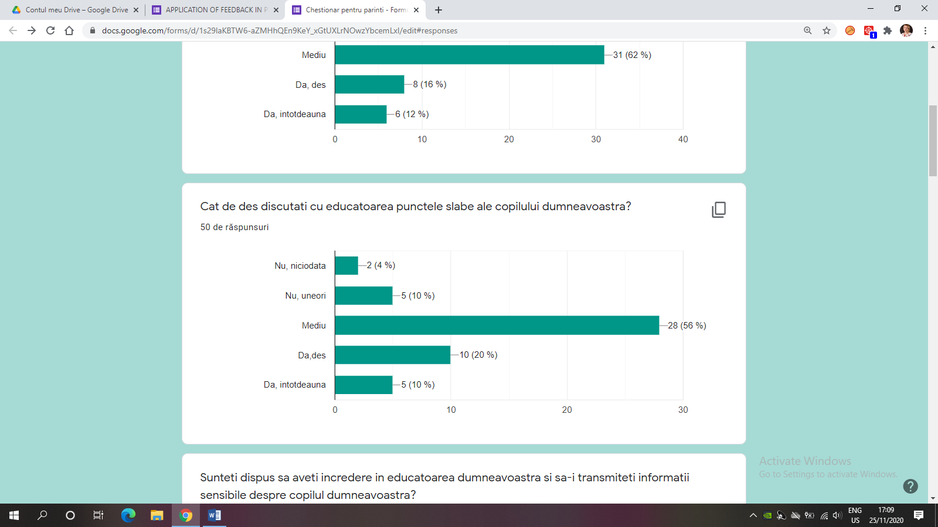

3.Are you willing to trust to pass sensitive information about your child's abilities to group teachers?
o Most likely, no
o Definitely not
o Most likely, yes
o Definitely, yes

4.Do you often discuss with teachers how you can help your child learn new things (behavior, learning, etc.)?
o No, never
o No, rarely
o Rare
o Yes, often
o Yes, always

5.How well informed are you about what educators would like to expect from your child?
o Very bad
o Bad
o On average
o Good
o Very well

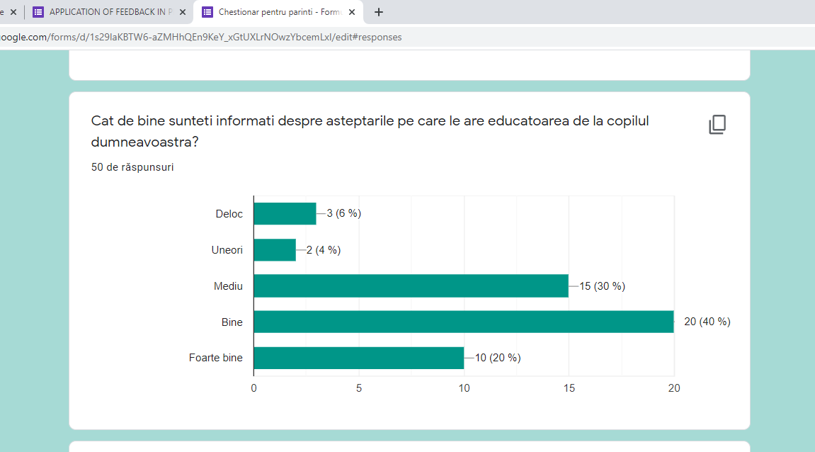

6.How would you like to receive information about your child?
o In person (Individual talks)
o By telephone (by calling teachers or in writing)
o ELLIS system
o By email

7.How often do you receive information about your child's achievements?
o Never
o Rare
o Sometimes
o Once a week or more often

8.Is the meeting of parents and educators organized in a form of meeting acceptable to you?
· Yes
· No.

Please suggestions on how you would like to work with educators:
Written communication
It's not necessary
More frequent communications
Parents' visits in kindergarten
We want school face to face.
Easy online communication
Online communication suggestions
I have no suggestions
Thank you!
The collaboration is already very good.
My opinion this year will be very difficult for children, for teachers and new parents with the online program because they are too young to have the patience to sit and listen to what they have to do. I imagine that at school they are not very patient but on the phone less. Otherwise, I am satisfied with the collaboration with the teacher and with the patience she has with the children. Thank you
To keep classes at school not at home
Involvement of kindergarten in community activities
Online communication
Fun activities for children outside kindergarten
I have no other suggestions
I don't have any suggestions at the moment ...
Quality synchronous and asynchronous communication
Difficulties in online collaboration
Online communication is very difficult
More frequent joint meetings
There should be more activities in kindergarten in which we parents can participate together with the educator and the children.
Individual face-to-face communication
I have no suggestions

