Activity A11
Ss become producers of their simple visual production in school. Ss take photos of everyday objects in different ways following directions. They take photos of the item: “as we usually see it”, “as an element of social interaction”, “as we would have never seen it”, “as a hero of a children’s fairy tale”, “as the object of an advertisement campaign”.

- An item “as we usually see it” – A plastic bottle
We drink out of our bottles on a daily basis. We fill them with water and this keeps us hydrated whilst at school, and allows us to concentrate better. Plastic water bottles are convenient and easily used.

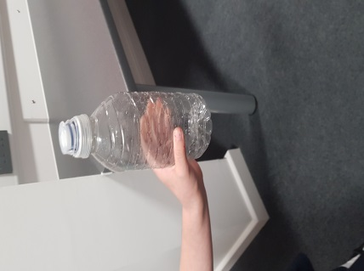

- The item “as an element of social interaction”
We drink out of our bottles during playtime and lunchtime with our friends. This gives us an opportunity to ‘chat’ and catch up with each other. This is one of our favourite parts of the day.

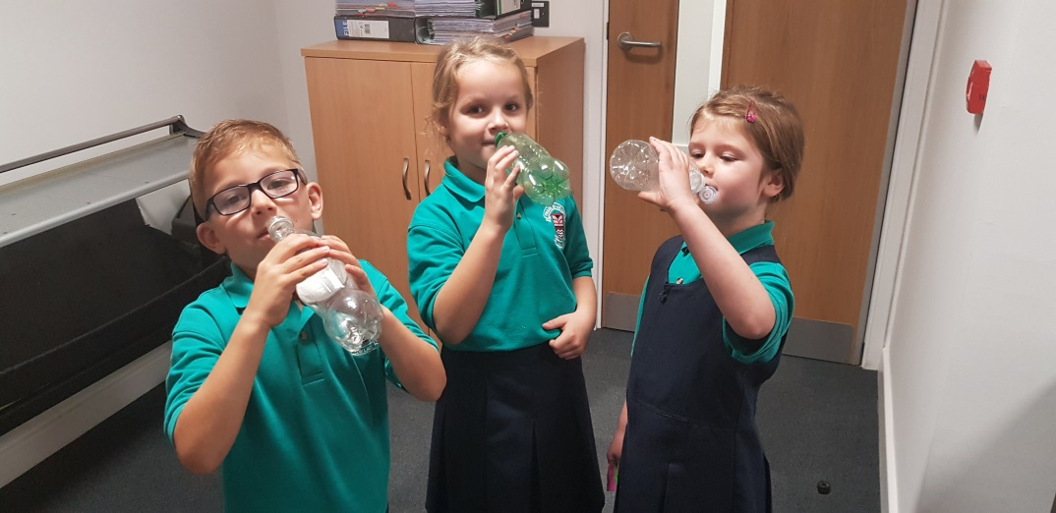

- The item as “we would have never seen it”
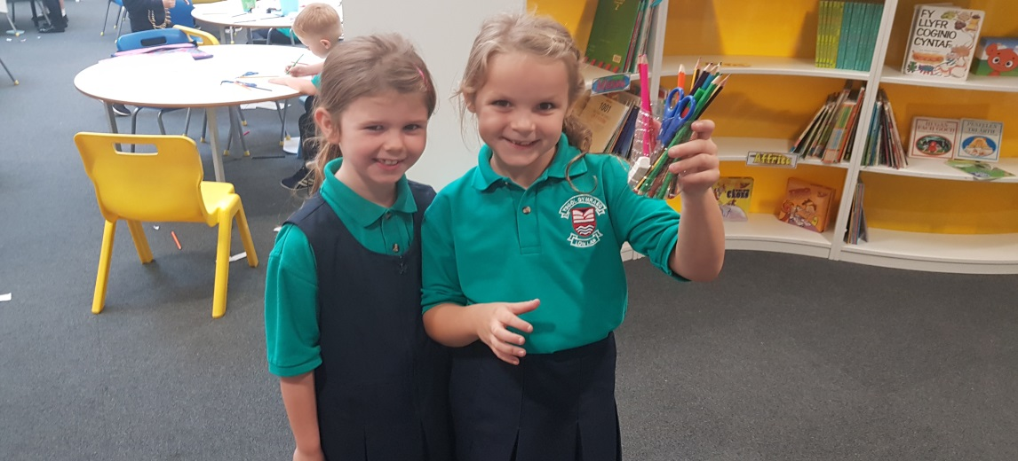
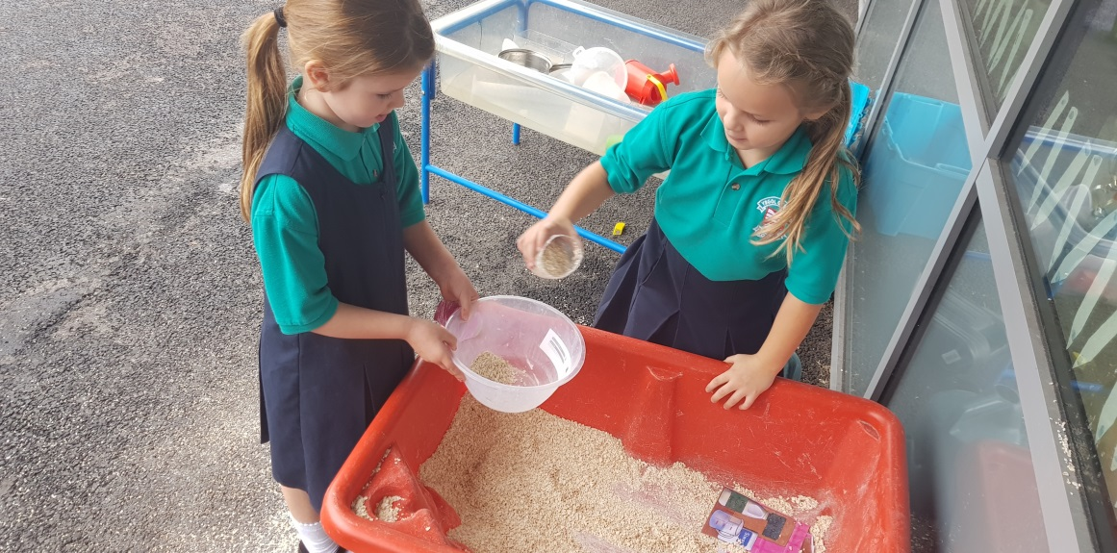
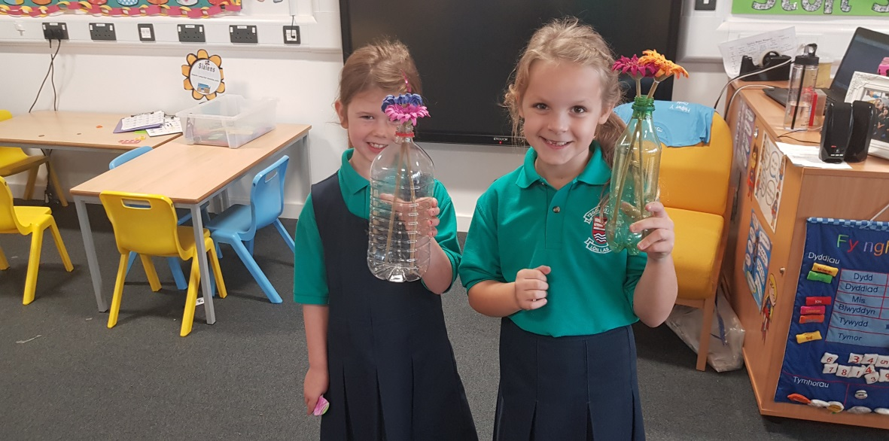
We have used our bottle to hold our stationery, as a flower vase and as a cup. We have also called one of our bottles ‘Bob’ the Superhero.

“We would like to introduce you to ‘Bob’ our supehero….”

