OUR TENNIS BALLS PROJECT
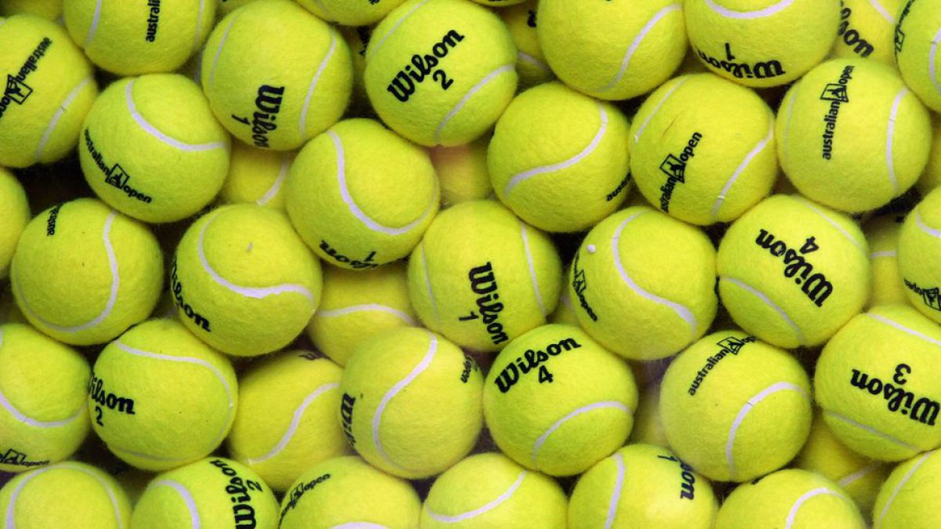

1.-In real situation
Students in 2nd grade take pìctures of tennis balls in actions. Althoug they are used specially at free time after school, during the breaks they use tennis balls to play another kind of game, typical from the North of Spain, called” Vasque ball”. Played against the walls of the school buildings.

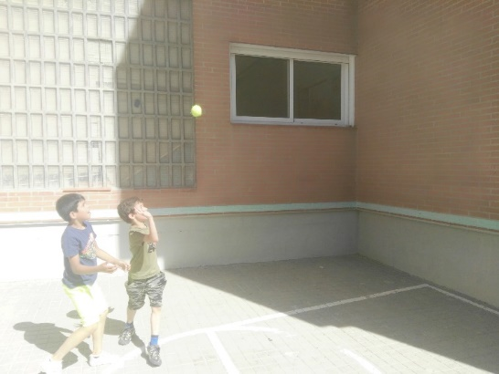
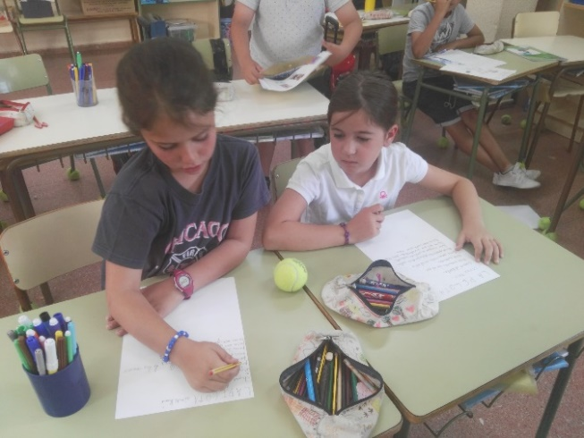
2.- As an element of social interaction
Students discuss about different aspects of the ball: materials it is made of inside, covering of the ball, size, trade mark, weight, ….

3.-As we would have never seen it
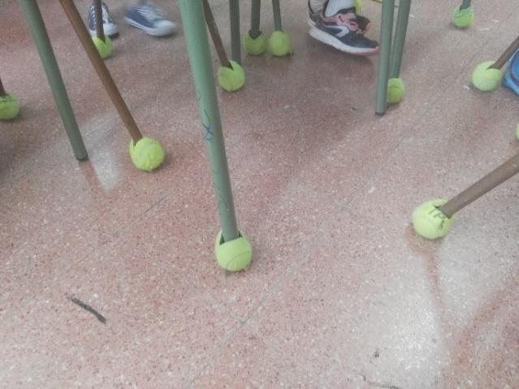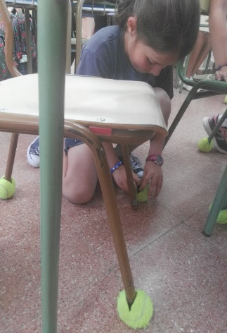
Students place a ball in the chairs, to avoid bizarre noices when moving the chairs . So the class under our class will be happy with our idea.

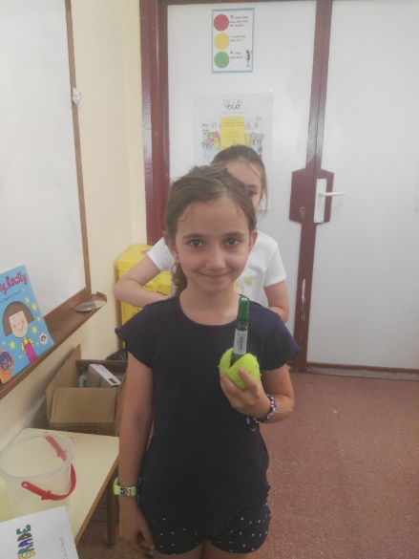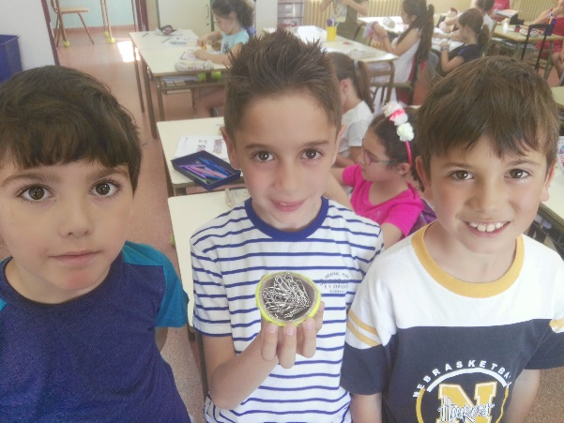
To hold objects : paper clips, pens, markers, …

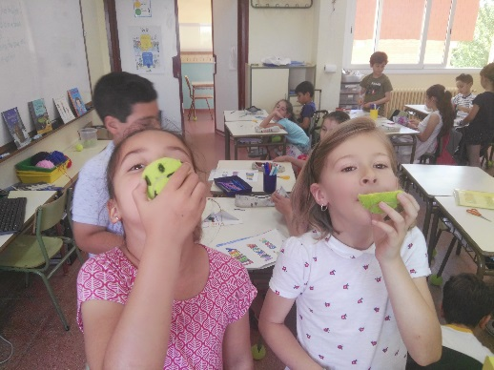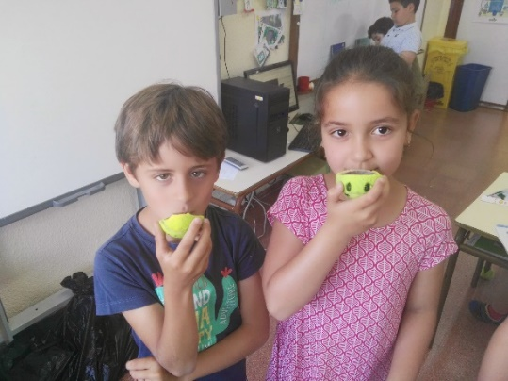
To drink
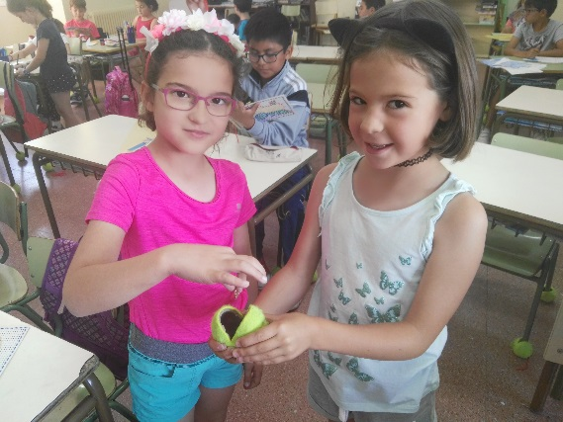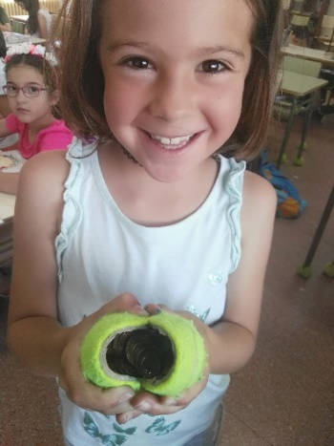
To keep money, as a coin purse

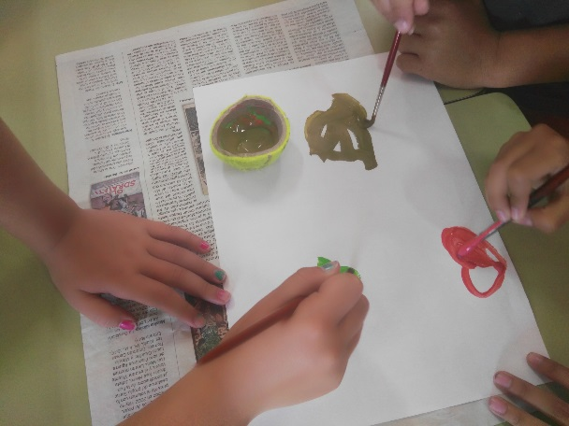
To mix colours

4.-As a hero of a children’s fairy tale
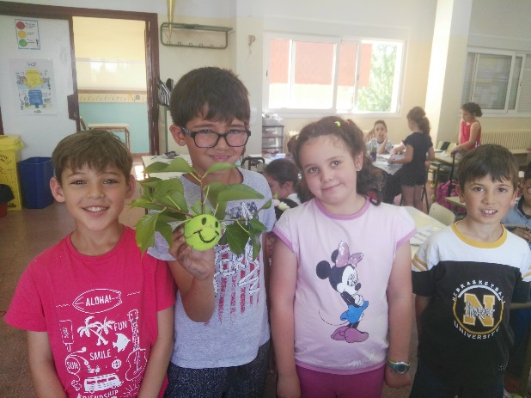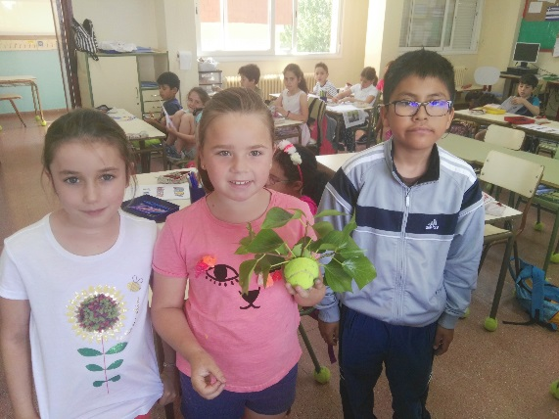

Pepito is one of our main characters of a wonderful fairy tail

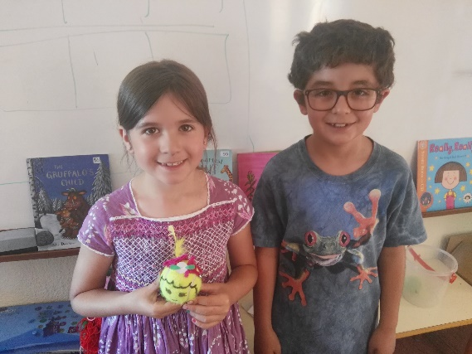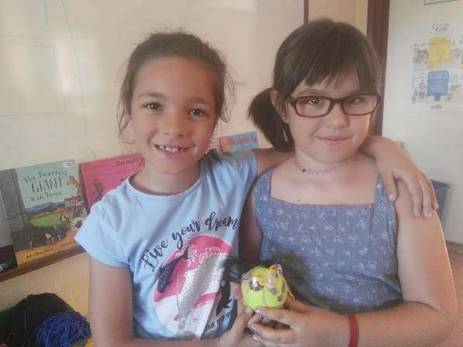
Andrea is another character, sweet Alice in wonderland
Sweet, sweet

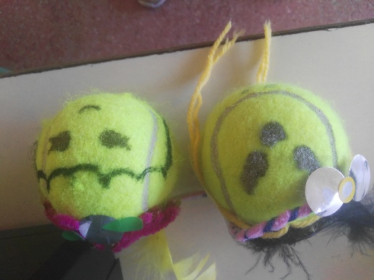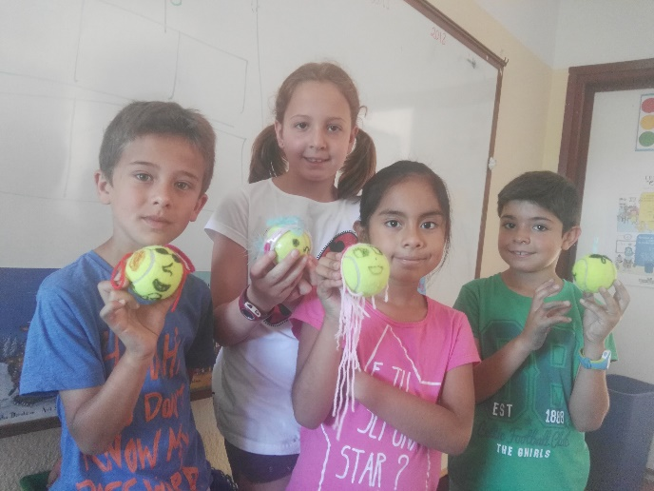

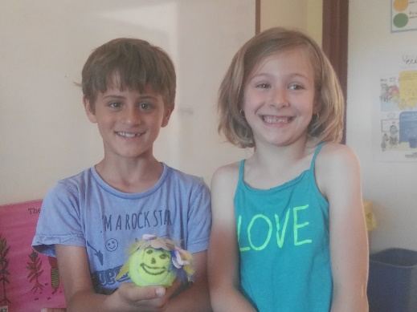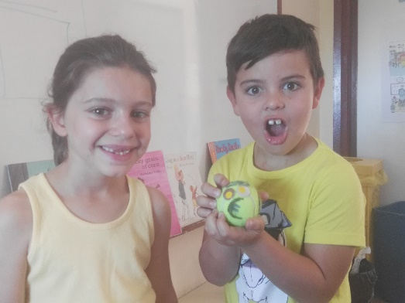
BOLLABANG EUROFACE

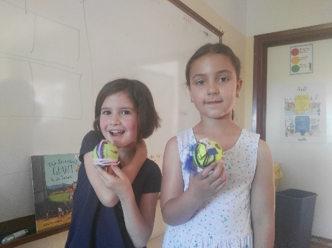
Maria Martin ball and NOA
5.- As the object of an advertisement campaign.

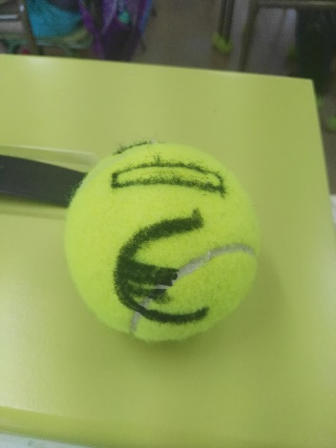

Promoting a piggy bank.
“Save money, saving money”
“RECYCLE YOUR TENNIS BALLS”

