My grandmother‘s name is Heidi. She was born 23th of October 1943 in Berlin. When she was 15, she lived together with her family, their cats Max and Moritz, just like me and my mother in a small village about 5 km from Berlin.
My grandmother thinks that she was a very happy and ambitious person back then and also now. She also really liked to read books like my mother and writing poems. In my grandmother‘s time they couldn’t even dream about having internet, so writing letters was the only way to stay in touch with other people. In her freetime she often met her friends, played tennis or went swimming in a small lake nearby. She also loved to hear music, especially Rock’n Roll and loved dancing. Moreover my grandmother was passionate about learning new languages just like my mother, that's why in school she not only learned
English but also French.
My grandmother often had to help her mother because she had two younger siblings. She had to cook and do the washing up very often. She didn't get much pocket money, that's why she gave tutoring.
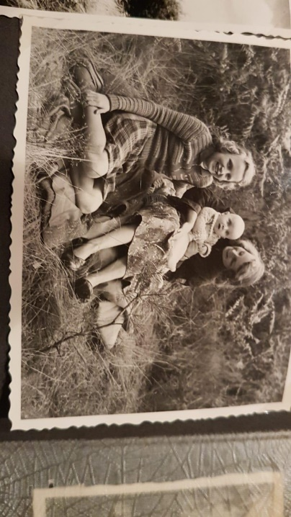
She started school at the age of 6 and when she was 15 she went to a highschool in Berlin. They had a library at their school to study at which my grandmother used very often. She always went to school by food. The first lesson started at 8:00 a.m. and class ended at 14:00 p.m., sometimes even earlier or later. They had a lot of different subjects, such as Maths, German, English, French, Geography and Biology. Punishments at school were things like extra work, detention, standing in the corner but my grandma told me that students had more respect for their teachers than the students have today. Today my grandmother is 77 years old and enjoys living in the black forest together with my grandfather. We often visit her to go hiking.

