Life at 15- Parents- Personal Profile:
Hi, today I will talk about my Parents, to be specific, about my father when he was as 15 years old.
My father’s name is Karl-Heinz Ketelsen, he was born on the 28th of September in 1963, in a village called Okholm, in North Frisia, that is in the north of Germany.
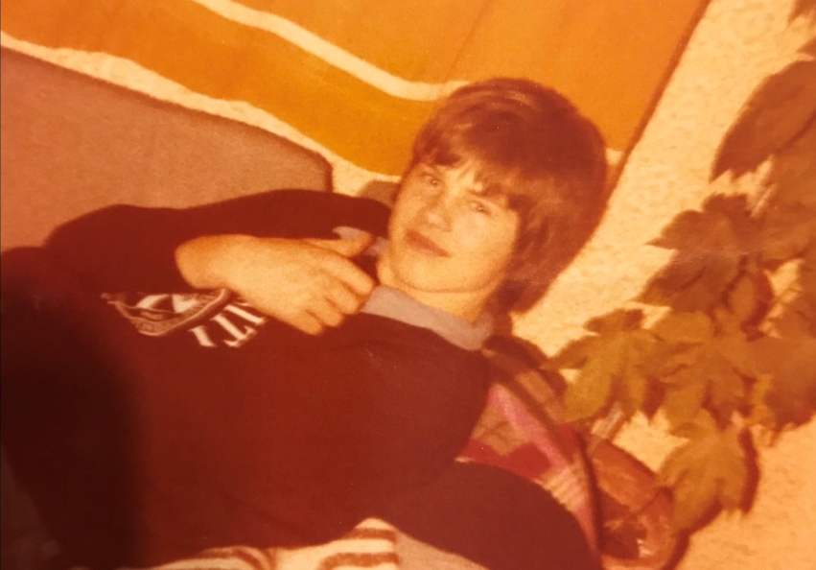
Later they moved to nearby village which is called Enge Sande.
There he lived with his sister and his parents.

Back then, my father was a really lively boy, together with his friends they did all kinds of nonsense, at 15 he was also allowed to drive a moped without a license!
And if he didn’t shoot with his moped through the neighborhood, he liked to shoot or score goals on the football field.
At the age of six, my father attended the primary school.
After that he attended the secondary school.
Usually he walked with his friends to school and later they had an own schoolbus, but he only drover twice a day, that’s why my father bought a moped:D.
Usually school starts at 8 a.m and ends at 1 p.m. On weekend they had no extra lessons.
At his school they had 10 subjects, like math, history and PE lesson, they also had Workshops, for the boys an artisanal/craftsman’s workshop and for the girls a sewing and cooking workshop, also only English was available as a foreign language.
His favorite subjects were the artisanal/craftsman’s workshop, math’s and the PE lesson.
My father didn’t care that much about his future, his big dream was to play football successfully and travel to the USA.
Today my father is 57 years old, architect and married to my mother.

