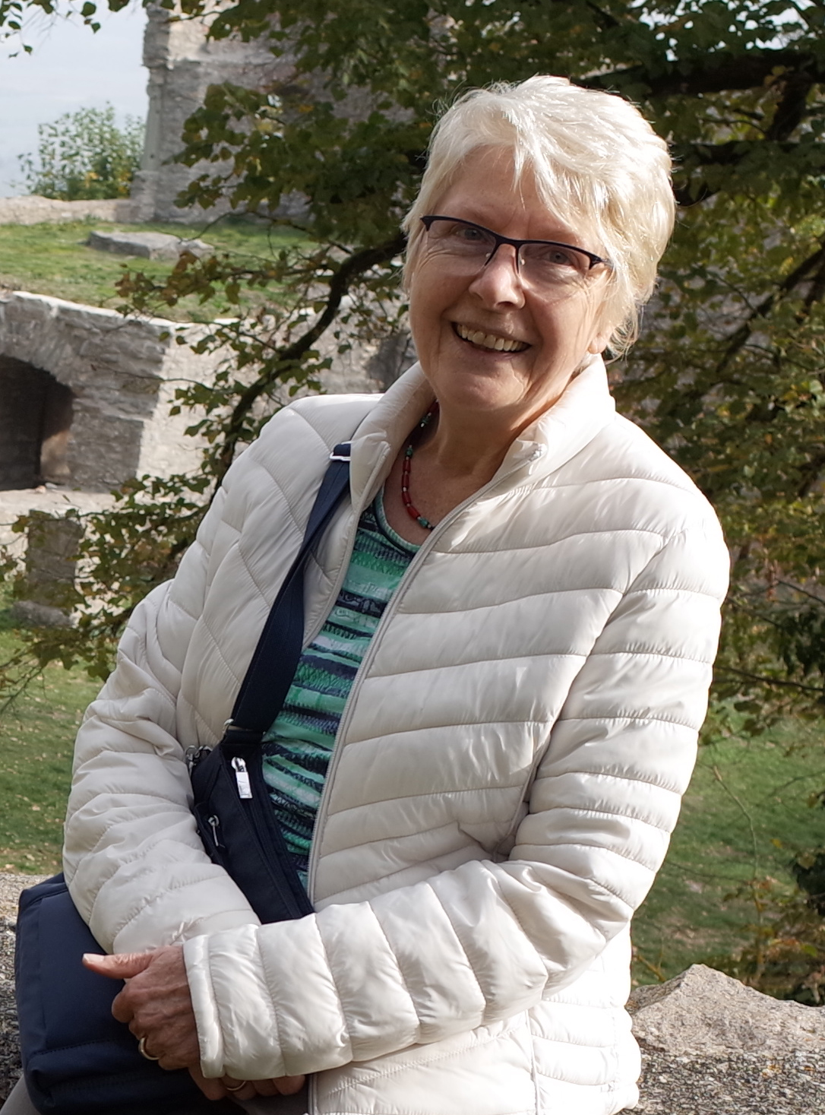
My Grandma‘s life (at 15)

My grandma‘s name is Irmtraut and she was born on 19th August 1941.

She‘s very wise and generous. She cares for her family and always tries to get the perfect gifts for them. She‘s an amazing listener and when problems occur, she finds the best solutions. Being negative is very rare for her and she always suprises us with her creativity. She loves travelling and getting to know more about the different cultures a land can have. Going outside is something she still does and will never stop until it‘s the end for her.

When my grandma was 15, she loved playing outside with her friends or just walking around in the woods. She always sought adventures and never backed down, even if the situation was dangerous. She easily found new friends when she travelled with her family and has plenty of memories with them. She sometimes listened to music but she prefered being active to being lazy.

Her family consisted of her sister, her brother, her mother and her father. Her father had to go to war so she, her mother, her sister and her grandparents had to escape. Their journey ended in Lower Saxony where they had a family-reunion with her father. Her mother worked as a housekeeper and sometimes in the industry while her father looked for a job. He found one and got his family to move in with him. The apartment only had one room which they had to share. They lived there for a while until they got the chance to live in Velbert. Her father made a good deal with the owner of the land and they lived on that farm from then on. She had to do housework like her siblings, for example cleaning their shoes, washing the dishes or cleaning their room. Pocket money didn‘t exist at that time.

She was 7 when she started school. Her school was an elementary school and her grades from 1-8 were all held in the same room. The rules were very strict. If someone didn‘t obey the teachers, they had to stand in the corner for the rest of the lesson or they got their fingers slapped with a ruler. She didn‘t have a library at school and the only thing she did in the breaks was playing with her friends. She got to school by bus.

After finishing school in 1956 she started studying as a trained retail saleswoman for three years.

Now she has a loving husband, wonderful kids and is still as confident and cheerful as ever. The past was hard for her and her family, but they managed to get through it together.

