My father’s profile
My father was born on 5th July 1966, his name is Marc. Now he lives in Großhansdorf with his family.
He’s a friendly, reliable and interested person.
When he was 15 he played tennis and and football, he met his friends very often, too, and read many books in his free time. He lived with his father, his mother and his brother in a big house with a big garden. They also had two dogs. He had to do some housework but not much, because his mother was often at home.
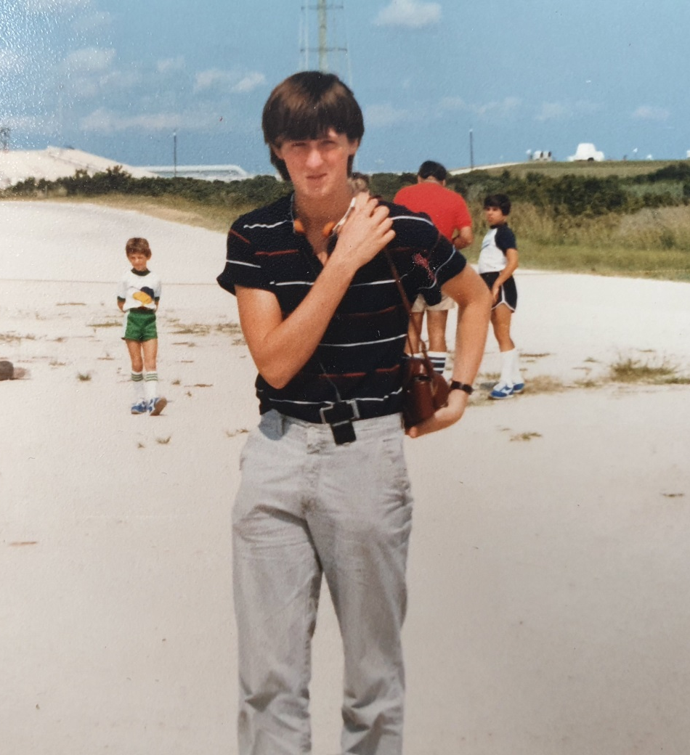
My father went tot he Lauenburgsche Gelehrten School in Ratzeburg which is a secondary grammar school. There were over 1000 students at the school and 6 classes in their grade. At school they had many activities and they trained a lot for “Jugend trainiert für Olympia“ sports competition because they had a big sports groundand many students interested in sports.

